**CORONAVIRUS PROBABILITY AND SYMPTOM (PNEUMONIA) CLASSIFIER ASSISTANT USING LOGISTIC REGRESSION AND NEURAL NETWORK**

**A project report submitted in fulfilment of the requirement for the degree of**

**BACHELOR OF ENGINEERING (B.E.)**

**IN**

**COMPUTER SCIENCE AND ENGINEERING**

Submitted by:

I. Navin Kumar BE/6015/16

Sudeep Ghosal BE/6025/16

Sonu Kumar BE/6119/16

Under the supervision of:

Prof. Swapan Kumar Borat



DEPARTMENT OF COMPUTER SCIENCE AND ENGINEERING

**BIRLA INSTITUTE OF TECHNOLOGY, MESRA**

DEOGHAR CAMPUS, JHARKHAND-814142

**BIRLA INSTITUTE OF TECHNOLOGY, MESRA**

A Deemed University u/s 3 of UGC Act, 1956

**Deoghar Campus**

P.O. Jasidih, Dist.-Deoghar 814142 JHARKHAND

Ph: 09234158610 Fax: 06432-292565 www.deoghar.bitmesra.ac.in

**DEPARTMENT OF COMPUTER SCIENCE AND ENGINEERING**

**CERTIFICATE**

This is to certify that Mr. I. NAVIN KUMAR, Mr. SUDEEP GHOSAL and Mr. SONU KUMAR have developed the project titled “Coronavirus probability and symptom (pneumonia) classifier assistant using logistic regression and neural network” in my supervision and guidance. To the best of my knowledge the project work is original.

(Signature with Date) (Signature with Date)

Prof. Swapan Kumar Borat Dr. Kamta Nath Mishra

Department of Comp. Sc. & Engg. Department of Comp. Sc. & Engg.

Birla Institute of Technology, Ranchi Birla Institute of Technology, Ranchi

Off Campus – Deoghar, Jharkhand Off Campus – Deoghar, Jharkhand

**ACKNOWLEDGEMENT**

It gives us great sense of pleasure to present the report of the final year B.E. project undertaken during B.E. 8th semester. We owe special debt of gratitude to **Prof. Swapan Kumar Borat** and **Dr. Sounak Paul**, assistant professor, Birla institute of technology, Mesra for their constant support and guidance throughout the course of our work. Their sincerity and perseverance have been a constant source of inspiration for us.

We also take the opportunity to acknowledge the contribution of **Dr. Kamta Nath Mishra**, Head of department Computer Science and Engineering, Birla Institute of Technology, Mesra for his support and assistance during the development of the project.

We are also grateful to all the faculty members of the department of Computer Science and Engineering for their kind assistance and cooperation during development of our project. Last but not the least, we acknowledge our friends for their contribution in the completion of the project.

**TABLE OF CONTENTS**

Title……………………………………………………………………Page No.

**Chapter 1: Introduction**

* 1. Brief 6
  2. Problem Definition 8
  3. Objective 8

**Chapter 2: Related Work**

2.1 Related Work 15

**Chapter 3: Requirement Specification**

3.1 Specification 17

**Chapter 4: Problem Design and Experimental Setup**

4.1 Problem Statement 21

4.2 Experimental Setup 70

**Chapter 5: Results and Discussions**

5.1 Results of Coronavirus Detection Part for Severe Symptoms 107

5.2 Results of Coronavirus Detection Part for Mild Symptoms111

**Chapter 6: Interface**

6.1 Interface 114

**Chapter 7: Conclusion and Future Scope**

7.1 Conclusion and Future Scope 141

**Chapter 8: References**

8.1 References 143

CHAPTER 1

INTRODUCTION

**CHAPTER 1**

**Introduction**

**1.1 Brief**

The field of deep learning encompasses a group of artificial intelligence methods which employ a large number of simple interconnected units to perform complicated tasks. Deep learning algorithms, rather than using a set of pre-programmed instructions, are capable of learning from large amounts of data. The tasks solved by these algorithms include localizing and classifying objects in images, understanding language, playing games, and many others. While the flagship of deep learning, convolutional neural networks, were first introduced decades ago, it is only the last 5 years that showed an astonishing success of these algorithms elevating their status from an interesting but mostly impractical idea to the go-to algorithm in artificial intelligence. In recent years, not only have deep learning algorithms been able to surpass performance of other methods in artificial intelligence but in some tasks, they have shown performance superior to humans.

There are likely three reasons for the recent success of deep learning algorithms: availability of data, increased processing power, and rapid development of algorithms. These are highly connected: availability of large datasets of images and computing power made it possible to demonstrate the strength of the basic concepts of deep learning and, motivated the development of further datasets and algorithms. Increasing ease in applying algorithms and affordable graphical processing units have allowed for larger scientific and technical communities to get involved, and develop even more powerful algorithms which further advanced the field. As the primary strength of deep learning has been in image analysis, the potential applications in radiology have become very quickly apparent. The development of algorithms for radiology has shown some inertia due to the time needed for acquisition of the appropriate expertise in the medical imaging community as well as limited availability of large medical imaging datasets. However, the last 2-3 years have seen remarkable productivity in the field. It is now well recognized by both researchers and clinicians that deep learning will play a significant role in radiology. In this paper, we begin with a general overview of radiology as the application domain and consider where deep learning could have the most significant impact. Then, we introduce the general concepts of deep learning. This is followed by an overview of the recent work in the field. The article closes with remarks regarding the future of deep learning in radiology.

* **Radiology**

Radiology is a branch of medicine that focuses on using medical images for detection, diagnosis, and characterization of disease (diagnostic radiology) as well as guiding procedural interventions (interventional radiology). In the United States, a typical radiologist undergoes 14-15 years of education after high school including 4 years of college, 4 years of medical school, 1 year of internship, 4 years of radiology residency, and generally 1-2 years of fellowship training. While medical image interpretation work is centred in radiology practices and academic departments, some of it is also performed within other branches of medicine including cardiology, orthopaedics, and surgery. In diagnostic radiology, personal interaction between a radiologist with patients and other physicians is often limited. The primary duty of a radiologist (particularly outside of an academic institution) is to view an image delivered to his/her reading station and generate a written report of findings. This well-structured and isolated nature of the radiologist's work makes is a particularly attractive application of artificial intelligence algorithms. Deep learning techniques (and artificial intelligence algorithms in general) have a tremendous potential to influence the practice of radiology. Unlike most other facets of medicine, all or nearly all of the primary data utilized in imaging is digital, lending itself to analysis by artificial intelligence algorithms. In this section, we describe some of the primary challenges that a radiologist faces in his/her daily diagnostic radiology practice and briefly point to opportunities for deep learning to address them. While this is not intended to be an exhaustive description of every task that radiologists perform in their practice, it reacts majority of diagnostic radiology practice. We conclude this section with a description of some medical image interpretation tasks that are currently not performed by radiologists, but could be incorporated in radiology practice using deep learning.

* **Disease Detection**

One of the most challenging tasks in the interpretation of imaging is the rapid differentiation of abnormalities from normal background anatomy. For example, in the interpretation of mammography, each radiograph contains thousands of individual focal densities, regional densities, and geometric points and lines that must be interpreted to detect a small number of suspicious or abnormal findings. In most cases, the entire mammogram should be interpreted as normal or negative, adding further complexity to the interpretive task. In order to be useful, a computer algorithm does not have to detect all objects of interest (e.g., abnormalities) and be perfectly specific (i.e., not mark any normal locations). For example, in screening mammography, approximately 80% of screening mammograms should be read as negative according to the ACR BI-RADS guideline, and of the 20% of examinations that trigger additional evaluation, many will ultimately be categorized as negative or benign. An algorithm that could successfully categorize even half of screening mammograms as definitely negative would dramatically reduce the effort required to interpret a large batch of examinations.

**Conventional Method of pneumonia detection**

According to [www.radiologyinfo.org](http://www.radiologyinfo.org) which is a radiology information resource for patients

State that “Chest x-ray: An x-ray exam will allow your doctor to see your lungs, heart and blood vessels to help determine if you have pneumonia. When interpreting the x-ray, the radiologist will look for white spots in the lungs (called infiltrates) that identify an infection. This exam will also help determine if you have any complications related to pneumonia such as abscesses or pleural effusions (fluid surrounding the lungs).”

**1.2 Problem Definition**

Due to the widespread of COVID-19 the sector that has suffered the maximum load upon itself is the healthcare system. Every healthcare professional is experiencing a very hectic schedule and those who are already in intensive care need their attention. Moreover professionals like doctors and radiologists are not always available which makes it often difficult to determine through the symptoms and even medical reports that whether they have a particular disease or not,

In the viewpoint of COVID-19, the symptom noted by World Health Organization that is most likely to occur in a serious patient of Covid’19 is pneumonia. Therefore, it takes an experienced radiologist to see an x-ray image of the chest and infer the case whether the person is suffering from pneumonia or not. As described above it takes nearly 15 years of study for being a radiologist. Therefore not many practitioners are available to have the required expertise to assess a case.

Additionally, it is very tough job to determine whether a person suffering from pneumonia has the corona virus as its root cause. People suffering from corona may develop pneumonia as well as not all patients having pneumonia may not necessarily be having corona virus.

**1.3 Objective**

The problem that our project focuses on is to bridge the gap between Covid19 patients and practitioners. Before moving onto the main idea of the project, we would be first discussing the inference or the motivation that led to our idea.



This was the news that was spread while coronavirus was at its initial stage and WHO confirmed that pneumonia is a definite symptom that is caused at a severe stage of Covid19.

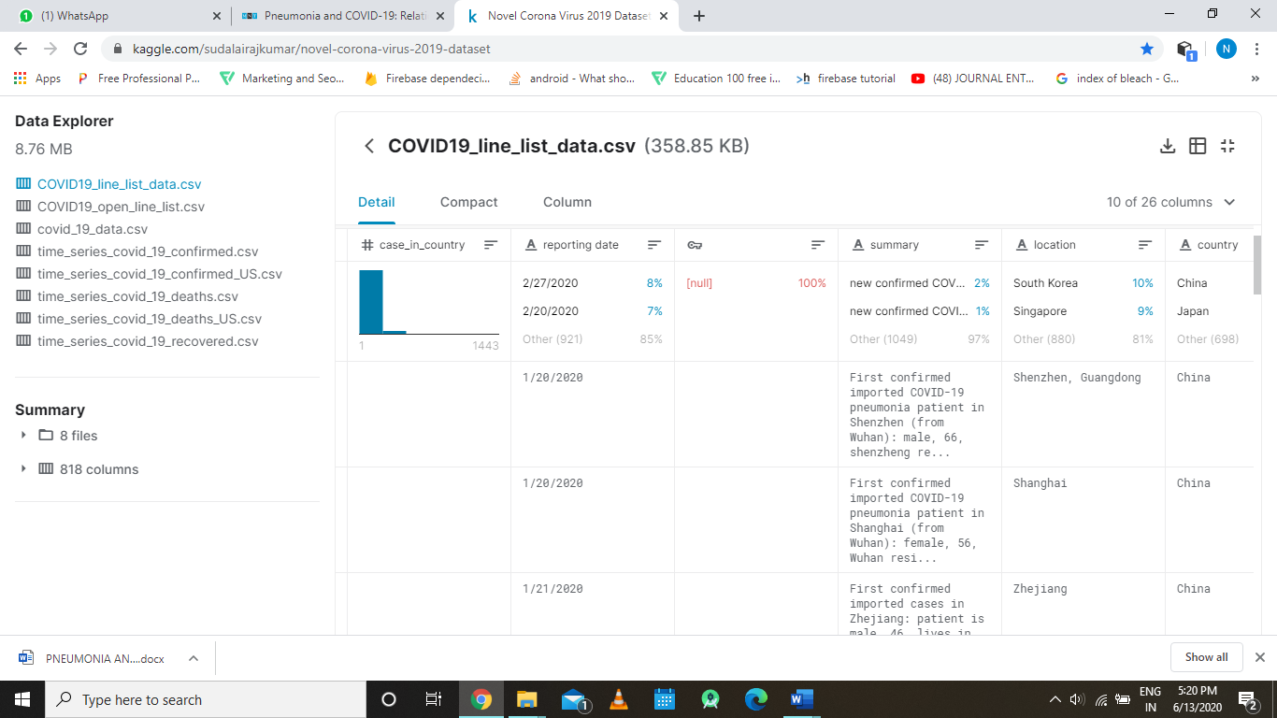

<https://www.kaggle.com/sudalairajkumar/novel-corona-virus-2019-dataset>

the above was the original dataset that was being referred to at the initial stage of coronavirus that was hosted at Kaggle for all deep learning aspirants, the above data is original committed data from john Hopkins university and this dataset has daily level information on the number of affected cases, deaths and recovery from 2019 novel coronavirus and has the following information:

* Sno - Serial number
* ObservationDate - Date of the observation in MM/DD/YYYY
* Province/State - Province or state of the observation (Could be empty when missing)
* Country/Region - Country of observation
* Last Update - Time in UTC at which the row is updated for the given province or country. (Not standardized and so please clean before using it)
* Confirmed - Cumulative number of confirmed cases till that date
* Deaths - Cumulative number of deaths till that date
* Recovered - Cumulative number of recovered cases till that date

Using this data we started to find a pattern were our computer science’s deep learning can be useful, while we were digging up the data we found the following pattern

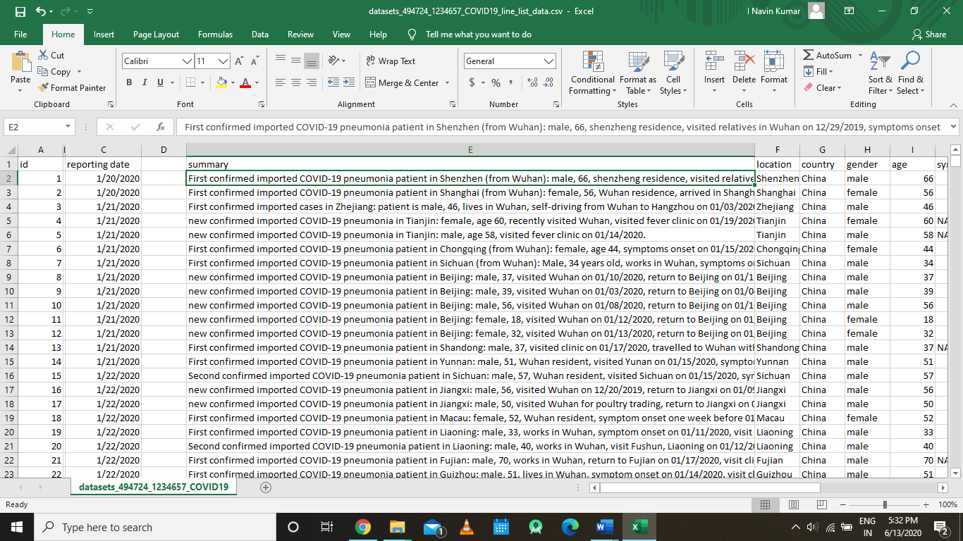

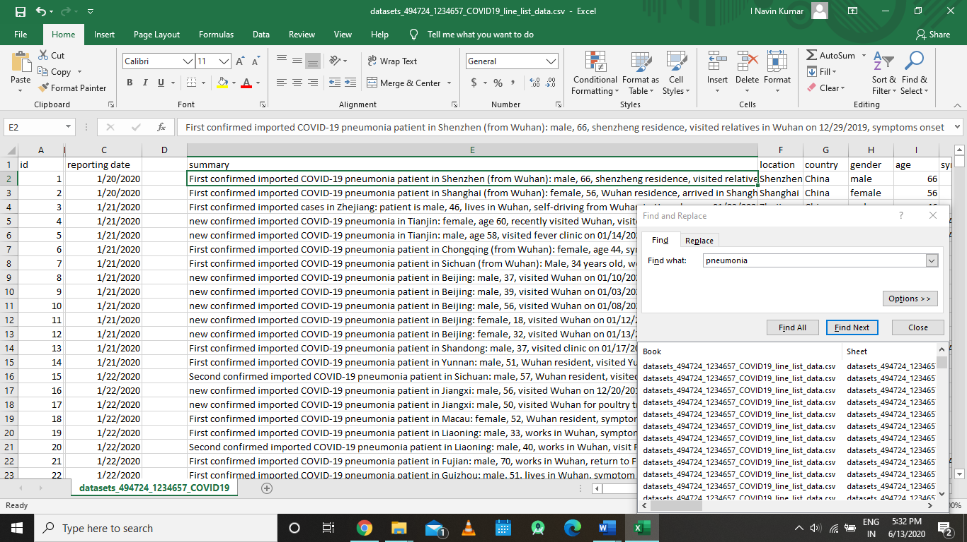

As we can see from the above images it was clear that there were many cases of Covid 19 which pneumonia as its symptom.

From these patterns and information we planned to build a coronavirus detector assistant but there were some short comings at that time such the data that was available with us was dynammic and everyday some new symptoms were being discovered but the fact that pneumonia was detected in the severe covid19 cases remined so we tried to develop an application that would help to detect at least one symptom, so we choose pneumonia as our symptom that we could work upon as it is a area were deep learning has made some progress and this particular disease had data upon which we could work upon.

So here our objective boiled down to developing a deep learning model can take the task of assessing the chest x-rays of patients and determine whether they are suffering from pneumonia or not. It is a two way solution:-

* It helps in unloading the burden of extra patients on medical practitioners.
* It covers the absence or inaccessibility of patients to medical diagnosis of pneumonia.

But as I discussed earlier that the data for the covid19 disease is dynamic and everyday new discoveries were being made and new theories were being stated, the people became more attentive over the covid19 situation, so now problem elevated to detecting the covid19 at mild stage or early stage.

So in order to address the above detection problem we started to research over how patients were initially taken into consideration of having Covid19 in various hospital and we found that every hospital and doctor made some initial inference about the probability of patient having covid19 was using some basic symptoms.

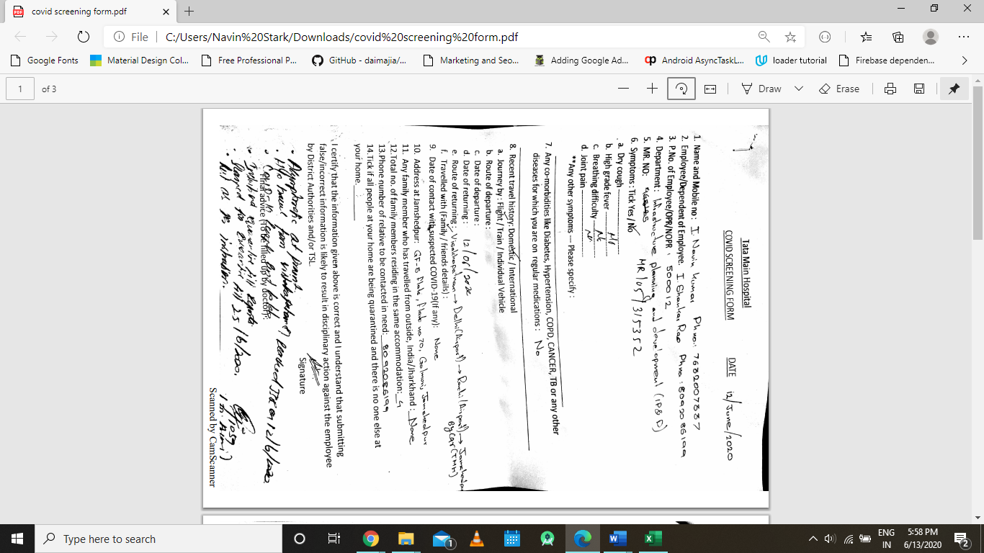

Fig: a sample that you have to fill for covid19 testing in Tata Main Hospital

From the image you can see the basic symptoms that a doctor needs to for covid19 screening test to test how much the patient is inclined to have coronavirus.

From the above facts and figure we tried to develop a deep learning that model that would take those common simple symptoms and predict a decent probability of having coronavirus, this approach also makes it easy to separate the cases of pneumonia from the cases that are caused by corona.

CHAPTER 2

RELATED WORK

**CHAPTER 2**

**2.1 Related Work**

The most well-known achievement of deep learning to date is its performance in the ImageNet competition. ImageNet is a database of more than 14,000,000 annotated natural images con- training real world objects such as cars, animals, and buildings (image-net.org). One of the goals of the competition, started in 2009, is to assign each image to one of 1 000 predefined categories. When a deep learning-based algorithm first appeared in the competition in 2012, it dramatically improved the error rate from 0.258 in the previous year (imagenet.org/challenges/LSVRC/2011/results) to 0.153

(image-net.org/challenges/LSVRC/2012/results). The performance of deep learning algorithms for image classification has been improving since then and is now considered to be comparable to or better than human performance. Other areas relevant to the topic of this article, where deep learning algorithms have seen impressive results, is in the automatic generation of sophisticated captions for images that consist of full sentences as well as localization and outlining of objects in images.

CHAPTER 3

REQUIREMENT SPECIFICATION

**CHAPTER 3**

**3.1 Requirement Specification**

**SPECIFICATION**

**FUNCTIONAL REQUIREMENTS**

1. **Dataset Requirements:-**

* The data should have chest X-ray images of patients having pneumonia.
* The data should have chest X-ray images not having pneumonia.
* The dataset should contain enough data to so that the model can be trained.
* The dataset should have test data to evaluate the performance of the model used.
* The dataset should have the geographical information of the corona virus.
* Pre-processing:- The datasets that are being used should not be a raw data. So, the following processes are involved in pre-processing.

1. Data Cleaning- It is the process of finding the inaccurate, incomplete and corrupt data from the dataset and correcting, replacing or deleting them.
2. Data Transformation- It is the process of converting the formal structure or format of the data into another structure or format using data mapping to define how individual fields are mapped, modified, joined, filtered, and aggregated.
3. Data Reduction- It is the process of reducing or condensing the large data set into compact form without losing the quality of original dataset.

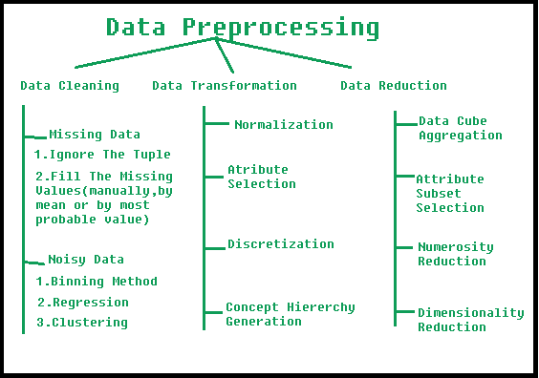

* Augmentation: - This is the process which helps in solving overfitting problems and enhances the model’s generalization ability during training.

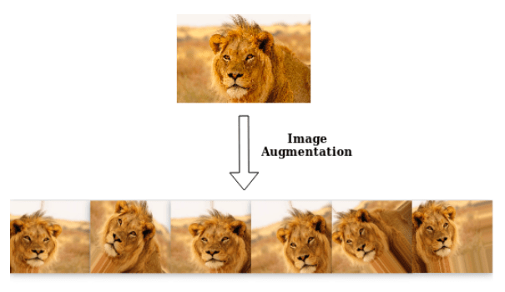

1. **Model Requirements:-**

The model should have a feature extractor. Each layer in the feature extraction layer takes its immediate preceding layer's output as input, and its output is passed as an input to the succeeding layers.

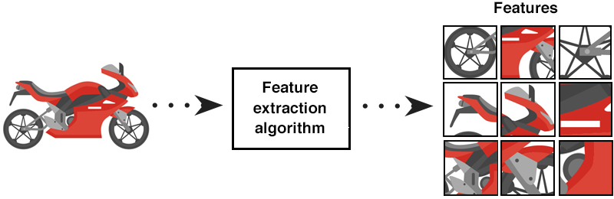

The model should have a classifier. Classifier requires individual features (vectors) to perform computations like any other classifier. Therefore, the output of the feature extractor (CNN part) is converted into a 1D feature vector for the classifiers.

**NON-FUNCTIONAL REQUIREMENTS**

* Reliability- This program is developed with machine learning and deep learning techniques. So, in this step there is no certain reliable percentage that is measurable.

* Usability- The program should be easy to use. This means it can even be used by even normal users with ease.
* Performance- Read time and response time should be as little as possible.
* Accuracy- The detection of pneumonia and corona are based on the dataset and the model. Therefore, accuracy gets better as more and more data is available in the dataset.
* Efficient- The program should be efficient enough to process the X-ray images as efficiently as possible.

CHAPTER 4

PROBLEM DESIGN AND

EXPERIMENTAL SETUP

**CHAPTER 4**

**Problem Design and Experimental Setup**

**4.1 Problem Design**

**4.1.1 Algorithm/Methodology**

**Algorithm: Coronavirus Detection Part for Severe Symptoms (Pneumonia detection)**

**Terminology**

To understand deep learning, it is helpful to first understand the related concepts of artificial intelligence and machine learning. Artificial intelligence is a set of computer algorithms that are able to perform complicated tasks or tasks that require intelligence when conducted by humans. Machine learning is a subset of artificial intelligence algorithms which, to perform these complicated tasks, are able to learn from provided data and do not require pre-defined rules of reasoning. The field of machine learning is very diverse and has already had notable applications in medical imaging. Deep learning is a sub-discipline of machine learning that relies on networks of simple interconnected units. In deep learning models, these units are connected to form multiple layers that are capable of generating increasingly high level representations of the provided input (e.g., images). Below, in order to explain the architecture of deep learning models, we introduce the artificial neural network in general and one specific type: the convolutional neural network. Then, we detail the “learning” process of these networks, which is the process of incorporating the patterns extracted from data into deep neural networks.

**Artificial Neural Networks**

Artificial neural networks (ANNs) are machine learning models based on basic concepts dating as far as 1940s, significant development in 1970s and 1980s and a period notable popularity in 1990s and 2000s followed by a period of being overshadowed by other machine learning algorithms. ANNs consist of a multitude of interconnected processing units, called neurons, usually organized in layers. A traditional ANN typically used in the practice of machine learning contains 2 to 3 layers of neurons. Each neuron performs a very simple operation. While many neuron models were proposed, a typical neuron simply multiplies each input by a certain weight, then adds all the products for all the inputs and applies a simple non decreasing function at the end. Even though each neuron performs a very rudimentary calculation, the interconnected nature of the network allows for the performance of very sophisticated calculations and implementation of very complicated functions.

**Design and Implementation of a Basic Neural Network**

A neural network is made up of neurons connected to each other; at the same time, each connection of our neural network is associated with a weight that dictates the importance of this relationship in the neuron when multiplied by the input value.

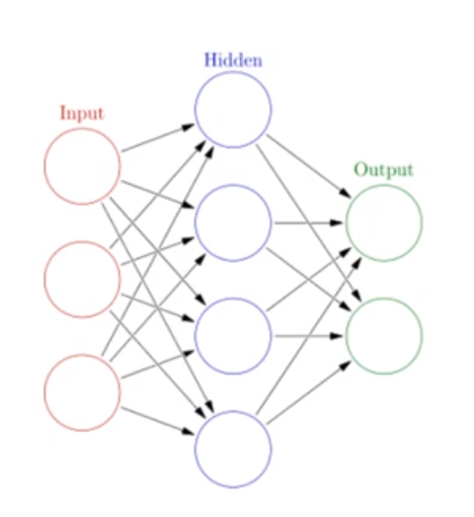

**Fig 3.1: A basic Architecture of the Neural Network**

Each neuron has an **activation function** that defines the output of the neuron. The activation function is used to introduce non-linearity in the modeling capabilities of the network.

Training our neural network, that is, learning the values of our parameters (weights wij and bj biases) is the most genuine part of Deep Learning and we can see this learning process in a neural network as an iterative process of “going and return” by the layers of neurons. The “going” is a forward propagation of the information and the “return” is a backpropagation of the information.

The first phase **forward propagation**occurs when the network is exposed to the training data and these cross the entire neural network for their predictions (labels) to be calculated. That is, passing the input data through the network in such a way that all the neurons apply their transformation to the information they receive from the neurons of the previous layer and sending it to the neurons of the next layer. When the data has crossed all the layers, and all its neurons have made their calculations, the final layer will be reached with a result of label prediction for those input examples.

Next, we will use a **loss function** to estimate the loss (or error) and to compare and measure how good/bad our prediction result was in relation to the correct result (remember that we are in a supervised learning environment and we have the label that tells us the expected value). Ideally, we want our cost to be zero, that is, without divergence between estimated and expected value. Therefore, as the model is being trained, the weights of the interconnections of the neurons will gradually be adjusted until good predictions are obtained.

Once the loss has been calculated, this information is propagated backwards. Hence, its name: **backpropagation**. Starting from the output layer, that loss information propagates to all the neurons in the hidden layer that contribute directly to the output. However, the neurons of the hidden layer only receive a fraction of the total signal of the loss, based on the relative contribution that each neuron has contributed to the original output. This process is repeated, layer by layer, until all the neurons in the network have received a loss signal that describes their relative contribution to the total loss.

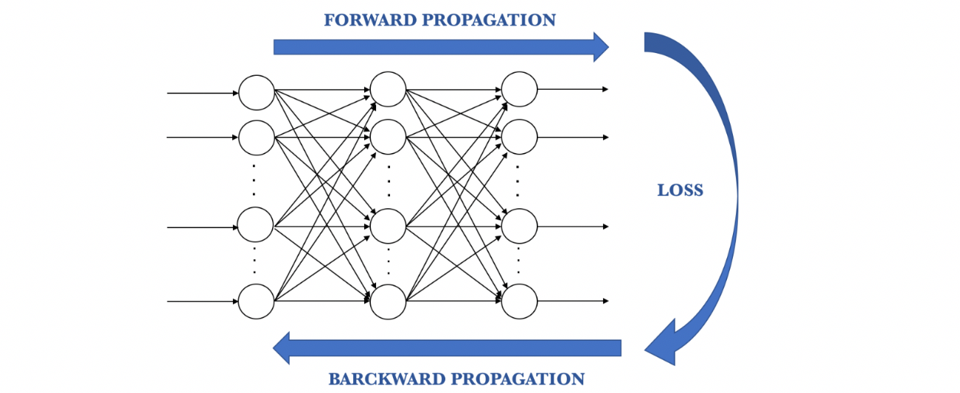

**Fig 3.2: Forward and Backward Propagation**

Now that we have spread this information back, we can adjust the weights of connections between neurons. What we are doing is making the loss as close as possible to zero the next time we go back to using the network for a prediction. For this, we will use a technique called **gradient descent**. This technique changes the weights in small increments with the help of the calculation of the derivative (or gradient) of the loss function, which allows us to see in which direction “to descend” towards the global minimum; this is done in general in batches of data in the successive iterations (epochs) of all the dataset that we pass to the network in each iteration.

The learning algorithm consists of: (The below Algorithm will form the basis building for understanding the learning algorithm for convolutional neural network0

**ALGORITHM 1:**

1. Start with values (often random) for the network parameters (*wij* weights and *bj* biases).
2. Take a set of examples of input data and pass them through the network to obtain their prediction.
3. Compare these predictions obtained with the values of expected labels and calculate the loss with them.
4. Perform the backpropagation in order to propagate this loss to each and every one of the parameters that make up the model of the neural network.
5. Use this propagated information to update the parameters of the neural network with the gradient descent in a way that the total loss is reduced and a better model is obtained.
6. Continue iterating in the previous steps until we consider that we have a good model.

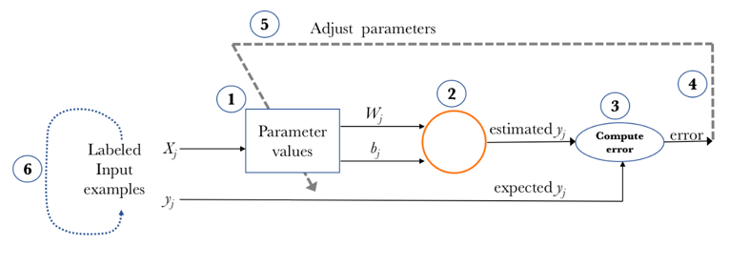

**Fig 3.3: The diagram depicting the Algorithm used by a neural network**

The above algorithm is generic description of how the neural network works in a nutshell in the upcoming section we will be introducing to the all the stated concepts briefly so as to understand the bigger picture

**Activation Function**

In reality each Hidden Node passes through an activation function. In the simplest terms an activation function changes the output of that function. We use the activation functions to propagate the output of a neuron forward. This output is received by the neurons of the next layer to which this neuron is connected (up to the output layer included).The activation function serves to introduce non-linearity in the modeling capabilities of the network.

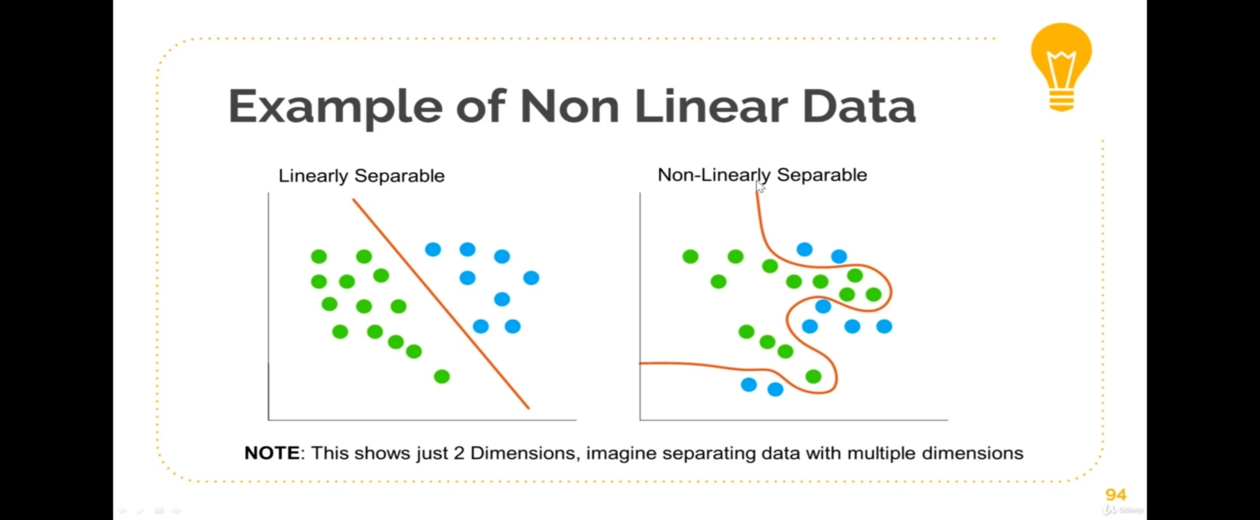

The above figure clearly shows two different types of data the first one evidently being a linearly separable data where the activation function are not required at the hidden nodes whereas coming to the case of the next diagram on the right the data is not linearly separable normal linear regression won’t work here, thus in this case the activation functions comes into play which provides the non-linear modelling capability.

Below are some of the widely used activation functions

## Sigmoid

 Its interest lies in the fact that it allows a reduction in extreme or atypical values in valid data without eliminating them: it converts independent variables of almost infinite range into simple probabilities between 0 and 1. Most of its output will be very close to the extremes of 0 or 1.

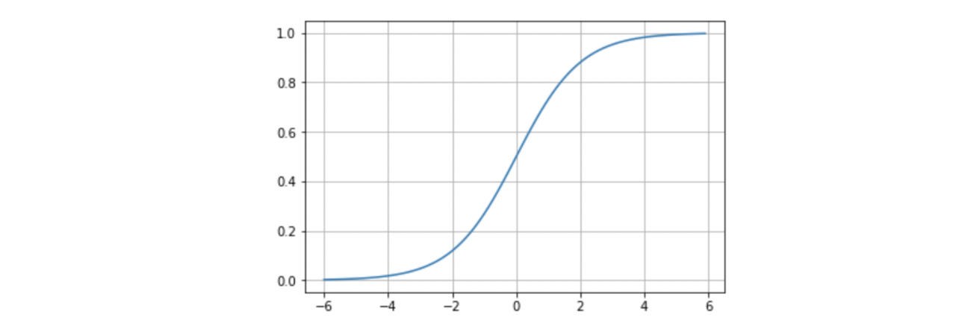

**Fig 3.4: Sigmoidal function**

**Tanh**

We can summarize that the tanh represents the relationship between the hyperbolic sine and the hyperbolic cosine: [tanh(x) = sinh(x)/cosh(x)](https://en.wikipedia.org/wiki/Hyperbolic_function). Unlike the sigmoid function, the normalized range of tanh is between -1 and 1, which is the input that goes well with some neural networks. The advantage of tanh is that negative numbers can be dealt with more easily.

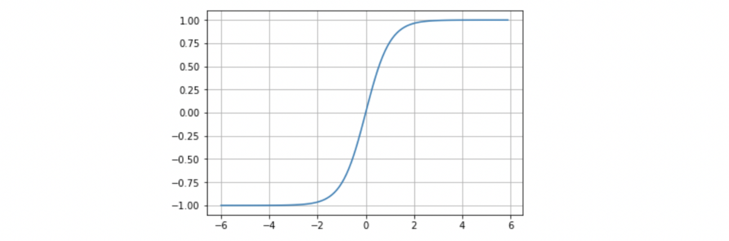

**Fig 3.5: Tanh function**

**Softmax**

The softmax activation function is used to generalize the logistic regression, insofar as instead of classifying in binary it can contain multiple decision limits. As we have seen, the softmax activation function will often be found in the output layer of a neural network and return the probability distribution over mutually exclusive output classes.

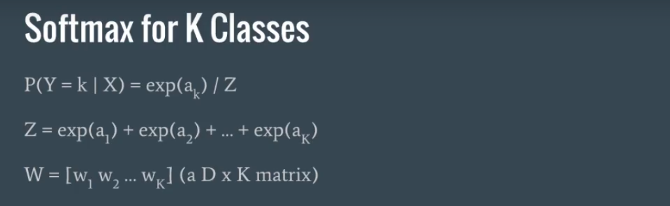

**Fig 3.6: Softmax Regression formula for k- Classes**

## **ReLU (Rectified Linear Unit) Activation Function**

## The ReLU is the most used activation function in the world right now. Since, it is used in almost all the convolutional neural networks or deep learning. As you can see from the below figure, the ReLU is half rectified (from bottom).

## f(z) is zero when z is less than zero and f(z) is equal to z when z is above or equal to zero. **Range:**[0 to infinity]. The function and its derivative **both are** **monotonic**. But the issue is that all the negative values become zero immediately which decreases the ability of the model to fit or train from the data properly. That means any negative input given to the ReLU activation function turns the value into zero immediately in the graph, which in turns affects the resulting graph by not mapping the negative values appropriately.

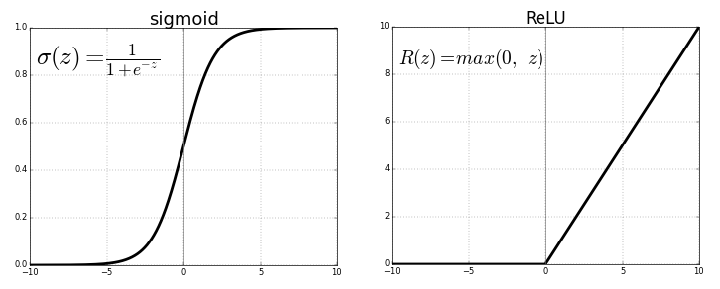

ReLU function

# **Backpropagation components**

In summary, we can consider backpropagation as a method to alter the parameters (weights and biases) of the neural network in the right direction. It starts by calculating the loss term first, and then the parameters of the neural network are adjusted in reverse order with an optimization algorithm taking into account this calculated loss.

## Loss function

A loss function is one of the parameters required to quantify how close a particular neural network is to the ideal weight during the training process. Loss functions are integral in training Neural Nets as they measure the inconsistency or difference between the predicted results & the actual target results. They are always positive and penalize big errors well. The lower the loss the 'better' the model

### Below are some of the widely used loss function

### **Mean Squared Error Loss**

Mean Squared Error loss, or MSE for short, is calculated as the average of the squared differences between the predicted and actual values.

The result is always positive regardless of the sign of the predicted and actual values and a perfect value is 0.0. The loss value is minimized, although it can be used in a maximization optimization process by making the score negative.

### **Cross-Entropy Loss (or Log Loss)**

Cross-entropy loss is often simply referred to as “cross-entropy,” “logarithmic loss,” “logistic loss,” or “log loss” for short. Each predicted probability is compared to the actual class output value (0 or 1) and a score is calculated that penalizes the probability based on the distance from the expected value. The penalty is logarithmic, offering a small score for small differences (0.1 or 0.2) and enormous score for a large difference (0.9 or 1.0). Cross-entropy loss is minimized, where smaller values represent a better model than larger values. A model that predicts perfect probabilities has a cross entropy or log loss of 0.0. Cross-entropy for a binary or two class prediction problem is actually calculated as the average cross entropy across all examples.

# **Binary Cross-Entropy**

# **BCE** loss is used for the binary classification tasks. If we are using BCE loss function, we just need one output node to classify the data into two classes. The output value should be passed through a sigmoid activation function and the range of output is (0 – 1).

# **Categorical Cross-Entropy**

# When we have a multi-class classification task, one of the loss function you can go ahead is this one. If you are using CCE loss function, there must be the same number of output nodes as the classes. And the final layer output should be passed through a softmax activation so that each node output a probability value between (0–1).

## 

## Fig 3.7: Categorical Cross Entropy Loss

## Gradient descent

Gradient descent uses the first derivative (gradient) of the loss function when updating the parameters. Remember that the gradient gives us the slope of a function at that point. Without being able to go into detail, the process consists in chaining the derivatives of the loss of each hidden layer from the derivatives of the loss of its upper layer, incorporating its activation function in the calculation (that’s why the activation functions must be derivable). In each of the iterations, once all the neurons have the value of the gradient of the loss function that corresponds to them, the values of the parameters are updated in the opposite direction to that indicated by the gradient. The gradient, in fact, always points in the direction in which the value of the loss function increases. Therefore, if the negative of the gradient is used, we can get the direction in which we tend to reduce the loss function.

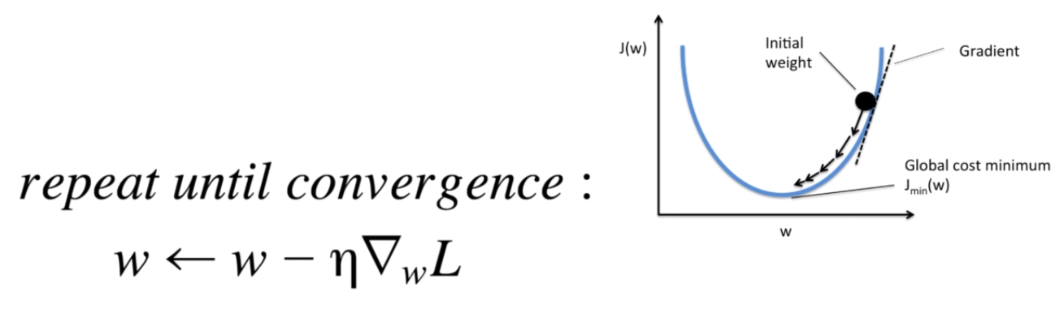

**Fig 3.8: Convergence Formula**

Suppose that this line represents the values that the loss function takes for each possible parameter value and that the negative of the gradient is depicted by the arrow in the initial point:

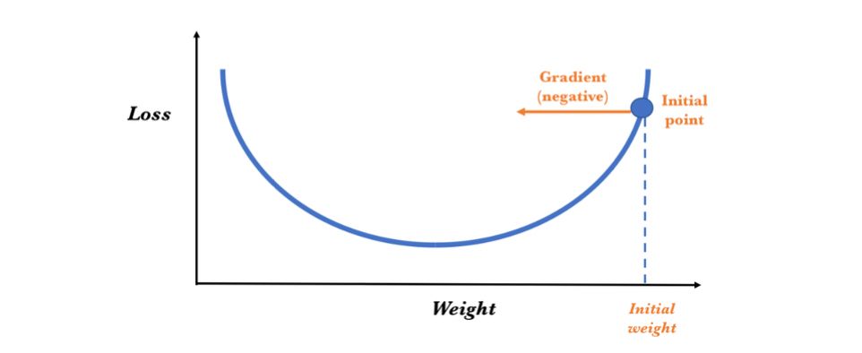

**Fig** **3.9.1: Gradient determination**

To determine the next value for the parameter, the gradient descent algorithm modifies the value of the initial weight to go in the opposite way to the gradient (since it points in the direction in which the loss grows and we want to reduce it), adding a proportional amount to this. The magnitude of this change is determined by the value of the gradient and by a learning rate hyperparameter that we can specify (which we will present shortly). Therefore, conceptually, it is as if we follow the slope downhill until we reach a local minimum:

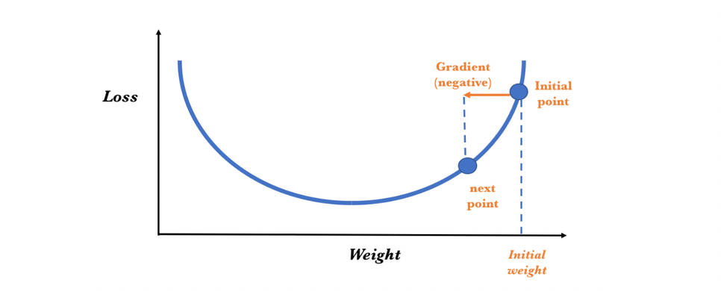

**Fig 3.9.2: Gradient determination**

The gradient descent algorithm repeats this process getting closer and closer to the minimum until the value of the parameter reaches a point beyond which the loss function cannot decrease:

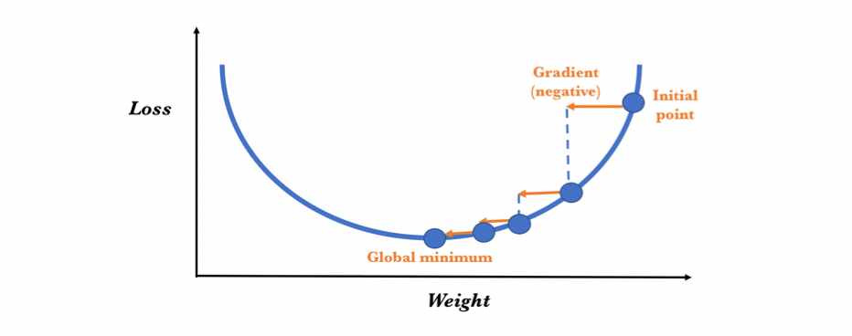

**Fig 3.9.3: Gradient determination**

# Gradient descent variants

There are three variants of gradient descent, which differ in how much data we use to compute the gradient of the objective function. Depending on the amount of data, we make a trade-off between the accuracy of the parameter update and the time it takes to perform an update.

# **Batch Gradient Descent**

In Batch Gradient Descent, all the training data is taken into consideration to take a single step. We take the average of the gradients of all the training examples and then use that mean gradient to update our parameters. So that’s just one step of gradient descent in one epoch.

Batch Gradient Descent is great for convex or relatively smooth error manifolds. In this case, we move somewhat directly towards an optimum solution.

# **Stochastic Gradient Descent**

In Batch Gradient Descent we were considering all the examples for every step of Gradient Descent. But what if our dataset is very huge. Deep learning models crave for data. The more the data the more chances of a model to be good. Suppose our dataset has 5 million examples, then just to take one step the model will have to calculate the gradients of all the 5 million examples. This does not seem an efficient way. To tackle this problem we have Stochastic Gradient Descent. In Stochastic Gradient Descent (SGD), we consider just one example at a time to take a single step. We do the following steps in **one epoch** for SGD:

1. Take an example
2. Feed it to Neural Network
3. Calculate it’s gradient
4. Use the gradient we calculated in step 3 to update the weights
5. Repeat steps 1–4 for all the examples in training dataset

SGD can be used for larger datasets. It converges faster when the dataset is large as it causes updates to the parameters more frequently.

# **Mini Batch Gradient Descent**

We have seen the Batch Gradient Descent. We have also seen the Stochastic Gradient Descent. Batch Gradient Descent can be used for smoother curves. SGD can be used when the dataset is large. Batch Gradient Descent converges directly to minima. SGD converges faster for larger datasets. But, since in SGD we use only one example at a time, we cannot implement the vectorized implementation on it. This can slow down the computations. To tackle this problem, a mixture of Batch Gradient Descent and SGD is used.

Neither we use all the dataset all at once nor do we use the single example at a time. We use a batch of a fixed number of training examples which is less than the actual dataset and call it a mini-batch. Doing this helps us achieve the advantages of both the former variants we saw. So, after creating the mini-batches of fixed size, we do the following steps in **one epoch:**

1. Pick a mini-batch
2. Feed it to Neural Network
3. Calculate the mean gradient of the mini-batch
4. Use the mean gradient we calculated in step 3 to update the weights
5. Repeat steps 1–4 for the mini-batches we created

**Overfitting**

Overfitting leads to a poor model and is one of the most common problem faced in developing AI/Machine Learning/Neural Nets. Overfitting occurs when our model fits perfectly to our training data, i.e. when the model even tries to fit the outlier in the data**.**

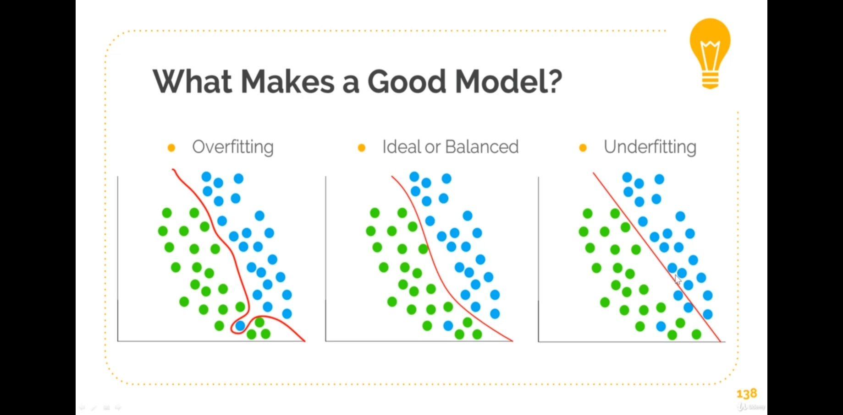

Regularization

Regularization is a technique which makes slight modifications to the learning algorithm such that the model generalizes better. This in turn improves the model’s performance on the unseen data as well.

## Different Regularization Techniques in Deep Learning

### **L2 & L1 regularization**

L1 and L2 are the most common types of regularization. These update the general cost function by adding another term known as the regularization term.

Cost function = Loss (say, binary cross entropy) + Regularization term

Due to the addition of this regularization term, the values of weight matrices decrease because it assumes that a neural network with smaller weight matrices leads to simpler models. Therefore, it will also reduce overfitting to quite an extent.

However, this regularization term differs in L1 and L2.

In L2, we have:

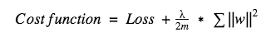

Here, **lambda** is the regularization parameter. It is the hyperparameter whose value is optimized for better results. L2 regularization is also known as weight decay as it forces the weights to decay towards zero (but not exactly zero).

In L1, we have:

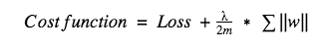

In this, we penalize the absolute value of the weights. Unlike L2, the weights may be reduced to zero here. **Hence, it is very useful when we are trying to compress our model. Otherwise, we usually prefer L2 over it.**

### **Dropout**

This is the one of the most interesting types of regularization techniques. It also produces very good results and is consequently the most frequently used regularization technique in the field of deep learning.

To understand dropout, let’s say our neural network structure is akin to the one shown below:

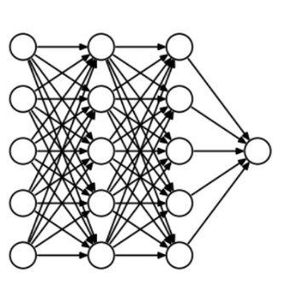

Fig: A Basic neural network with dropout being applied

In dropout, at every iteration, it randomly selects some nodes and removes them along with all of their incoming and outgoing connections as shown below.

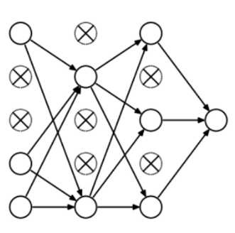

Neural network after the dropout has been applied

So each iteration has a different set of nodes and this results in a different set of outputs. **It can also be thought of as an ensemble technique in machine learning.** Ensemble models usually perform better than a single model as they capture more randomness. Similarly, dropout also performs better than a normal neural network model.

This probability of choosing how many nodes should be dropped is the hyperparameter of the dropout function. As seen in the image above, dropout can be applied to both the hidden layers as well as the input layers. Due to these reasons, dropout is usually preferred when we have a large neural network structure in order to introduce more randomness.



Fig: Dropout being applied at the las hidden layer

### **Data Augmentation**

The simplest way to reduce overfitting is to increase the size of the training data. In machine learning, we were not able to increase the size of training data as the labelled data was too costly.

But, now let’s consider we are dealing with images. In this case, there are a few ways of increasing the size of the training data – rotating the image, flipping, scaling, shifting, etc. In the below image, some transformation has been done on the handwritten digits dataset.

This technique is known as data augmentation. This usually provides a big leap in improving the accuracy of the model. It can be considered as a mandatory trick in order to improve our predictions. In keras, we can perform all of these transformations using [ImageDataGenerator](https://keras.io/preprocessing/image/). It has a big list of arguments which you can use to pre-process your training data.

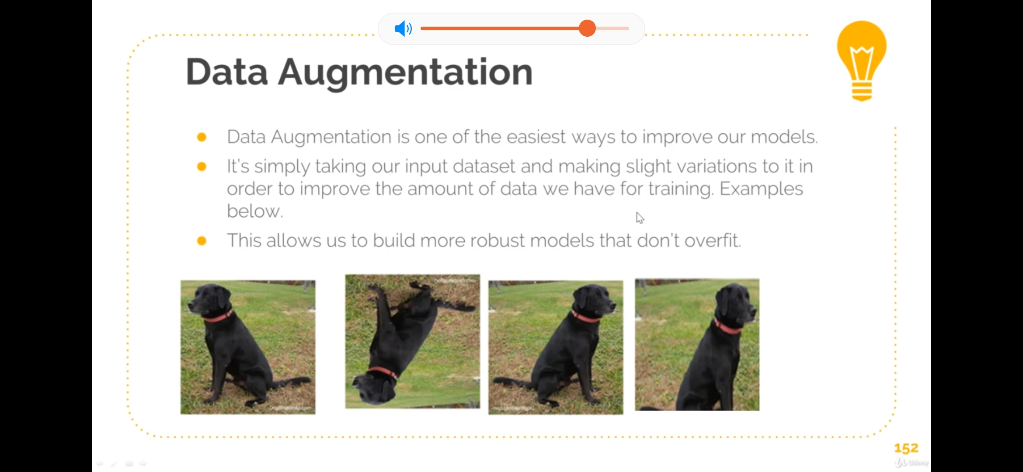

Fig: On applying different types of transformation such as rotation, scaling, flipping

### **Early stopping**

Early stopping is a kind of cross-validation strategy where we keep one part of the training set as the validation set. When we see that the performance on the validation set is getting worse, we immediately stop the training on the model. This is known as early stopping.

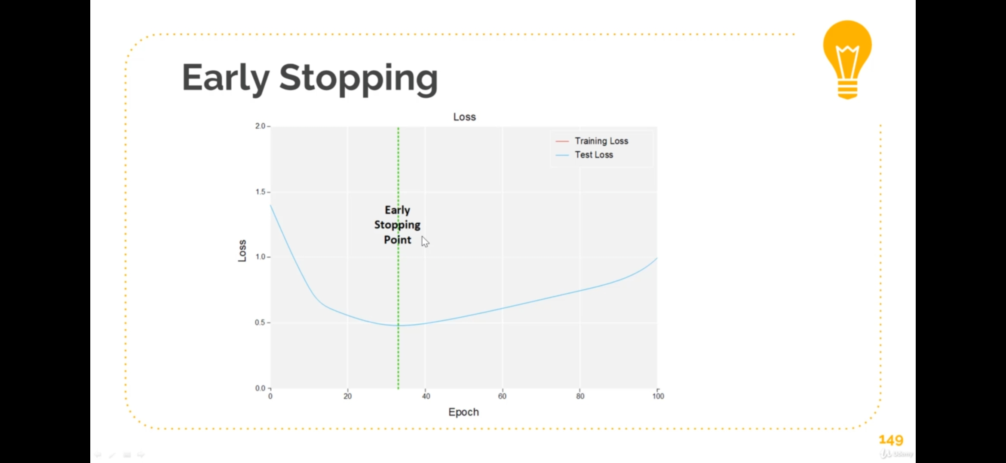

Fig: graph depicting the point where the training iteration stops due to early stopping

**Model parameterization**

**Parameters and hyper parameters**

We consider a parameter of the model as a configuration variable that is internal to the model and whose value can be estimated from the data. In contrast, by hyperparameter we refer to configuration variables that are external to the model itself and whose value in general cannot be estimated from the data, and are specified by the programmer to adjust the learning algorithms.

## Epochs

Epochs tells us the number of times all the training data have passed through the neural network in the training process. A good clue is to increase the number of epochs until the accuracy metric with the validation data starts to decrease, even when the accuracy of the training data continues to increase (this is when we detect a potential overfitting).

## Batches

## Unless we had huge volumes of RAM, we can't simply pass all our training data to our Neural Network in need to split the data up into segments or Batches. Batch Size is the number of training samples we use in a single batch. Example, say we had 1000 samples of data, and specified batch size of 100. In training, we'd take 100 samples of that data and use it in the forward/backward pass then update our weights. If the batch size is 1, we're simply doing Stochastic Gradient Descent.

## Learning rate

The gradient vector has a direction and a magnitude. Gradient descent algorithms multiply the magnitude of the gradient by a scalar known as learning rate (also sometimes called step size) to determine the next point.

In a more formal way, the backpropagation algorithm computes how the error changes with respect to each weight:



In order to update each weight of the network using a simple update rule:



Where α is the learning rate.

**Why CNN’s are used Over ANN’s for Image Data:**

**Neural Networks (NN)**, or more precisely **Artificial Neural Networks (ANN)**, is a class of Machine Learning algorithms that recently received a lot of attention (again!) due to the availability of Big Data and fast computing facilities (most of Deep Learning algorithms are essentially different variations of ANN).

The class of ANN covers several architectures including **Convolutional Neural Networks** ([CNN](https://en.wikipedia.org/wiki/Convolutional_neural_network)), Recurrent Neural Networks ([RNN](https://en.wikipedia.org/wiki/Recurrent_neural_network)) e.g. [LSTM](https://en.wikipedia.org/wiki/Long_short-term_memory) and [GRU](https://en.wikipedia.org/wiki/Gated_recurrent_unit), [Autoencoders](https://en.wikipedia.org/wiki/Autoencoder), and [Deep Belief Networks](https://en.wikipedia.org/wiki/Deep_belief_network). Therefore, CNN is just one kind of ANN.

Generally speaking, an ANN is a collection of connected and tunable units (a.k.a. nodes, neurons, and artificial neurons) which can pass a signal (usually a real-valued number) from a unit to another. The number of (layers of) units, their types, and the way they are connected to each other is called the network architecture.

A CNN, in specific, has one or more layers of **convolution** units. A convolution unit receives its input from multiple units from the previous layer which together create a proximity. Therefore, the input units (that form a small neighbourhood) share their weights.

The convolution units (as well as pooling units) are especially beneficial as:

* They reduce the number of units in the network (since they are many-to-one mappings). This means, there are fewer parameters to learn which reduces the chance of overfitting as the model would be less complex than a fully connected network.
* They consider the context/shared information in the small neighborhoods. This future is very important in many applications such as image, video, text, and speech processing/mining as the neighboring inputs (e.g. pixels, frames, words, etc.) usually carry related information.

**4.1.1.1 Convolutional Neural Networks**

Deep neural networks are a special type of an ANN. The most common type of a deep neural network is a deep convolutional neural network (CNN). A deep convolutional neural network, while inheriting the properties of a generic ANN, has also its own specific features. First, it is deep. A typical number of layers is 10-30 but in extreme cases it could exceed 1 000. Second, the neurons are connected such that multiple neurons share weights. This effectively allows the network to perform convolutions (or template matching) of the input image with the filters (defined by the weights) within the CNN. Other special feature of CNNs is that between some layers, they perform pooling which makes the network invariant to small shifts of the images. Finally, CNNs typically use a different activation function of the neurons as compared to traditional ANNs.

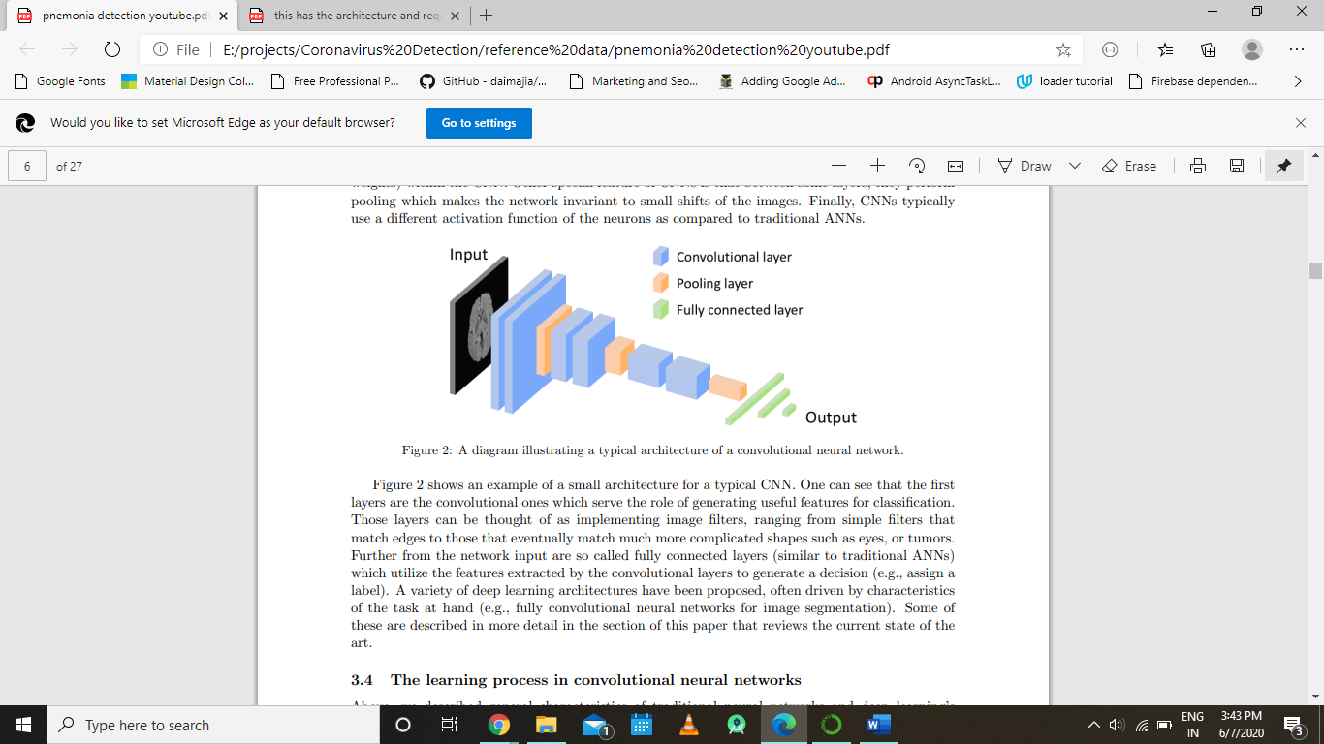

The above figure shows an example of a small architecture for a typical CNN. One can see that the first layers are the convolutional ones which serve the role of generating useful features for classification. Those layers can be thought of as implementing image filters, ranging from simple filters that match edges to those that eventually match much more complicated shapes such as eyes, or tumors. Further from the network input are so called fully connected layers (similar to traditional ANNs) which utilize the features extracted by the convolutional layers to generate a decision (e.g., assign a label). A variety of deep learning architectures have been proposed, often driven by characteristics of the task at hand (e.g., fully convolutional neural networks for image segmentation). Some of these are described in more detail in the section of this paper that reviews the current state of the art.

Convolutional Neural Networks uses a three-dimensional arrangement for its neurons, because our input data is in an image, we can constrain or design our Neural Network to better suit this type of data using three-dimensional arrangement.

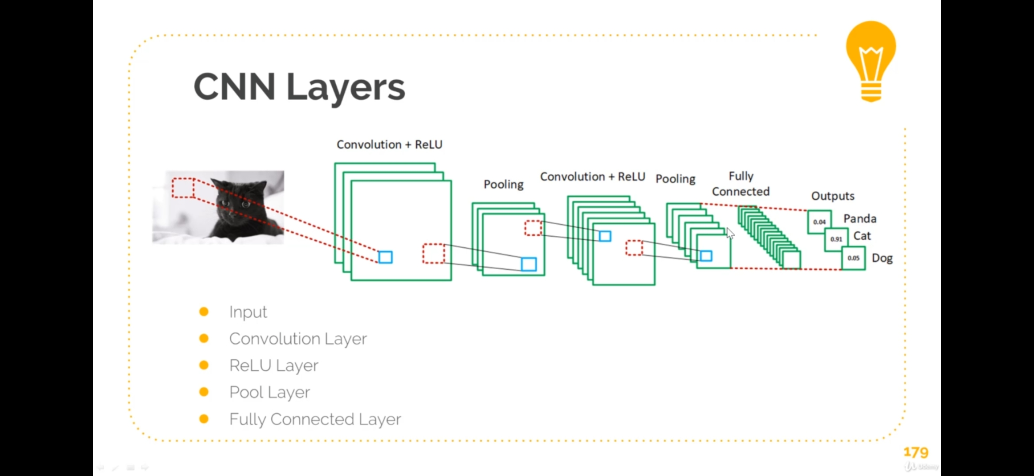

Fig: A basic Convolutional Neural Network

A basic Convolutional Neural Network has the following layers

* Input
* Convolution Layer
* ReLU Layer
* Pool Layer
* Fully Connected Layer

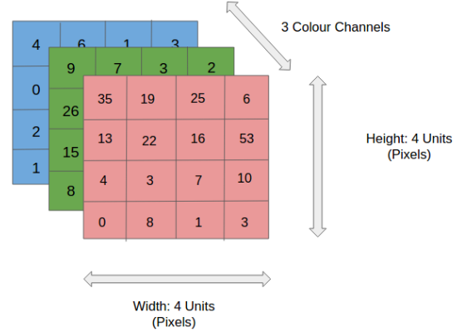

In the figure, we have an RGB image which has been separated by its three color planes — Red, Green, and Blue. There are a number of such color spaces in which images exist — Grayscale, RGB, HSV, CMYK, etc.

You can imagine how computationally intensive things would get once the images reach dimensions, say 8K (7680×4320). The role of the ConvNet is to reduce the images into a form which is easier to process, without losing features which are critical for getting a good prediction. This is important when we are to design an architecture which is not only good at learning features but also is scalable to massive datasets.

**Image Features**

Image Features are simply interesting areas of an image. Examples: Edges, Colors Patterns/Shapes

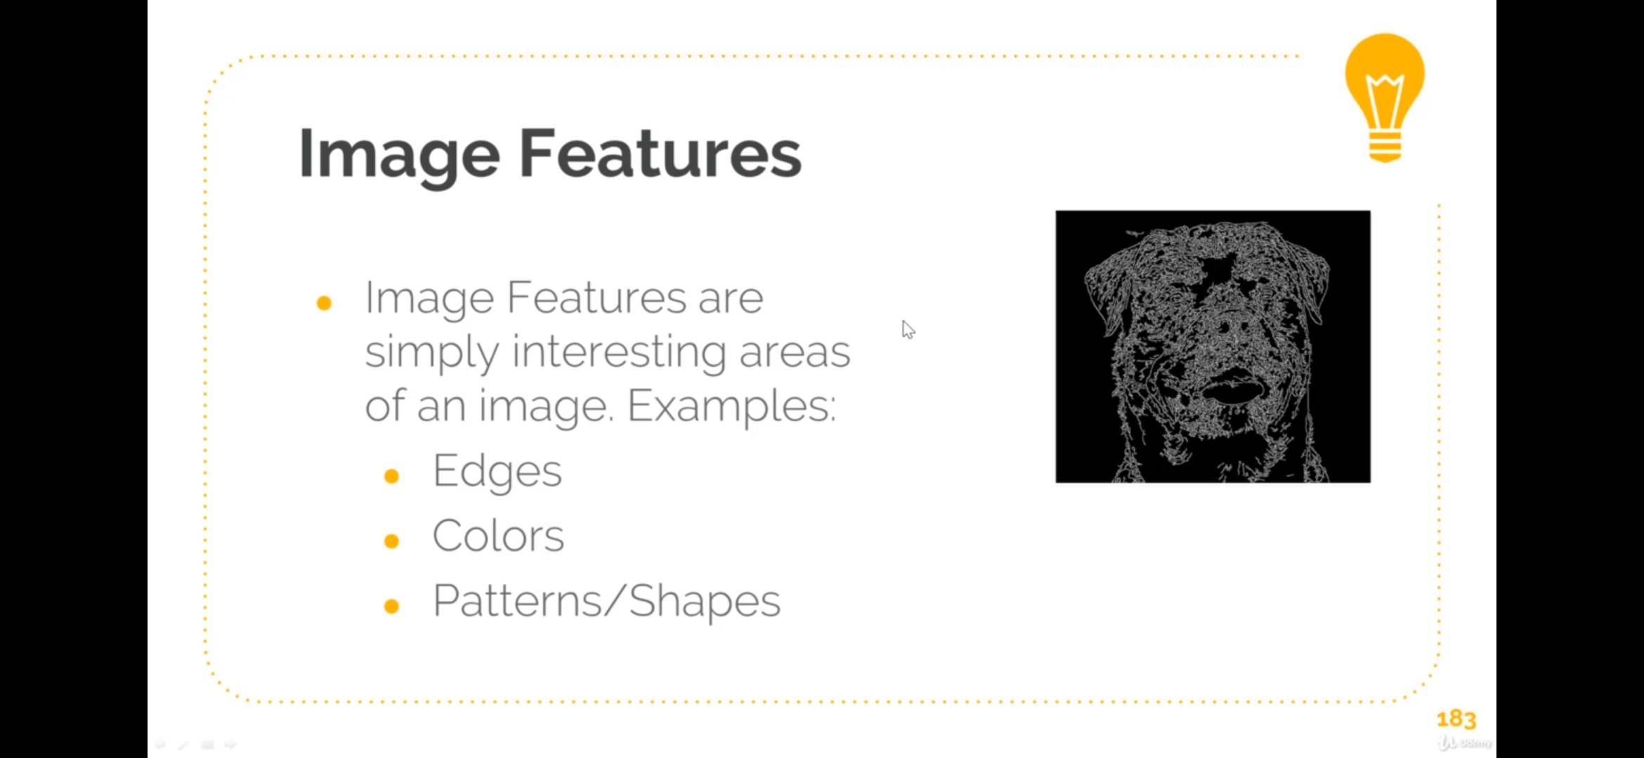

Fig: the above figure is highlighting the edges feature of an image

**Convolutional Layer – The Kernel**

**Convolution**

Convolution is a mathematical term to describe the process of combining two functions to produce a third function. In Convolutional Neural Network this third function or the output is called a Feature Map. A convolution is the action of using a filter or kernel that is applied to the input.

**Kernel**

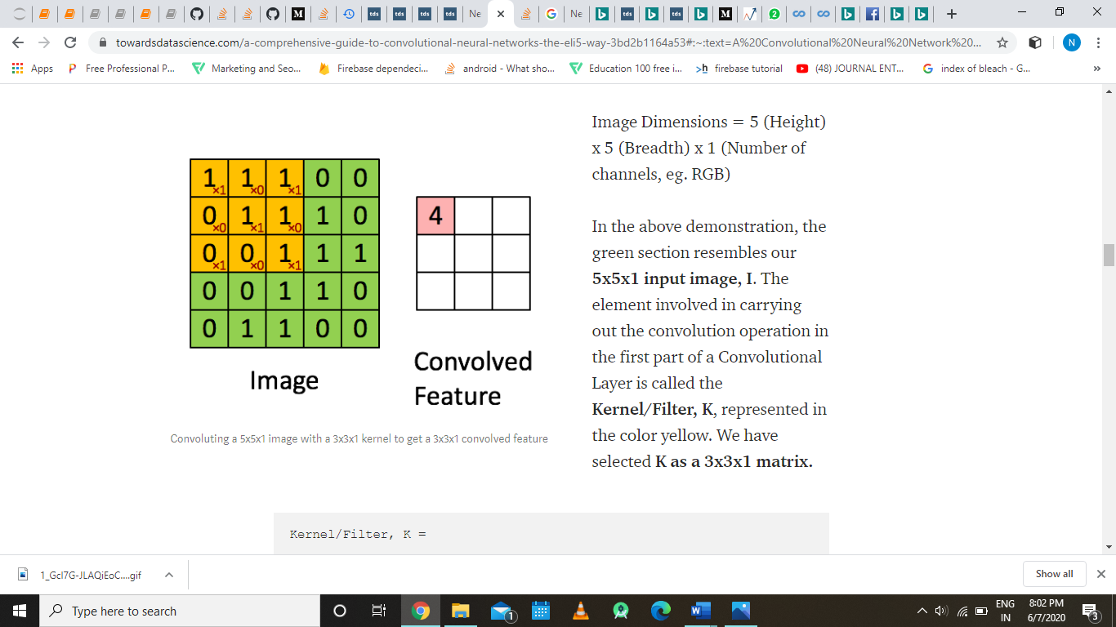 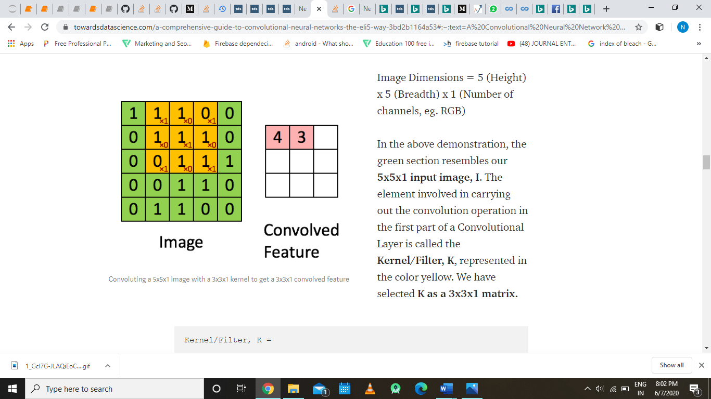 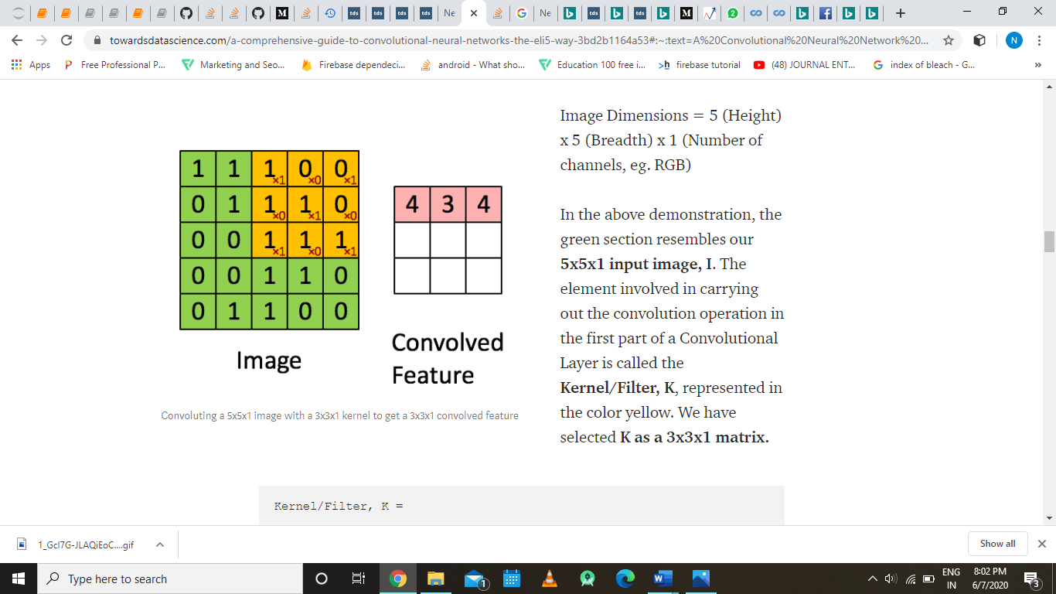 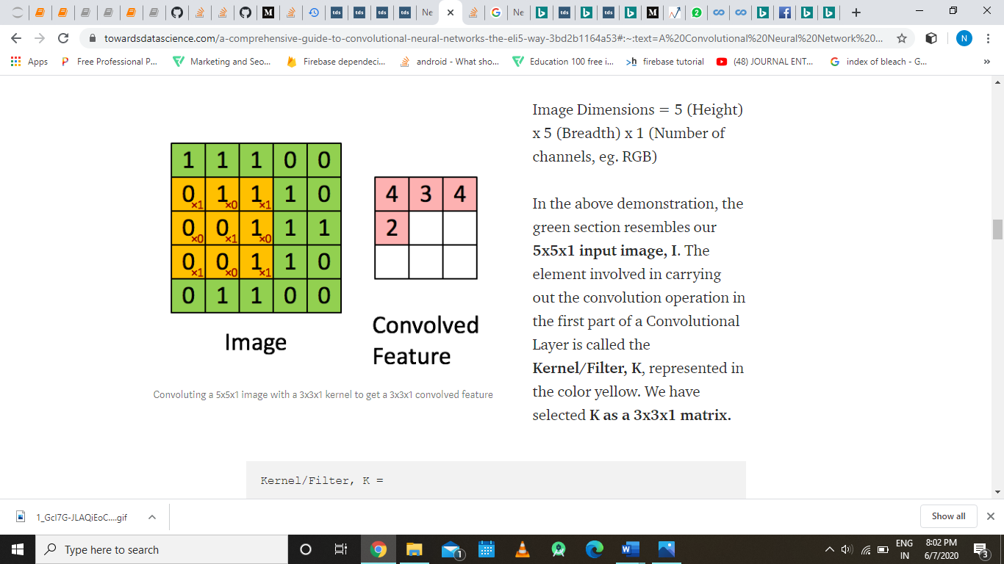 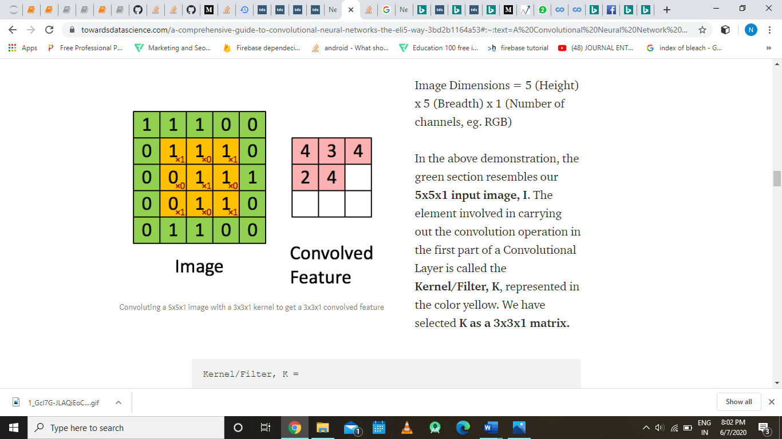 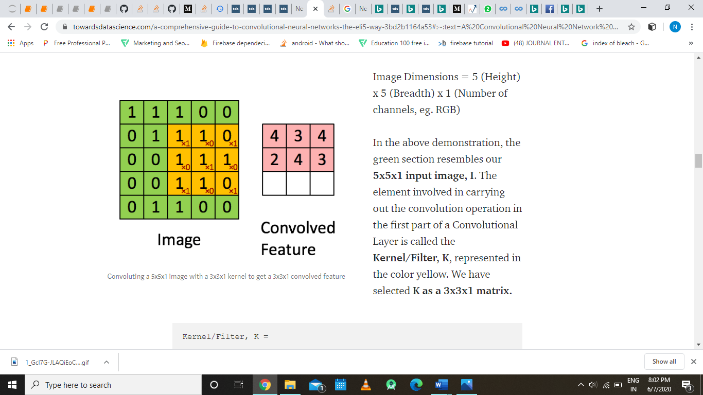

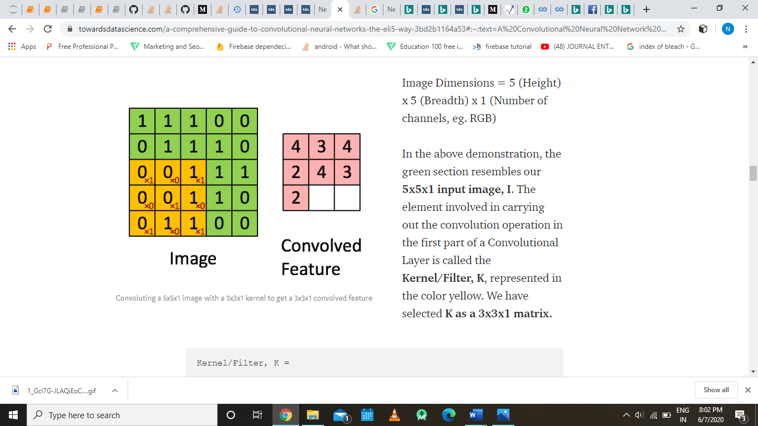 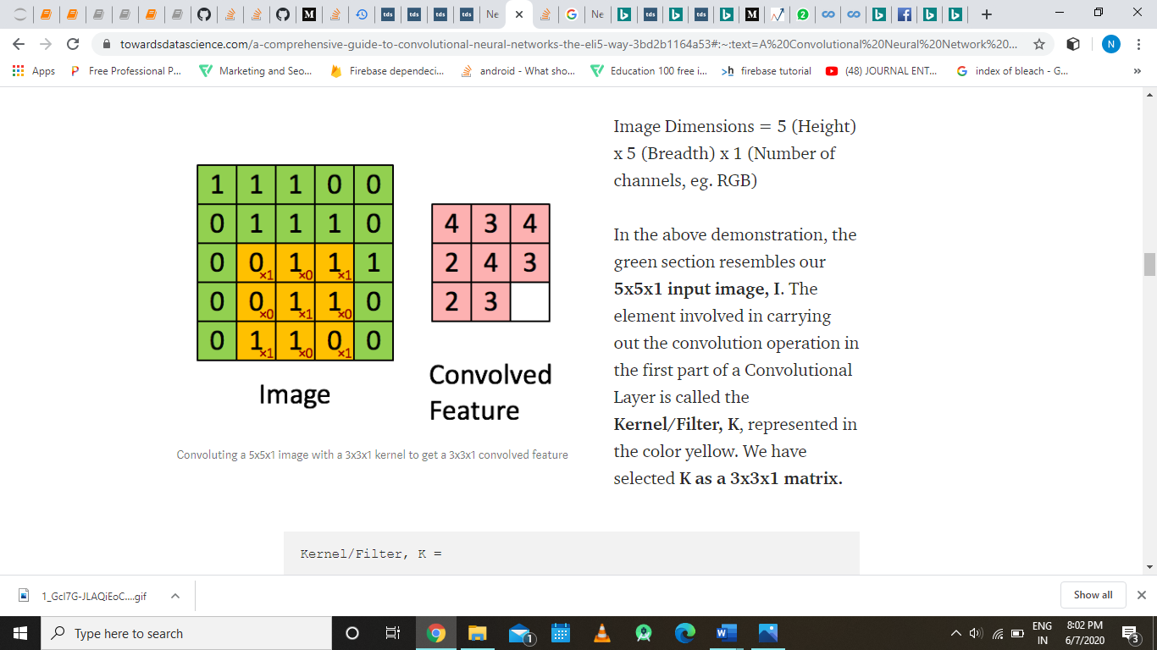;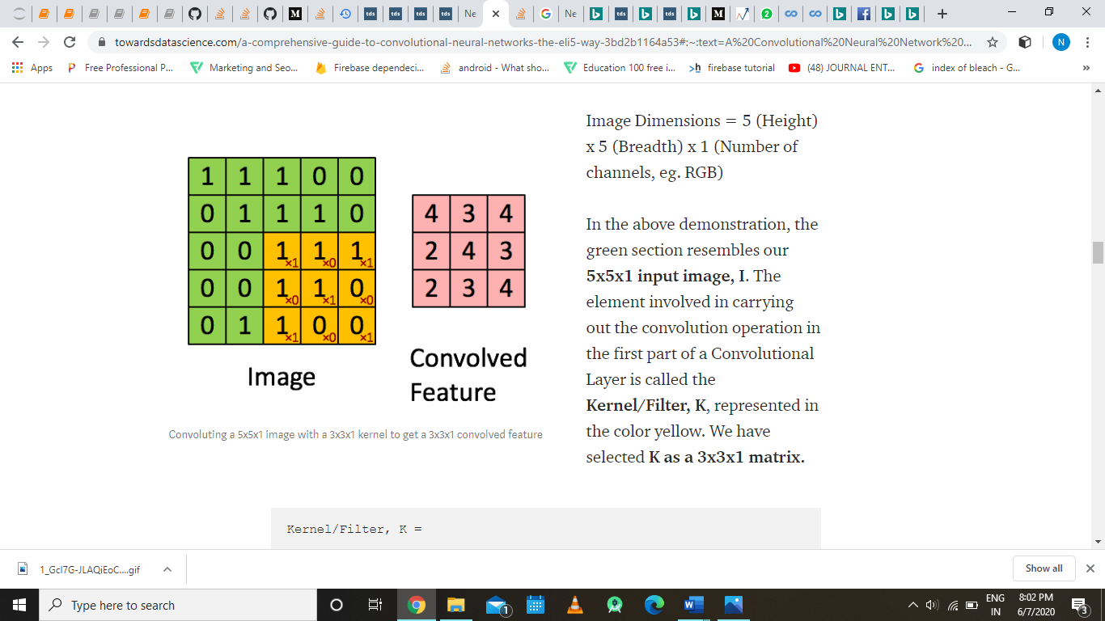

Fig: figure demonstarting kernel operation on a image, Image Dimensions = 5 (Height) x 5 (Breadth) x 1 (Number of channels, eg. RGB)

In the above demonstration, the green section resembles our **5x5x1 input image, I**. The element involved in carrying out the convolution operation in the first part of a Convolutional Layer is called the **Kernel/Filter, K**, represented in the color yellow. We have selected **K as a 3x3x1 matrix.** The Kernel shifts 9 times because of **Stride Length = 1 (Non-Strided)**, every time performing a **matrix multiplication operation between K and the portion P of the image** over which the kernel is hovering.

The filter moves to the right with a certain Stride Value till it parses the complete width. Moving on, it hops down to the beginning (left) of the image with the same Stride Value and repeats the process until the entire image is traversed. In the case of images with multiple channels (e.g. RGB), the Kernel has the same depth as that of the input image. Matrix Multiplication is performed between Kn and in stack ([K1, I1]; [K2, I2]; [K3, I3]) and all the results are summed with the bias to give us a squashed one-depth channel Convoluted Feature Output.

The objective of the Convolution Operation is to **extract the high-level features** such as edges, from the input image. ConvNets need not be limited to only one Convolutional Layer. Conventionally, the first ConvLayer is responsible for capturing the Low-Level features such as edges, color, gradient orientation, etc. With added layers, the architecture adapts to the High-Level features as well, giving us a network which has the wholesome understanding of images in the dataset, similar to how we would.

**What Are the Effects of the Kernel?**

Depending on the values on the kernel matrix, we produce different feature maps. Applying our kernel produces scalar outputs as we just saw in the above demonstration Convolving with different kernels produces interesting feature maps that can be used to detect different features. Convolution keeps the spatial relationship between pixels by learning image features over the small segments we pass over on the input image.

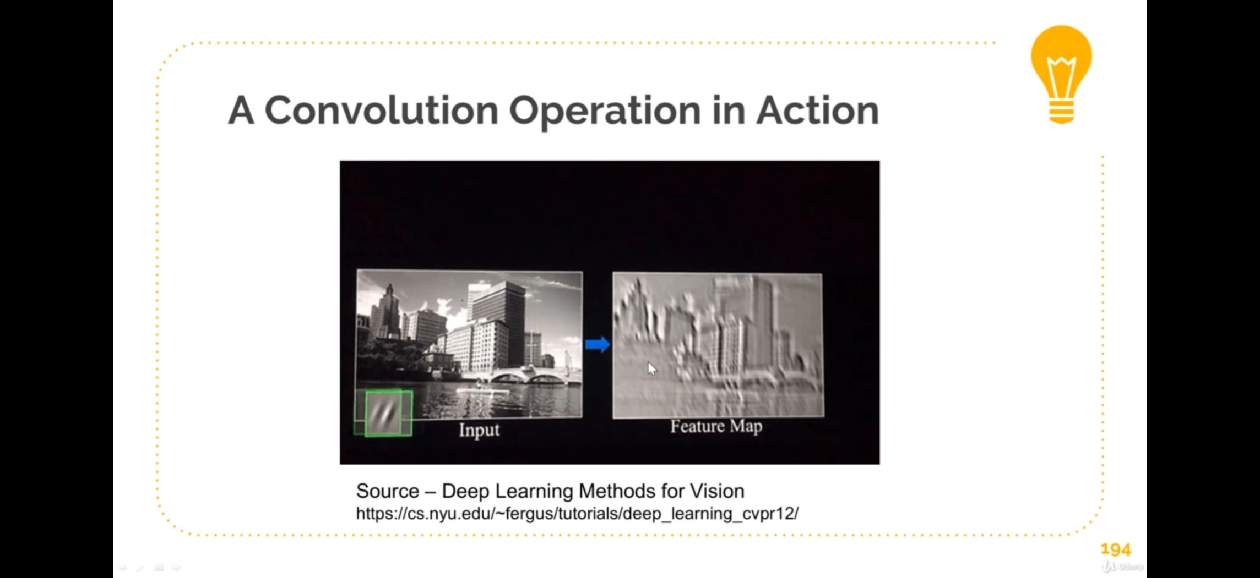

Fig: Convolution operation in action

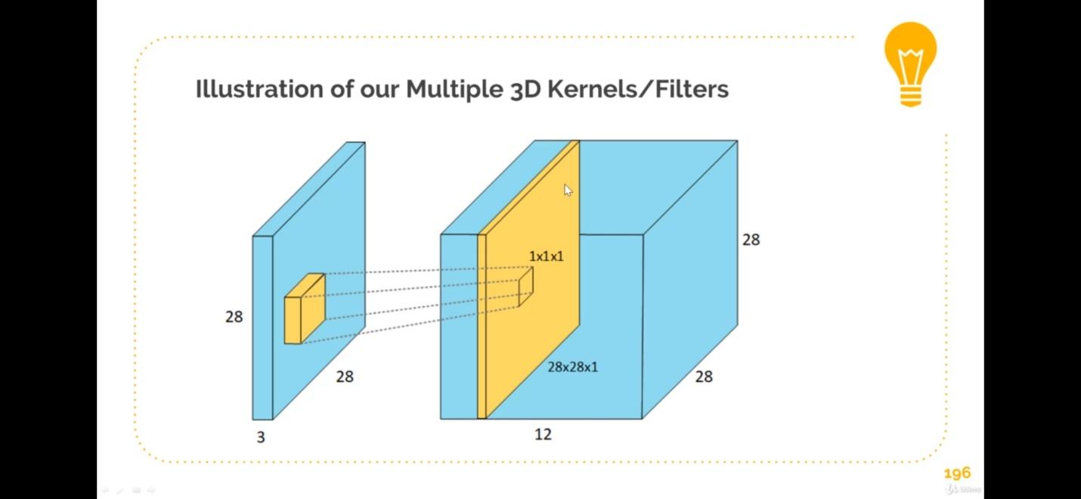

Fig: Illustration of multiple Filter /3D Kernel

The above figure illustrates a small fact about why the convolution layer has subsequent three dimensional layers, this because the when we apply different filter/kernels to same image we produce different feature map resulting in a three dimensional input the convolutional layer, in the above example we are applying 12 filters (of size 3x3X3) to our input image (of size 28x28x3) we produced 12 Feature Maps (also called Activation Maps). These outputs are stacked together and treated as another 3D Matrix (in our example, our output was of size 28x28x12. This 3D output is the input to our next layer in our CNN

**Depth**

Depth describes the number of filters used. It does not relate to the image depth nor does it describe the number of hidden layers in our Convolutional Neural Network.

**Stride**

Stride simply refers to the step size we take when we slide our kernel the input image. Stride controls the size of the Convolutional Layer Output, using a larger stride produces less overlap in kernels. Stride is one of the methods from which we can control the spatial input size that is the volume of the input into the other layers of our CNN.

**Padding**

There are two types of results to the operation of Kernels — one in which the convolved feature is reduced in dimensionality as compared to the input, and the other in which the dimensionality is either increased or remains the same. This is done by applying **Valid Padding** in case of the former, or **Same Padding** in the case of the latter.

When we augment the 5x5x1 image into a 6x6x1 image and then apply the 3x3x1 kernel over it, we find that the convolved matrix turns out to be of dimensions 5x5x1. Hence the name — **Same Padding**. On the other hand, if we perform the same operation without padding, we are presented with a matrix which has dimensions of the Kernel (3x3x1) itself — **Valid Padding**.

The following repository houses many such GIFs which would help you get a better understanding of how Padding and Stride Length work together to achieve results relevant to our needs.

**Zero Padding**

We add a border of zeros around our input basically this is equivalent of adding a black border around an image

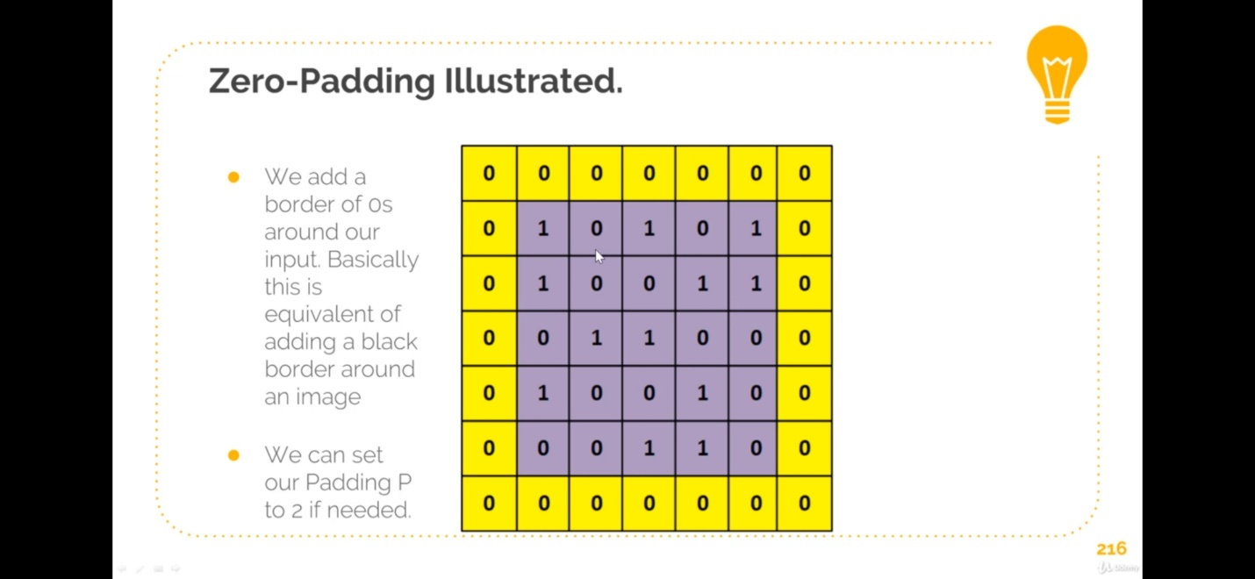

Fig: zero padding

**ReLU Layer**

This layer can basically harbor any activation function which we have discussed in the artificial neural network section, but in our case as we are using ReLU as our activation function, thus we are describing this layer a ReLU layer. ReLU or Rectified Linear Unit simply changes all the negative values to 0 while leaving the positives values unchanged.

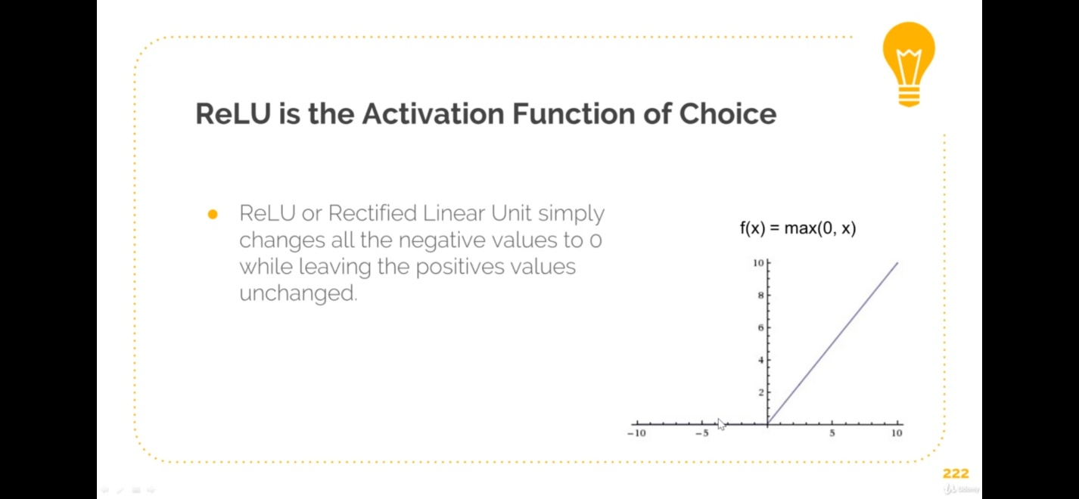

Fig: ReLU activation function

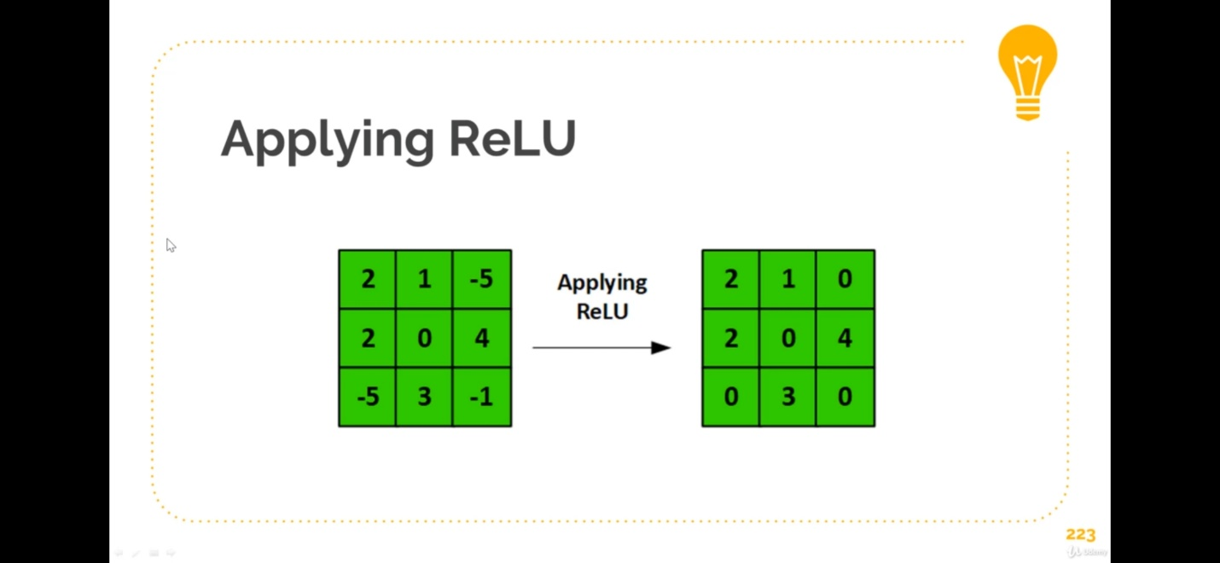

Fig: Figure illustrating the application of a ReLU function over a feature map

**Pool Layer**

Similar to the Convolutional Layer, the Pooling layer is responsible for reducing the spatial size of the Convolved Feature. This is to **decrease the computational power required to process the data** through dimensionality reduction. Furthermore, it is useful for **extracting dominant features** which are rotational and positional invariant, thus maintaining the process of effectively training of the model.

There are two types of Pooling: Max Pooling and Average Pooling. **Max Pooling** returns the **maximum value** from the portion of the image covered by the Kernel. On the other hand, **Average Pooling**returns the **average of all the values**from the portion of the image covered by the Kernel.

Max Pooling also performs as a**Noise Suppressant**. It discards the noisy activations altogether and also performs de-noising along with dimensionality reduction. On the other hand, Average Pooling simply performs dimensionality reduction as a noise suppressing mechanism. Hence, we can say that **Max Pooling performs a lot better than Average Pooling**.

The Convolutional Layer and the Pooling Layer, together form the i-th layer of a Convolutional Neural Network. Depending on the complexities in the images, the number of such layers may be increased for capturing low-levels details even further, but at the cost of more computational power.

After going through the above process, we have successfully enabled the model to understand the features. Moving on, we are going to flatten the final output and feed it to a regular Neural Network for classification purposes.

**Fully Connected Layer**

Adding a Fully-Connected layer is a way of learning non-linear combinations of the high-level features as represented by the output of the convolutional layer. The Fully-Connected layer is learning a possibly non-linear function in that space.

Now that we have converted our input image into a suitable form for our Multi-Level Perceptron, we shall flatten the image into a column vector. The flattened output is fed to a feed-forward neural network and backpropagation applied to every iteration of training. Over a series of epochs, the model is able to distinguish between dominating and certain low-level features in images and classify them using the **Softmax Classification** technique.

Beginning from this full connected layer the now Convolution neural network will act an Artificial Neural network, form now onward all the concepts described in the Artificial neural network part will be applied here.

In addition to these layers which would be present in almost every deep learning model, there concepts such as the callbacks, checkpoints, optimizers, momentum etc. which try to optimize the model even further, such concepts as discussed below.

## Momentum

Instead of depending only on the current gradient to update the weight, gradient descent with momentum ([Polyak, 1964](https://www.researchgate.net/publication/243648538_Some_methods_of_speeding_up_the_convergence_of_iteration_methods)) replaces the current gradient with m (“momentum”), which is an aggregate of gradients. This aggregate is the exponential moving average of current and past gradients (i.e. up to time t)

**Optimizer:**

Optimizer are the function which reduces the loss parameter of the model, which is done by gradient descent, along with three variants of gradient descent there additional optimizer present in keras that help optimize the learning rates so as to optimize the whole mode reach to the required accuracy quickly.

The additional optimizer are as follows:

1. Stochastic gradient descent
2. Momentum
3. AdaGrad
4. RMSprop
5. Adadelta
6. NAG
7. Adam
8. AdaMax
9. Nadam
10. AMSGrad

**Callbacks**

A callback is a set of functions to be applied at given stages of the training procedure. You can use callbacks to get a view on internal states and statistics of the model during training*.*

## ****Model Checkpoint****

This callback will save your model as a checkpoint file (in hdf5 format) to disk after each successful epoch. You can actually set the output file to be dynamically named based on the epoch. You can also write either the loss value or accuracy value as part of the log’s file name. This is especially handy for models where epochs take an extremely long time.

This is a simple but very useful way saving your best model before it starts overfitting (i.e. Loss on our test/validation data starts increases as our Epochs increase) Checkpointing allows us keep saving our weights/models after each epoch. Keras then allows us to keep saving the 'best' model by monitoring validation loss (we can monitor accuracy if you desire).

**Early Stopping**

Early stopping is another Keras Callback that allows us to stop

training once the training once the value being monitored has stopped getting better. We can even use a patience parameter to wait X amount of epochs before stopping.

**Reducing Learning Rate on Plateau**

Keras also comes with a Learning Rate adjustment callback. We can avoid having our loss oscillate around the global minimum by attempting to reduce the Learn Rate by a certain fact. If no improvement is seen in our monitored metric we wait a certain number of epochs (patience) then this callback reduces the learning rate by a factor

**Learning Algorithm for Convolution Neural Network:**

**ALGORITHM:**

Just the Artificial Neural Network, training Convolutional neural network is essentially the same once we setup our neural network layer. The flow follows the following steps:

1. Random Weights initialization in the convolution kernels
2. Forward Propagates an image through our network (Input => CONV => ReLU => Pooling => FC
3. Calculate the Total Error e.g. say we got an output of [0.2,0.4,0.4] while the true probabilities where [0,1,0]
4. We use back propagation to update our gradients (that is weights in the kernel filters) via gradient descent
5. Keep propagating all images through our network till an epoch is complete
6. Keep completing Epochs till our loss and accuracy are satisfactory

The learning process in convolutional neural networks

Above, we described general characteristics of traditional neural networks and deep learning’s flagship: the convolutional neural network. Next, we will explore how to make those networks perform useful tasks. This is accomplished in the process referred to as learning or training. The learning process of a convolutional neural network simply consists of changing the weights of the individual neurons in response to the provided data. In the most popular type of learning process, called supervised learning, a training example contains an object of interest (e.g., an image of a tumor) and a label (e.g., the tumor’s pathology: benign or malignant). In our example, the image is presented to the network’s input, and the calculation is carried out within the network to produce a prediction based on the current weights of the network. Then, the network’s prediction is compared to the actual label of the object and an error is calculated. This error is then propagated 6 through the network to change the values of the network’s weights such that the next time the network analyzes this example, the error decreases. In practice, the adaptation of the weights is performed after a group of examples (a batch) are presented to the network. This process is called error backpropagation or stochastic gradient descent. Various modifications of stochastic gradient descent algorithm have been developed [18]. In principle, this iterative process consists of calculations of error between the output of the model and the desired output and adjusting the weights in the direction where the error decreases.

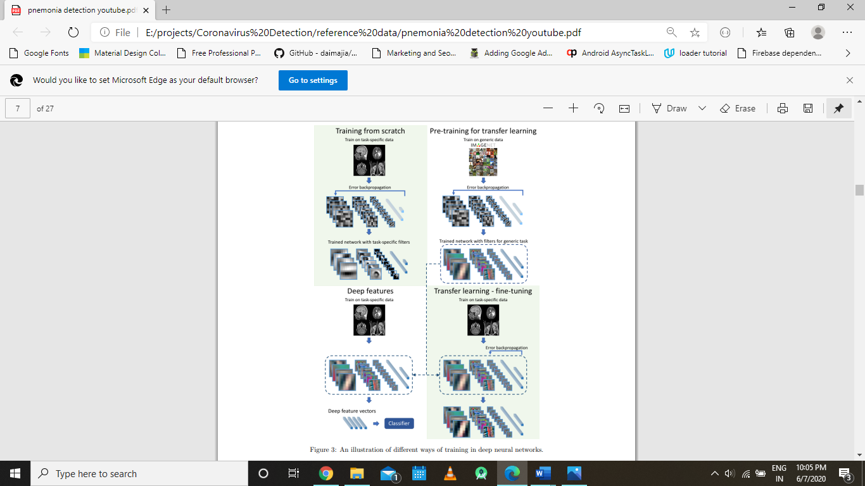

Fig: An illustration of different ways of training in deep neural networks

The most straightforward way of training is to start with a random set of weights and train using available data specific to the problem being solved (training from scratch). However, given the large number of parameters (weights) in a network, often above 10 million, and a limited amount of training data (common in medical imaging), a network may overfit to the available data, resulting 7 in poor performance on test data. Two training methods have been developed to address this issue: transfer learning and off-the-shelf features (a.k.a. deep features). A diagram comparing training from scratch with transfer learning and off-the-shelf deep features is shown in Figure 3. In the transfer learning approach, the network is first trained using a different dataset, for example an ImageNet collection. Then, the network is “fine-tuned” through additional training with data specific to the problem to be addressed. The idea behind this approach is that solving different visual tasks shares a certain level of processing such as recognition of edges or simple shapes. This approach has been shown successful in, for example, prediction of survival time from brain MRI in patients with glioblastoma tumor or in skin lesion classification. Another approach that addresses the issue of limited training data is the deep ”off-the-shelf” features approach which uses convolutional neural networks which have been trained on a different dataset to extract features from the images. This is done by extracting outputs of layers prior to the network’s final layer. Those layers typically have hundreds or thousands of outputs. Then, these outputs are used as inputs to “traditional” classifiers such as linear discriminant analysis, support vector machines, or decision trees. This is similar to transfer learning (and is sometimes considered a part of transfer learning) with the difference being that the last layers of a CNN are replaced by a traditional classifier and the early layers are not additionally trained.

**Transfer Learning**

A range of high-performing models have been developed for image classification and demonstrated on the annual [ImageNet Large Scale Visual Recognition Challenge](http://www.image-net.org/challenges/LSVRC/), or ILSVRC.

This challenge, often referred to simply as [ImageNet](http://image-net.org/), given the source of the image used in the competition, has resulted in a number of innovations in the architecture and training of convolutional neural networks. In addition, many of the models used in the competitions have been released under a permissive license.

These models can be used as the basis for transfer learning in computer vision applications.

This is desirable for a number of reasons, not least:

* **Useful Learned Features**: The models have learned how to detect generic features from photographs, given that they were trained on more than 1,000,000 images for 1,000 categories.
* **State-of-the-Art Performance**: The models achieved state of the art performance and remain effective on the specific image recognition task for which they were developed.
* **Easily Accessible**: The model weights are provided as free downloadable files and many libraries provide convenient APIs to download and use the models directly.

The model weights can be downloaded and used in the same model architecture using a range of different deep learning libraries, including Keras.

## How to Use Pre-Trained Models

The use of a pre-trained model is limited only by your creativity.

For example, a model may be downloaded and used as-is, such as embedded into an application and used to classify new photographs.

Alternately, models may be downloaded and use as feature extraction models. Here, the output of the model from a layer prior to the output layer of the model is used as input to a new classifier model.

Recall that convolutional layers closer to the input layer of the model learn low-level features such as lines, that layers in the middle of the layer learn complex abstract features that combine the lower level features extracted from the input, and layers closer to the output interpret the extracted features in the context of a classification task.

Armed with this understanding, a level of detail for feature extraction from an existing pre-trained model can be chosen. For example, if a new task is quite different from classifying objects in photographs (e.g. different to ImageNet), then perhaps the output of the pre-trained model after the few layers would be appropriate. If a new task is quite similar to the task of classifying objects in photographs, then perhaps the output from layers much deeper in the model can be used, or even the output of the fully connected layer prior to the output layer can be used.

The pre-trained model can be used as a separate feature extraction program, in which case input can be pre-processed by the model or portion of the model to a given an output (e.g. vector of numbers) for each input image, that can then use as input when training a new model.

Alternately, the pre-trained model or desired portion of the model can be integrated directly into a new neural network model. In this usage, the weights of the pre-trained can be frozen so that they are not updated as the new model is trained. Alternately, the weights may be updated during the training of the new model, perhaps with a lower learning rate, allowing the pre-trained model to act like a weight initialization scheme when training the new model.

We can summarize some of these usage patterns as follows:

* **Classifier**: The pre-trained model is used directly to classify new images.
* **Standalone Feature Extractor**: The pre-trained model, or some portion of the model, is used to pre-process images and extract relevant features.
* **Integrated Feature Extractor**: The pre-trained model, or some portion of the model, is integrated into a new model, but layers of the pre-trained model are frozen during training.
* **Weight Initialization**: The pre-trained model, or some portion of the model, is integrated into a new model, and the layers of the pre-trained model are trained in concert with the new model.

Each approach can be effective and save significant time in developing and training a deep convolutional neural network model.

It may not be clear as to which usage of the pre-trained model may yield the best results on your new computer vision task, therefore some experimentation may be required.

## Models for Transfer Learning

There are perhaps a dozen or more top-performing models for image recognition that can be downloaded and used as the basis for image recognition and related computer vision tasks.

Perhaps three of the more popular models are as follows:

* VGG (e.g. VGG16 or VGG19).
* GoogLeNet (e.g. InceptionV3).
* Residual Network (e.g. ResNet50).

These models are both widely used for transfer learning both because of their performance, but also because they were examples that introduced specific architectural innovations, namely consistent and repeating structures (VGG), inception modules (GoogLeNet), and residual modules (ResNet).

Keras provides access to a number of top-performing pre-trained models that were developed for image recognition tasks.

They are available via the [Applications API](https://keras.io/applications/), and include functions to load a model with or without the pre-trained weights, and prepare data in a way that a given model may expect (e.g. scaling of size and pixel values).

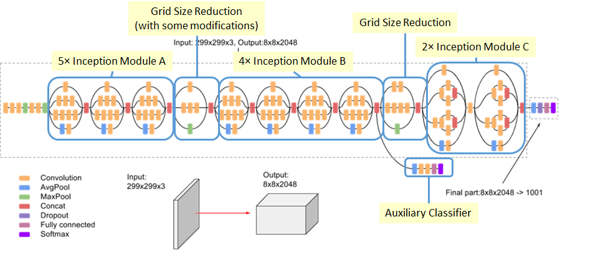

Fig: inception V3 Architecture

**Algorithm: Coronavirus Detection Part for Mild Symptoms**

**4.1.1.2. Logistic regression**

In [statistics](https://en.wikipedia.org/wiki/Statistics), the **logistic model** (or **logit model**) is used to model the probability of a certain class or event existing such as pass/fail, win/lose, alive/dead or healthy/sick. This can be extended to model several classes of events such as determining whether an image contains a cat, dog, lion, etc. Each object being detected in the image would be assigned a probability between 0 and 1 and the sum adding to one.

Logistic regression is a [statistical model](https://en.wikipedia.org/wiki/Statistical_model) that in its basic form uses a [logistic function](https://en.wikipedia.org/wiki/Logistic_function) to model a [binary](https://en.wikipedia.org/wiki/Binary_variable) [dependent variable](https://en.wikipedia.org/wiki/Dependent_variable), although many more complex [extensions](https://en.wikipedia.org/wiki/Logistic_regression#Extensions) exist. In [regression analysis](https://en.wikipedia.org/wiki/Regression_analysis), **logistic regression** [[1]](https://en.wikipedia.org/wiki/Logistic_regression#cite_note-1) (or **logit regression**) is [estimating](https://en.wikipedia.org/wiki/Estimation_theory) the parameters of a logistic model (a form of [binary regression](https://en.wikipedia.org/wiki/Binary_regression)). Mathematically, a binary logistic model has a dependent variable with two possible values, such as pass/fail which is represented by an [indicator variable](https://en.wikipedia.org/wiki/Indicator_variable), where the two values are labeled "0" and "1". In the logistic model, the [log-odds](https://en.wikipedia.org/wiki/Log-odds) (the [logarithm](https://en.wikipedia.org/wiki/Logarithm) of the [odds](https://en.wikipedia.org/wiki/Odds)) for the value labeled "1" is a [linear combination](https://en.wikipedia.org/wiki/Linear_function_(calculus)) of one or more [independent variables](https://en.wikipedia.org/wiki/Independent_variable) ("predictors"); the independent variables can each be a binary variable (two classes, coded by an indicator variable) or a [continuous variable](https://en.wikipedia.org/wiki/Continuous_variable) (any real value). The corresponding [probability](https://en.wikipedia.org/wiki/Probability) of the value labeled "1" can vary between 0 (certainly the value "0") and 1 (certainly the value "1"), hence the labeling; the function that converts log-odds to probability is the logistic function, hence the name. The [unit of measurement](https://en.wikipedia.org/wiki/Unit_of_measurement) for the log-odds scale is called a [*logit*](https://en.wikipedia.org/wiki/Logit), from ***log****istic un****it***, hence the alternative names. Analogous models with a different [sigmoid function](https://en.wikipedia.org/wiki/Sigmoid_function) instead of the logistic function can also be used, such as the [probit model](https://en.wikipedia.org/wiki/Probit_model); the defining characteristic of the logistic model is that increasing one of the independent variables multiplicatively scales the odds of the given outcome at a *constant* rate, with each independent variable having its own parameter; for a binary dependent variable this generalizes the [odds ratio](https://en.wikipedia.org/wiki/Odds_ratio).

The model builds a regression model to predict the probability that a given data entry belongs to the category numbered as “1”. Just like Linear regression assumes that the data follows a linear function, Logistic regression models the data using the sigmoid function.

Logistic regression becomes a classification technique only when a decision threshold is brought into the picture. The setting of the threshold value is a very important aspect of Logistic regression and is dependent on the classification problem itself.

The decision for the value of the threshold value is majorly affected by the values of [precision and recall.](https://www.geeksforgeeks.org/confusion-matrix-machine-learning/) Ideally, we want both precision and recall to be 1, but this seldom is the case. In case of a Precision-Recall trade-off we use the following arguments to decide upon the threshold:

1. **Low Precision/High Recall:** In applications where we want to reduce the number of false negatives without necessarily reducing the number false positives, we choose a decision value which has a low value of Precision or high value of Recall. For example, in a cancer diagnosis application, we do not want any affected patient to be classified as not affected without giving much heed to if the patient is being wrongfully diagnosed with cancer. This is because, the absence of cancer can be detected by further medical diseases but the presence of the disease cannot be detected in an already rejected candidate.

2. **High Precision/Low Recall:** In applications where we want to reduce the number of false positives without necessarily reducing the number false negatives, we choose a decision value which has a high value of Precision or low value of Recall. For example, if we are classifying customers whether they will react positively or negatively to a personalised advertisement, we want to be absolutely sure that the customer will react positively to the advertisement because otherwise, a negative reaction can cause a loss potential sales from the customer.

Based on the number of categories, Logistic regression can be classified as:

1. **Binomial:** target variable can have only 2 possible types: “0” or “1” which may represent “win” vs “loss”, “pass” vs “fail”, “dead” vs “alive”, etc.
2. **Multinomial:** target variable can have 3 or more possible types which are not ordered (i.e. types have no quantitative significance) like “disease A” vs “disease B” vs “disease C”.
3. **Ordinal:** it deals with target variables with ordered categories. For example, a test score can be categorized as: “very poor”, “poor”, “good”, “and very good”. Here, each category can be given a score like 0, 1, 2, and 3.

## [Binary logistic regression](https://ml-cheatsheet.readthedocs.io/en/latest/logistic_regression.html#id20):-

Say we’re given [data](http://scilab.io/wp-content/uploads/2016/07/data_classification.csv) on student exam results and our goal is to predict whether a student will pass or fail based on number of hours slept and hours spent studying. We have two features (hours slept, hours studied) and two classes: passed (1) and failed (0).

|  |  |  |
| --- | --- | --- |
| **Studied** | **Slept** | **Passed** |
| 4.85 | 9.63 | 1 |
| 8.62 | 3.23 | 0 |
| 5.43 | 8.23 | 1 |
| 9.21 | 6.34 | 0 |

Graphically we could represent our data with a scatter plot.

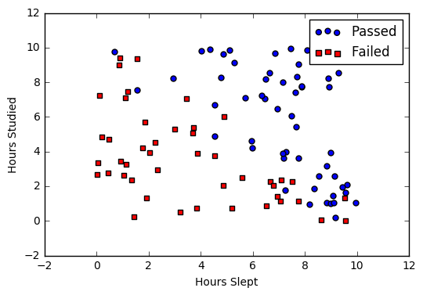

### [**Sigmoid activation**](https://ml-cheatsheet.readthedocs.io/en/latest/logistic_regression.html#id21)

In order to map predicted values to probabilities, we use the [sigmoid](https://ml-cheatsheet.readthedocs.io/en/latest/activation_functions.html#activation-sigmoid) function. The function maps any real value into another value between 0 and 1. In machine learning, we use sigmoid to map predictions to probabilities.

**S(z)=11+e−zS(z)=11+e−z**

**Graph**

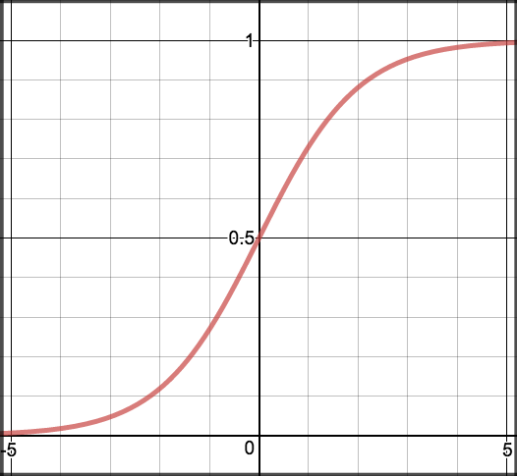

**Code**

def sigmoid(z):

return 1.0 / (1 + np.exp(-z))

### [**Decision boundary**](https://ml-cheatsheet.readthedocs.io/en/latest/logistic_regression.html#id22)

Our current prediction function returns a probability score between 0 and 1. In order to map this to a discrete class (true/false, cat/dog), we select a threshold value or tipping point above which we will classify values into class 1 and below which we classify values into class 2.

**p≥0.5,class=1p<0.5,class=0p≥0.5,class=1p<0.5,class=0**

For example, if our threshold was .5 and our prediction function returned .7, we would classify this observation as positive. If our prediction was .2 we would classify the observation as negative. For logistic regression with multiple classes we could select the class with the highest predicted probability.

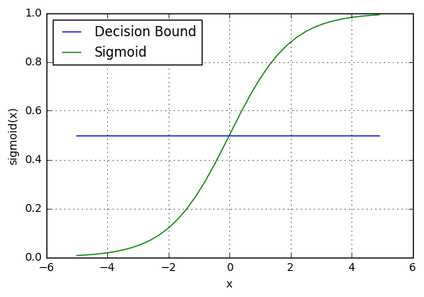

### [**Making predictions**](https://ml-cheatsheet.readthedocs.io/en/latest/logistic_regression.html#id23)

Using our knowledge of sigmoid functions and decision boundaries, we can now write a prediction function. A prediction function in logistic regression returns the probability of our observation being positive, True, or “Yes”. We call this class 1 and its notation is P(class=1)P(class=1). As the probability gets closer to 1, our model is more confident that the observation is in class 1.

Let’s use the same [multiple linear regression](https://ml-cheatsheet.readthedocs.io/en/latest/linear_regression.html#multiple-linear-regression-predict) equation from our linear regression tutorial.

**z=W0+W1Studied+W2Sleptz=W0+W1Studied+W2Slept**

This time however we will transform the output using the sigmoid function to return a probability value between 0 and 1.

**P(class=1)=11+e−zP(class=1)=11+e−z**

If the model returns .4 it believes there is only a 40% chance of passing. If our decision boundary was .5, we would categorize this observation as “Fail.”“

**Code**

We wrap the sigmoid function over the same prediction function we used in [multiple linear regression](https://ml-cheatsheet.readthedocs.io/en/latest/linear_regression.html#multiple-linear-regression-predict)

**def** predict(features, weights):

*'''*

*Returns 1D array of probabilities*

*that the class label == 1*

*'''*

z = np.dot(features, weights)

**return** sigmoid(z)

### [**Cost function**](https://ml-cheatsheet.readthedocs.io/en/latest/logistic_regression.html#id24)

Squaring this prediction as we do in MSE results in a non-convex function with many local minimums. If our cost function has many local minimums, gradient descent may not find the optimal global minimum.

**Math**

Instead of Mean Squared Error, we use a cost function called [Cross-Entropy](https://ml-cheatsheet.readthedocs.io/en/latest/loss_functions.html#loss-cross-entropy), also known as Log Loss. Cross-entropy loss can be divided into two separate cost functions: one for y=1y=1 and one for y=0y=0.

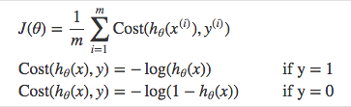

The benefits of taking the logarithm reveal themselves when you look at the cost function graphs for y=1 and y=0. These smooth monotonic functions [[7]](https://ml-cheatsheet.readthedocs.io/en/latest/logistic_regression.html#id14) (always increasing or always decreasing) make it easy to calculate the gradient and minimize cost. Image from Andrew Ng’s slides on logistic regression.

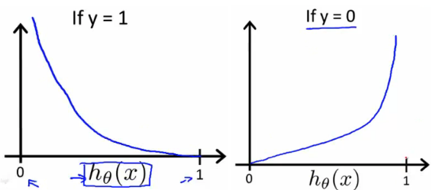

The key thing to note is the cost function penalizes confident and wrong predictions more than it rewards confident and right predictions. The corollary is increasing prediction accuracy (closer to 0 or 1) has diminishing returns on reducing cost due to the logistic nature of our cost function.

**Above functions compressed into one**

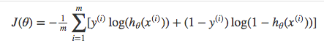

Multiplying by yy and (1−y)(1−y) in the above equation is a sneaky trick that lets us use the same equation to solve for both y=1 and y=0 cases. If y=0, the first side cancels out. If y=1, the second side cancels out. In both cases we only perform the operation we need to perform.

**Vectorized cost function**

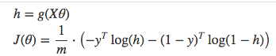

**Code**

**def** cost_function(features, labels, weights):

*'''*

*Using Mean Absolute Error*

*Features:(100,3)*

*Labels: (100,1)*

*Weights:(3,1)*

*Returns 1D matrix of predictions*

*Cost = (labels*log(predictions) + (1-labels)*log(1-predictions) ) / len(labels)*

*'''*

observations = len(labels)

predictions = predict(features, weights)

*#Take the error when label=1*

class1_cost = -labels*np.log(predictions)

*#Take the error when label=0*

class2_cost = (1-labels)*np.log(1-predictions)

*#Take the sum of both costs*

cost = class1_cost - class2_cost

*#Take the average cost*

cost = cost.sum() / observations

**return** cost

### [**Gradient descent**](https://ml-cheatsheet.readthedocs.io/en/latest/logistic_regression.html#id25)

To minimize our cost, we use [Gradient Descent](https://ml-cheatsheet.readthedocs.io/en/latest/gradient_descent.html) just like before in [Linear Regression](https://ml-cheatsheet.readthedocs.io/en/latest/linear_regression.html). There are other more sophisticated optimization algorithms out there such as conjugate gradient like [BFGS](https://ml-cheatsheet.readthedocs.io/en/latest/optimizers.html#optimizers-lbfgs), but you don’t have to worry about these. Machine learning libraries like Scikit-learn hide their implementations so you can focus on more interesting things.

**Math**

One of the neat properties of the sigmoid function is its derivative is easy to calculate. If you’re curious, there is a good walk-through derivation on stack overflow.

**s′(z)=s(z)(1−s(z))s′(z)=s(z)(1−s(z))**

Which leads to an equally beautiful and convenient cost function derivative:

**C′=x(s(z)−y)C′=x(s(z)−y)**

Notice how this gradient is the same as the [MSE (L2)](https://ml-cheatsheet.readthedocs.io/en/latest/loss_functions.html#mse) gradient, the only difference is the hypothesis function.

**Pseudocode**

Repeat {

1. Calculate gradient average

2. Multiply by learning rate

3. Subtract **from** **weights**

}

**Code**

**def** update_weights(features, labels, weights, lr):

*'''*

*Vectorized Gradient Descent*

*Features:(200, 3)*

*Labels: (200, 1)*

*Weights:(3, 1)*

*'''*

N = len(features)

*#1 - Get Predictions*

predictions = predict(features, weights)

*#2 Transpose features from (200, 3) to (3, 200)*

*# So we can multiply w the (200,1) cost matrix.*

*# Returns a (3,1) matrix holding 3 partial derivatives --*

*# one for each feature -- representing the aggregate*

*# slope of the cost function across all observations*

gradient = np.dot(features.T, predictions - labels)

*#3 Take the average cost derivative for each feature*

gradient /= N

*#4 - Multiply the gradient by our learning rate*

gradient *= lr

*#5 - Subtract from our weights to minimize cost*

weights -= gradient

**return** weights

### [**Mapping probabilities to classes**](https://ml-cheatsheet.readthedocs.io/en/latest/logistic_regression.html#id26)**:-**

The final step is assign class labels (0 or 1) to our predicted probabilities.

**Decision boundary**

**def** decision_boundary(prob):

**return** 1 **if** prob >= .5 **else** 0

**Convert probabilities to classes**

**def** classify(predictions):

*'''*

*input - N element array of predictions between 0 and 1*

*output - N element array of 0s (False) and 1s (True)*

*'''*

decision_boundary = np.vectorize(decision_boundary)

**return** decision_boundary(predictions).flatten()

**Example output**

Probabilities = [ 0.967, 0.448, 0.015, 0.780, 0.978, 0.004]

Classifications = [1, 0, 0, 1, 1, 0]

### [**Training**](https://ml-cheatsheet.readthedocs.io/en/latest/logistic_regression.html#id27)

Our training code is the same as we used for [linear regression](https://ml-cheatsheet.readthedocs.io/en/latest/linear_regression.html#simple-linear-regression-training).

**def** train(features, labels, weights, lr, iters):

cost_history = []

**for** i **in** range(iters):

weights = update_weights(features, labels, weights, lr)

*#Calculate error for auditing purposes*

cost = cost_function(features, labels, weights)

cost_history.append(cost)

*# Log Progress*

**if** i % 1000 == 0:

**print** "iter: "+str(i) + " cost: "+str(cost)

**return** weights, cost_history

### [**Model evaluation**](https://ml-cheatsheet.readthedocs.io/en/latest/logistic_regression.html#id28)

If our model is working, we should see our cost decrease after every iteration.

iter: 0 cost: 0.635

iter: 1000 cost: 0.302

iter: 2000 cost: 0.264

**Final cost:** 0.2487. **Final weights:** [-8.197, .921, .738]

**Cost history**

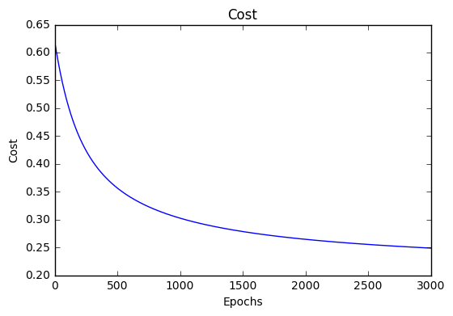

**Accuracy**

[Accuracy](https://ml-cheatsheet.readthedocs.io/en/latest/glossary.html#glossary-accuracy) measures how correct our predictions were. In this case we simply compare predicted labels to true labels and divide by the total.

**def** accuracy(predicted_labels, actual_labels):

diff = predicted_labels - actual_labels

**return** 1.0 - (float(np.count_nonzero(diff)) / len(diff))

**Decision boundary**

Another helpful technique is to plot the decision boundary on top of our predictions to see how our labels compare to the actual labels. This involves plotting our predicted probabilities and colouring them with their true labels.

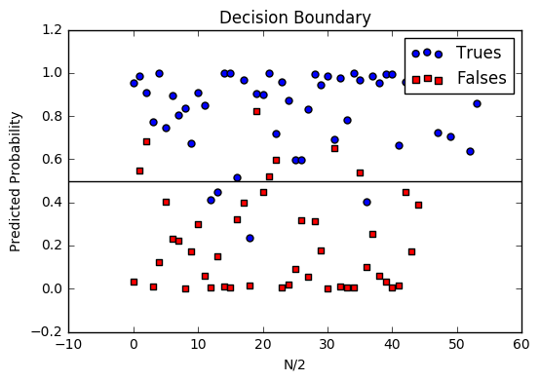

**Code to plot the decision boundary**

**def** plot_decision_boundary(trues, falses):

fig = plt.figure()

ax = fig.add_subplot(111)

no_of_preds = len(trues) + len(falses)

ax.scatter([i **for** i **in** range(len(trues))], trues, s=25, c='b', marker="o", label='Trues')

ax.scatter([i **for** i **in** range(len(falses))], falses, s=25, c='r', marker="s", label='Falses')

plt.legend(loc='upper right');

ax.set_title("Decision Boundary")

ax.set_xlabel('N/2')

ax.set_ylabel('Predicted Probability')

plt.axhline(.5, color='black')

plt.show()

## [Multiclass logistic regression](https://ml-cheatsheet.readthedocs.io/en/latest/logistic_regression.html#id29)

Instead of y=0,1y=0,1 we will expand our definition so that y=0,1...ny=0,1...n. Basically we re-run binary classification multiple times, once for each class.

### [**Procedure**](https://ml-cheatsheet.readthedocs.io/en/latest/logistic_regression.html#id30)

1. Divide the problem into n+1 binary classification problems (+1 because the index starts at 0?).
2. For each class…
3. Predict the probability the observations are in that single class.
4. prediction = <math>max(probability of the classes)

For each sub-problem, we select one class (YES) and lump all the others into a second class (NO). Then we take the class with the highest predicted value.

### [**Softmax activation**](https://ml-cheatsheet.readthedocs.io/en/latest/logistic_regression.html#id31)

The softmax function (softargmax or normalized exponential function) is a function that takes as input a vector of K real numbers, and normalizes it into a probability distribution consisting of K probabilities proportional to the exponentials of the input numbers. That is, prior to applying softmax, some vector components could be negative, or greater than one; and might not sum to 1; but after applying softmax, each component will be in the interval [ 0 , 1 ] , and the components will add up to 1, so that they can be interpreted as probabilities. The standard (unit) softmax function is defined by the formula

σ(zi)=ez(i)∑Kj=1ez(j)   for i=1,.,.,.,K and z=z1,.,.,.,zKσ(zi)=ez(i)∑j=1Kez(j)   for i=1,.,.,.,K and z=z1,.,.,.,zK

In words: we apply the standard exponential function to each element zizi of the input vector zz and normalize these values by dividing by the sum of all these exponentials; this normalization ensures that the sum of the components of the output vector σ(z)σ(z) is 1.

### [**Scikit-Learn example**](https://ml-cheatsheet.readthedocs.io/en/latest/logistic_regression.html#id32)

Let’s compare our performance to the Logistic Regression model provided by scikit-learn.

**import** **sklearn**

**from** **sklearn.linear_model** **import** LogisticRegression

**from** **sklearn.cross_validation** **import** train_test_split

*# Normalize grades to values between 0 and 1 for more efficient computation*

normalized_range = sklearn.preprocessing.MinMaxScaler(feature_range=(-1,1))

*# Extract Features + Labels*

labels.shape = (100,) *#scikit expects this*

features = normalized_range.fit_transform(features)

*# Create Test/Train*

features_train,features_test,labels_train,labels_test = train_test_split(features,labels,test_size=0.4)

*# Scikit Logistic Regression*

scikit_log_reg = LogisticRegression()

scikit_log_reg.fit(features_train,labels_train)

*#Score is Mean Accuracy*

scikit_score = clf.score(features_test,labels_test)

print 'Scikit score: ', scikit_score

*#Our Mean Accuracy*

observations, features, labels, weights = run()

probabilities = predict(features, weights).flatten()

classifications = classifier(probabilities)

our_acc = accuracy(classifications,labels.flatten())

print 'Our score: ',our_acc

**Scikit score:** 0.88. **Our score:** 0.89

**4.2 Experimental Setup**

**Implementation of Coronavirus Detection Part For Severe Symptoms (Pneumonia detection)**

The below code is written is python language and we have use different deep learning library for implementing the desired convolutional neural network. The code is explained partwise an in the same flow i.e. arrangement is followed in which the code was written

**Part 1**

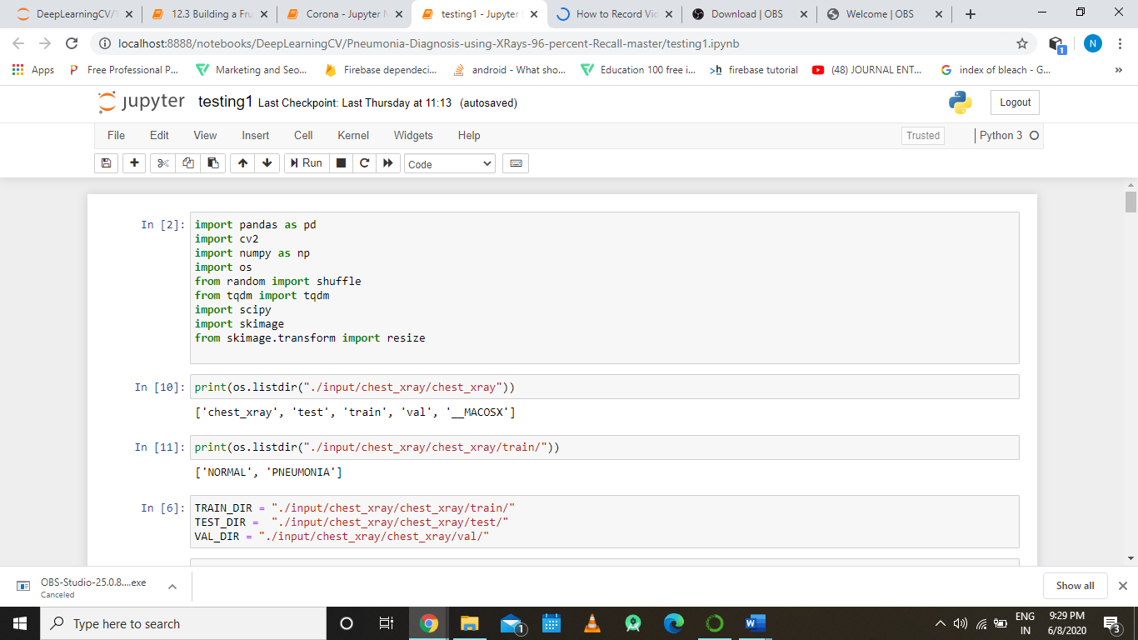

First, we are importing the libraries required for preprocessing the data over which we are going to work upon. The dataset for this module dealing with pneumonia detection has been fetched/downloaded into the system from Kaggle.

(<https://www.kaggle.com/paultimothymooney/chest-xray-pneumonia>)

The above dataset was around 2.3GB that is downloaded and stored into the system which will be later referenced in the code.

**Part 2**

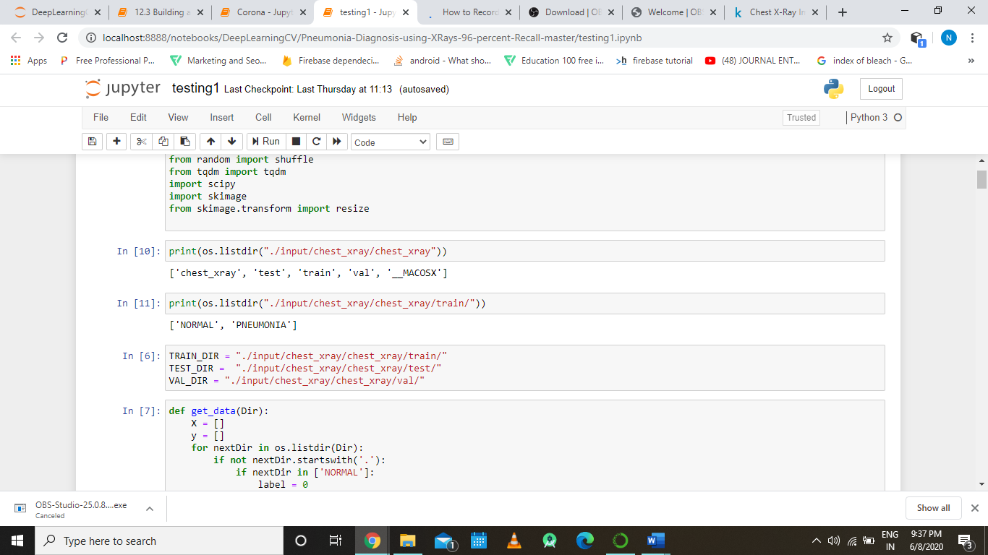

The above print statements are showing the directory structure of the area where we stored our dataset.

The dataset is divided into 3 subcategories for ease of understanding the three categories are test, train, val(validation). The train folder contains the x ray images which we are going use in our code to train our model, The test folder contain x ray images for testing ur trained model and the vaildation folder contains the X ray over which our model will finally be validated.

Each of the test, train and validation folder contains two sub folders namely PNEUMONIA, NORMAL the pneumonia folder contains the X ray images of the pneumonia affected Chests and the noraml folder contains the X ray image of a normal diesease free person.

**Part 3**



The above code defines the path variables for the input dataset.

**Part 4:**

The below part displays the function designed for preprocessing the input data.

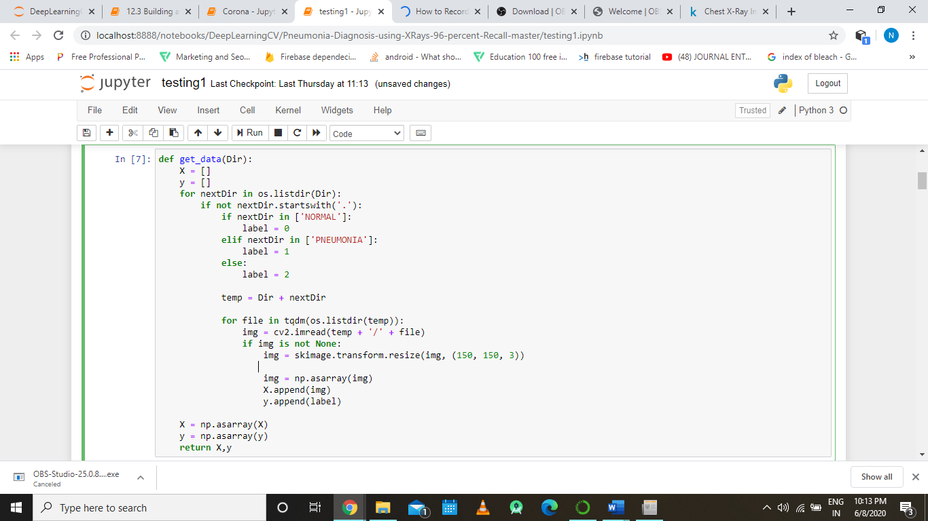

The above function takes in the directory path as input argument, instantiates two empty array X (X array will be containing the images ) and Y( Y array will be containing the label of the corresponding image present in the X array) in the beginning and return two numpy array. It is two for loops one enclosed within the other, the outer for loop iterates over each subdirectory present in the given directory whose path we have mentioned int the input argument and during these iteration it creates a variable named label whose value is to 0 if the subdirectory’s name is normal or 1 if the sub directory’s name is pneumonia otherwise it is given the value 2.

In the inner for loop we iterate over the files present in each sub directory, the files present in each sub directory are evidently image files as we were the ones who designed the input directory. We loop through every image in the directory and resize it 150 x 150 x 3 and also converts it into a numpy array after resizing the image we append the converted image and its respective label into the X and Y array, at last we also convert the arrays X and Y into numpy array and return it.

**Part 5**

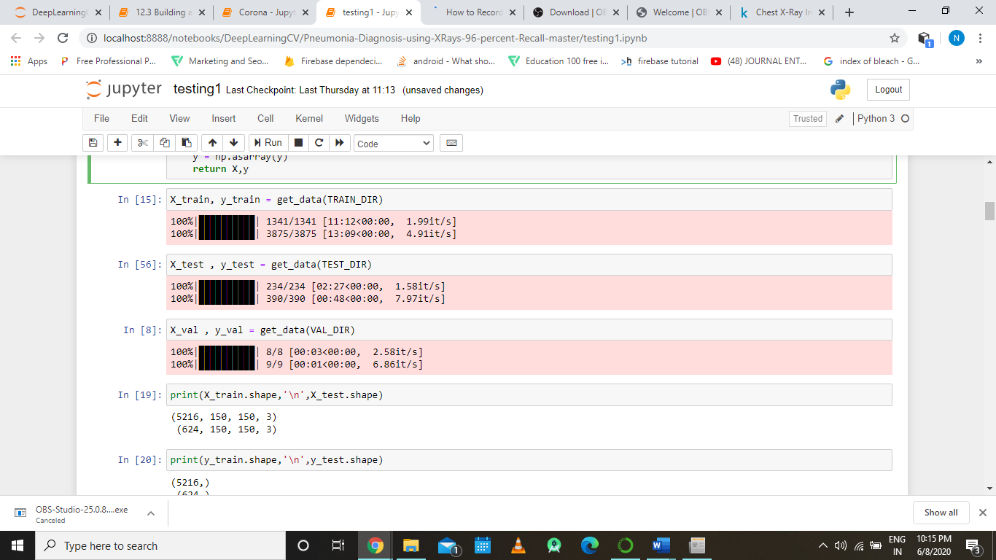

Here the function defined in the part 4 is called over the three path variables TRAIN_DIR, TEST_DIR, VAL_DIR which we have defined part 3, after the applying the function we would get six numpy array out which three of them contains the images and the other three contains labels.

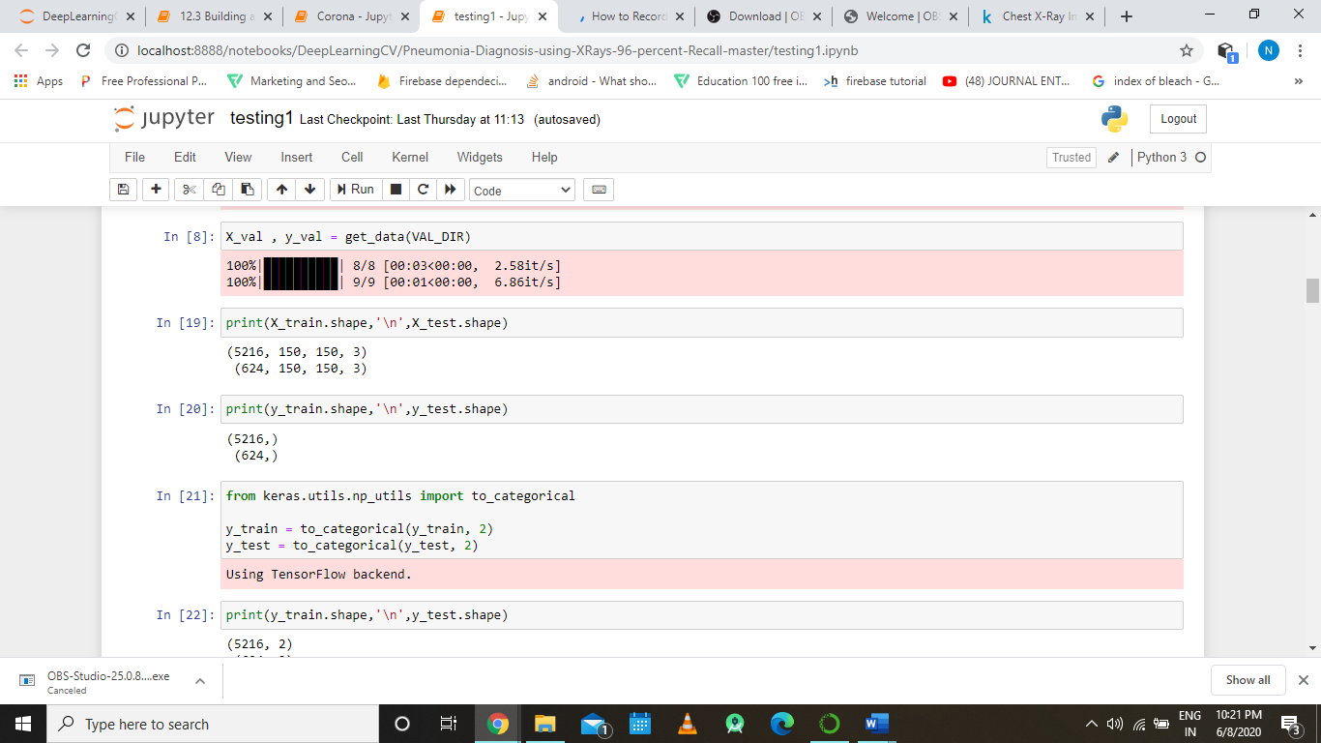

The above code prints the shape that is the dimensions of the resultant array, from the shape of the array we can infer the number of images present in the array.

**Part 6:**

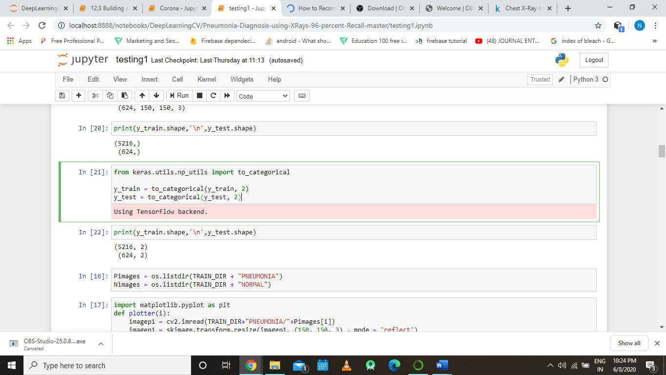

Here in this part we are importing the to_categorically function from keras utils package for on hot encoding the input sequence data. A one hot encoding is a representation of categorical variables as binary vectors. This first requires that the categorical values be mapped to integer values. Then, each integer value is represented as a binary vector that is all zero values except the index of the integer, which is marked with a 1.

Basically what we are doing is that we are converting our one dimensional array containing the labels into two dimensional array (this fact is depicted by the print statement which prints the shape of the y_train numpy array after on hot encoding), which would look something like this

|  |  |  |
| --- | --- | --- |
|  | 0 | 1 |
| 0 | 0 | 1 |
| 1 | 0 | 1 |
| 2 | 0 | 1 |
| ……… |  |  |
| 52614 | 1 | 0 |
| 52615 | 1 | 0 |

Here the top row is showing the classes of output categories and first column is depicting the index of the item, as we have only two classes of output that is why only two columns are present apart from the index column. The value 1 for the respective index under the column means it belongs to the category or class depicted by the column, and the value 0 is exact opposite of 1 that is it says that it does not belong to the category depicted by the column.

In Our case the column depicted by 0 belongs to normal class and column depicted by 1 belongs to pneumonia class.

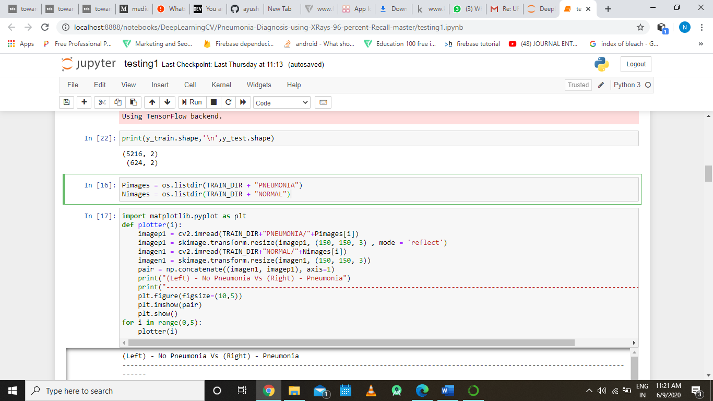

Here we are defining the exact path variables to the pneumonia and the normal directory present int the train directory.

**Part 7:**

Here in this part we will be visualizing the data that is present with us.



Here we are using matplotlib for displaying x ray images of normal and pneumonia affect chest so that we could have look over the difference between the with our own eyes which are evidently much superior than any deep learning algorithm present.

We are defining a function named plotter which taken integer input argument which basically acts as index for our images, for reading the image we are using the open cv’s pre-defined function imread(), for resizing the image we are using scikit image library’s predefined function then we are concatenating both images using the numpy library’s concatenate function and at last we are plotting the concatenated image in a graph by using matplotlib’s functions.

In the “for” loop we are calling the defined function five times.

Below images show the output of when above part of the code is executed.

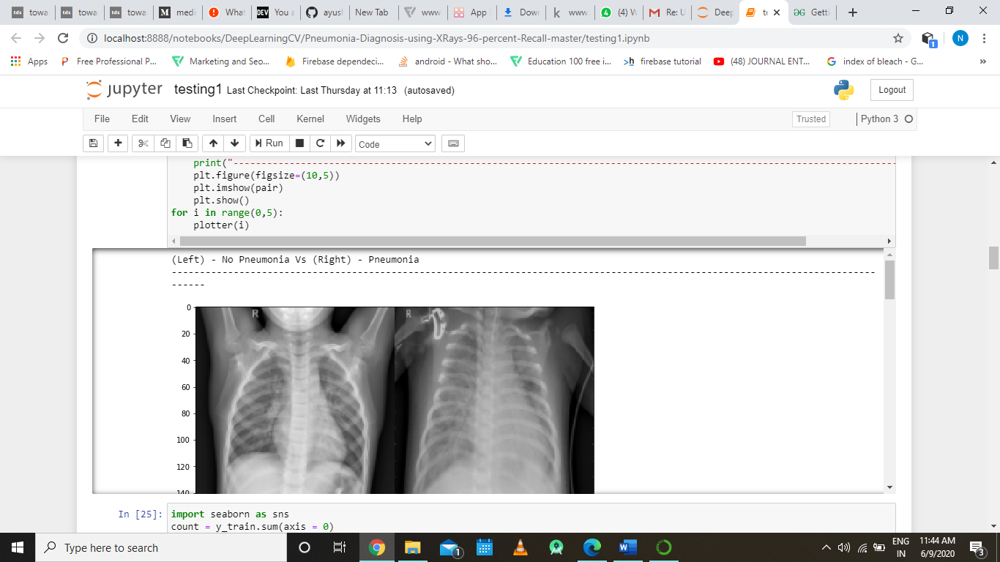

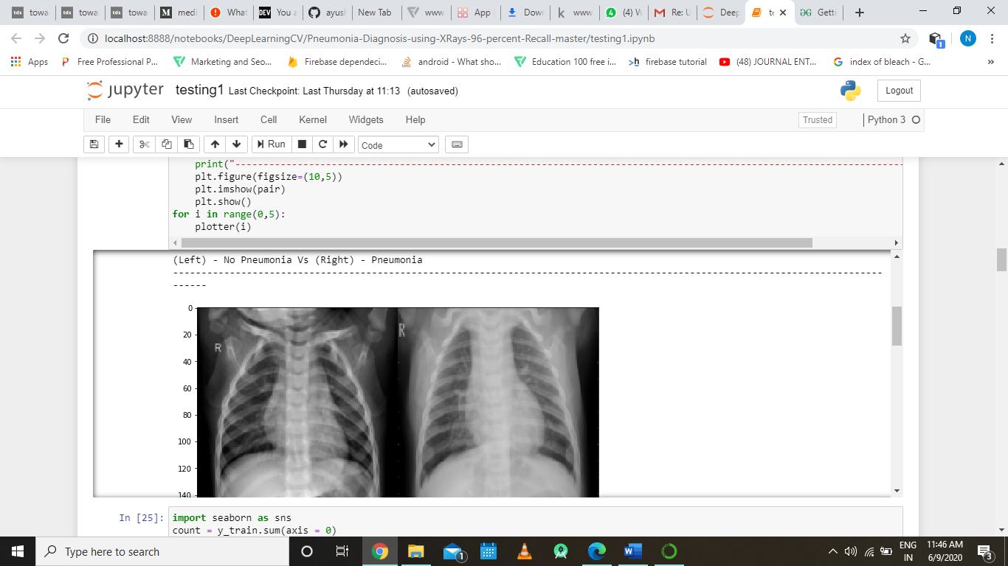

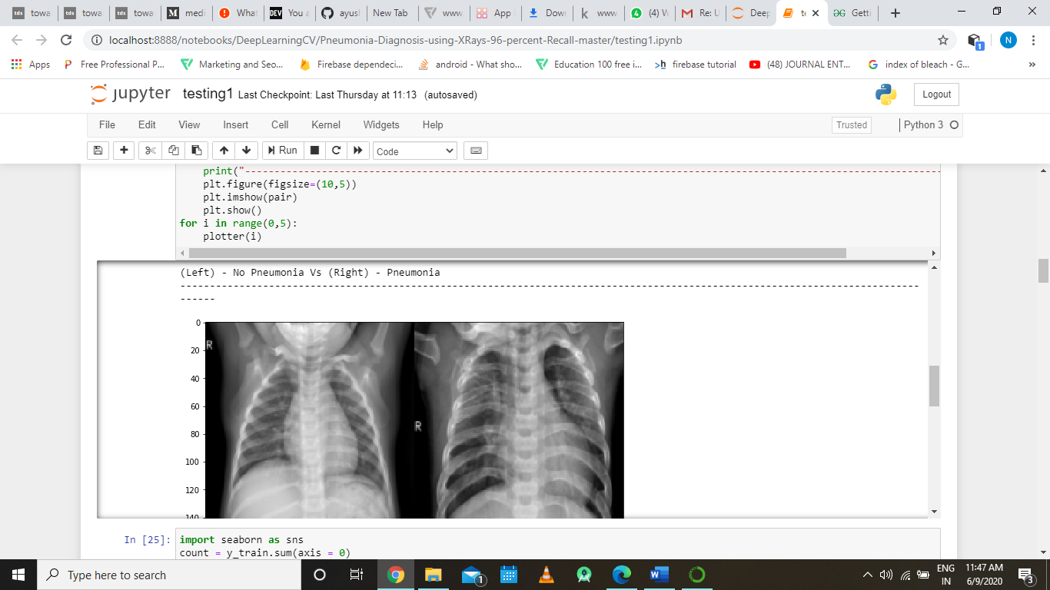

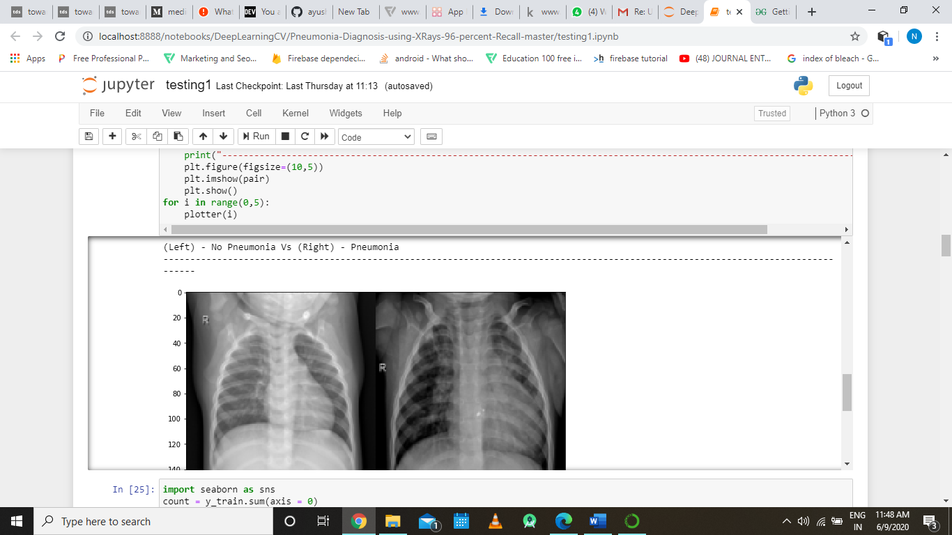

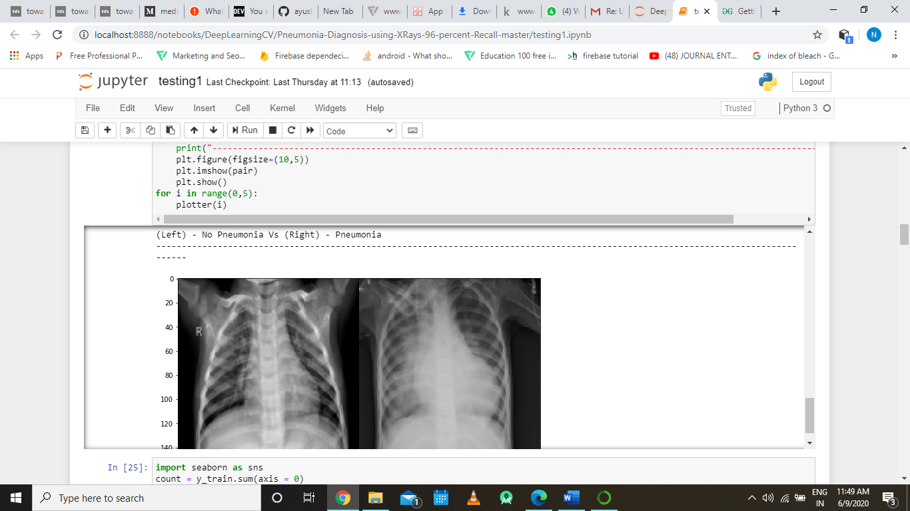

The above imges display the output of the five iteration of the for loop.

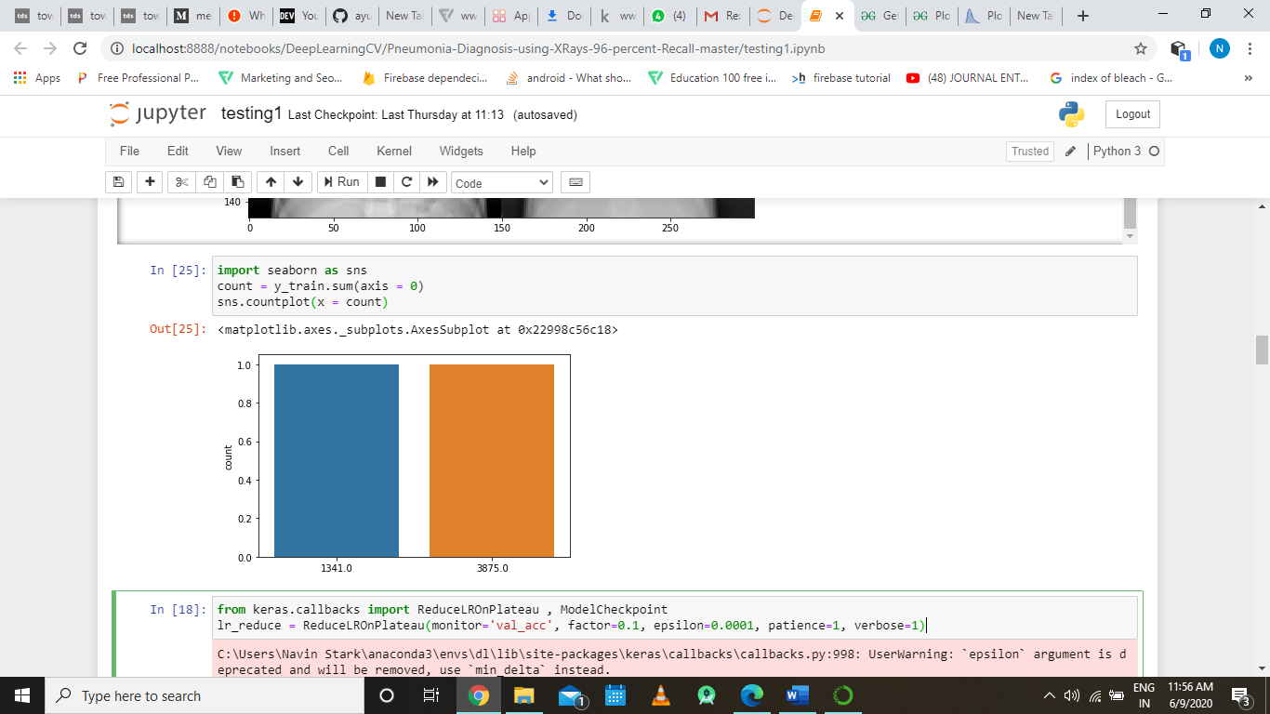

In this sub part of we are trying to visualize the number of different classes of data that is present in our training dataset and along with its count using the predefined countplot function of seaborn data visulaization library.

**Part 8:**

Now we will be heading toward our main part of the code that is defining the layers before defining the layers we wil be defining few checkpoints so as to optimize our code.

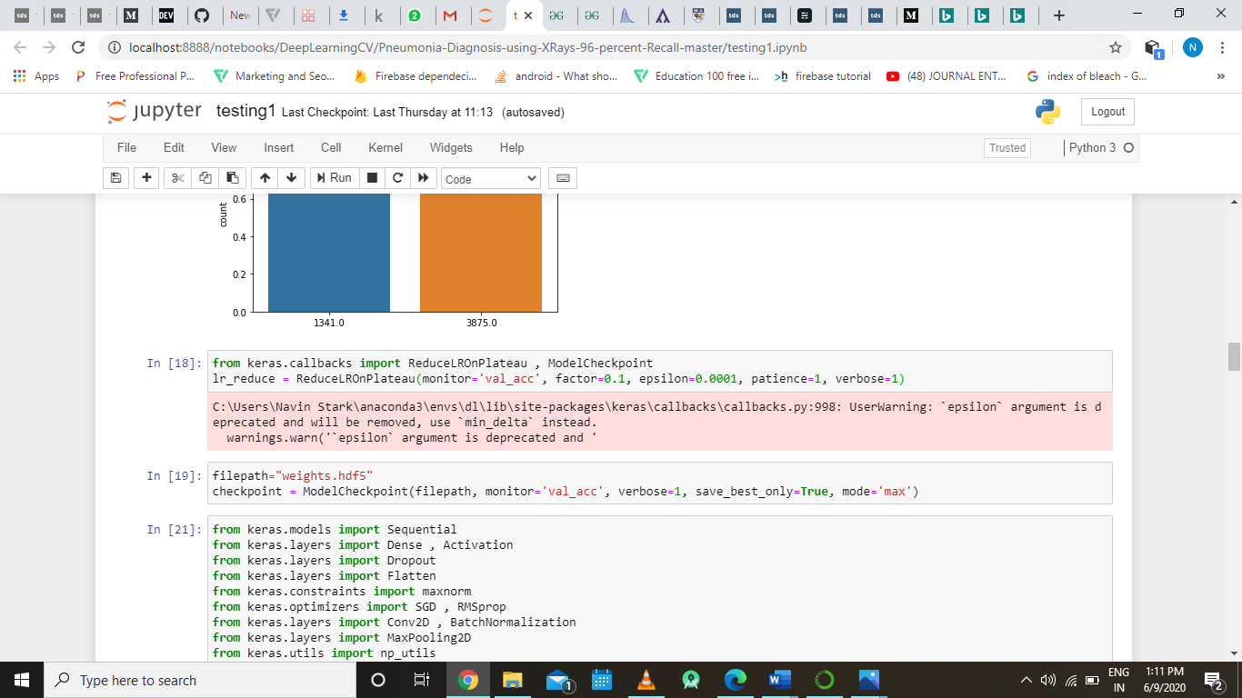

Here we instantiating callbacks of type ReduceLROnPlateau and ModelCheckpoint, the ReduceLROnPlateau monitors of the validation accuracy factor and reduces the learning rate by 0.1 if no improvement is seen in the motinored value. ModelCheckpoint monitors the validation accuracy value and saves the best weight in the weights.hdf5 file.

**Part9:**

In this part of the code we will be adding and importing libraries that is essential for building the convolutional layers of the neural network

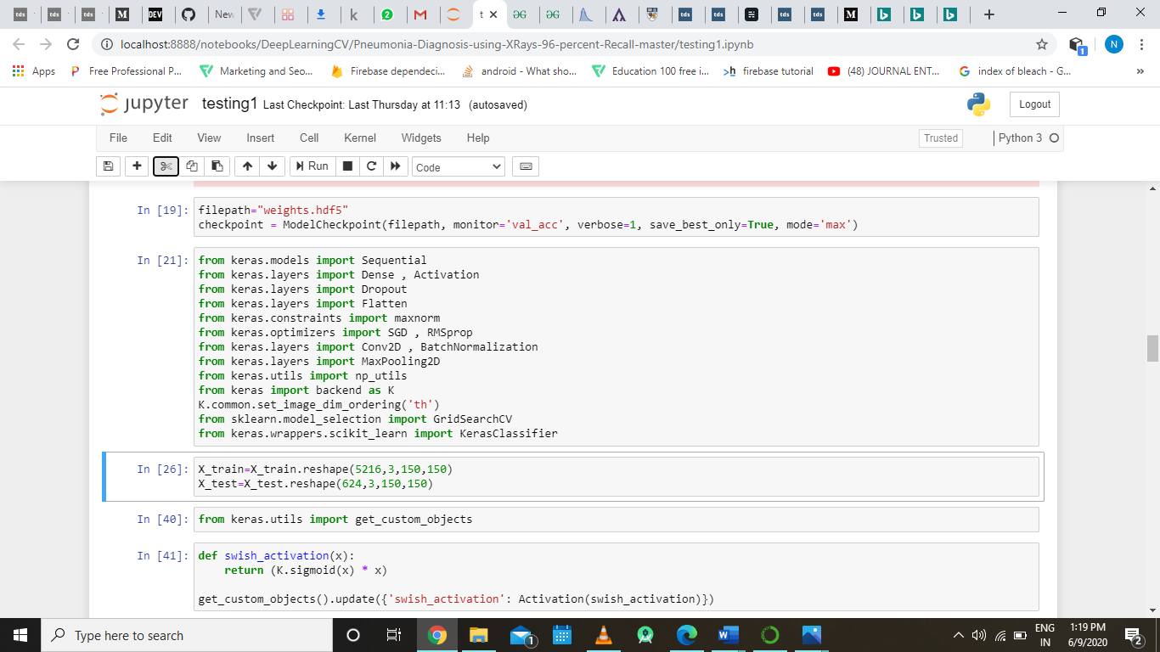

As we can see here we basically importing the keras libraries that required for building the different convolution layers. Keras is one of the leading high-level neural networks APIs. It is written in Python and supports multiple back-end neural network computation engines. The API was “designed for human beings, not machines,” and “follows best practices for reducing cognitive load. “Neural layers, cost functions, optimizers, initialization schemes, activation functions, and regularization schemes are all standalone modules that you can combine to create new models. New modules are simple to add, as new classes and functions. Models are defined in Python code, not separate model configuration files.

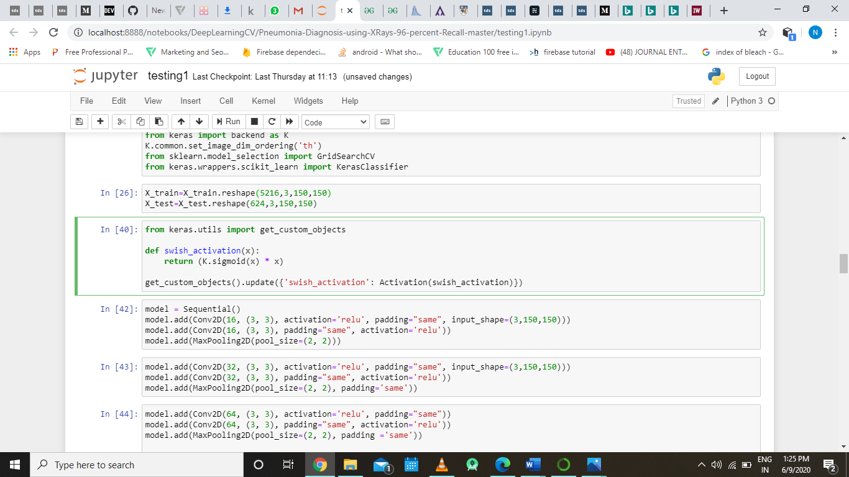

Here we are reshaping our numpy arrays which contain the training and the test data to a shape that is required by the our convolution layer’s input using the NumPy’s predefined function i.e. reshape().

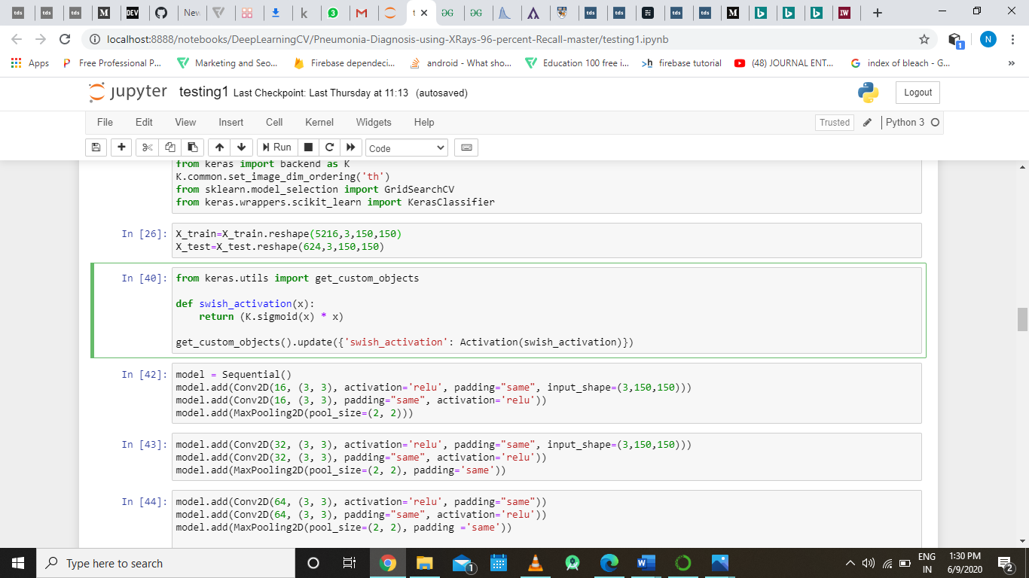

In the above sub part of the code we are defining a swish activation function, a custom activation function that we want to use in convolution layers. We are also making this swish activation function a global variable so that we load the saved model form an external file the program can understand what swish activation function means, for making this a global variable we are using the get_custom_object() function from keras utils package that we have imported in the first line in this part of the code.

**Part 10:**

This part will define and explain the heart of the code that is the part where we build the layer of the convolutional neural network. We will be using the libraries and the function that we imported in the part 9 while building different layers of our convolution neural network.

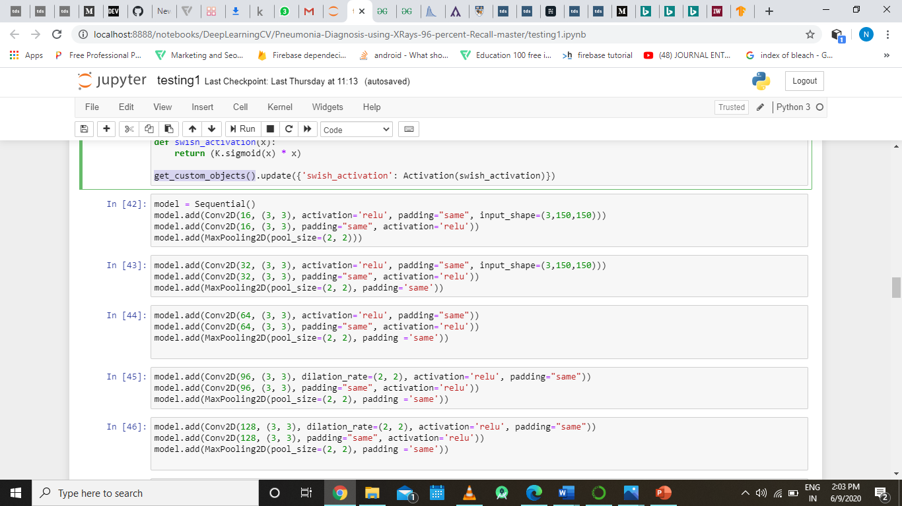

Here we are creating a variable model in which we are instantiating the sequential model using the predefined function of keras (Sequential()), after creating a sequential model we are adding different layers that make up the convolution neural network.

From the second line onwards of the above code are adding layers to our convolutional neural network as per the architecture we decided upon, using the keras api as we can see from the from the code model.add() is adding new layers to the existing sequential model and the argument given to the add method tell us perfectly which type of layer we are going to add, type of layer is evident from the name of the input argument function. Input argument of the inner passed in function are explained below:

First argument, tell us about the depth of the layer (that is the number of filter used) which is 16 I our case.

second argument, tells us about the size of the kernel/filter used which is (3,3) in our case

third argument, tells us about the activation function that we are going to use in our layer.

fourth argument tells about the padding type that we are going to us which is ‘same’ in our case which means we are adding padding to image such that the size of the output and input image are same.

Fifth argument tell us about the input shape of the image which is 3 x 150 x150 in our case.

Similarly, all the subsequent layers are added using the same keras api but different attribute that is input argument.

The beauty of the above code or we can also call the beauty of keras deep learning api is that it allows you to add layer to the convolutional model jus by knowing the basic concept of it. As we have discussed about the various types of layers and types of activation function in the convolution neural network explanation part of the code, we can now easily add the subsequent layers to the model using the api but with different input arguments. The subsequent layers that we added onto our model is displayed below:

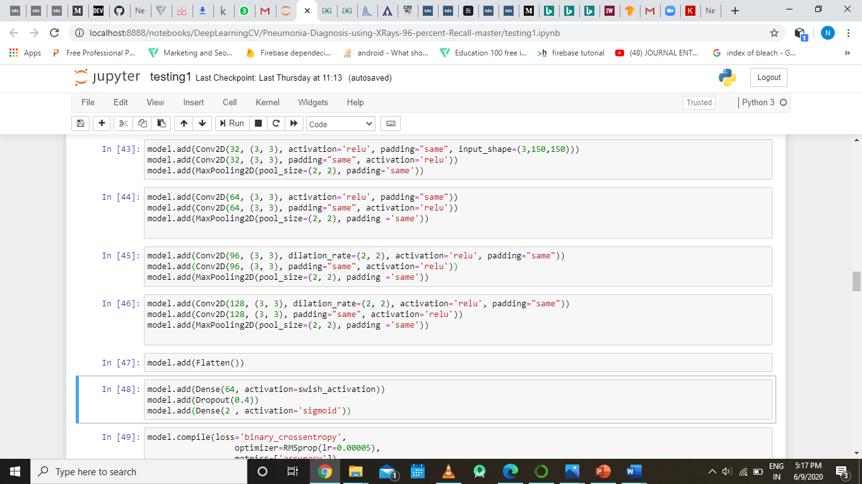

Up till the above code we have constructed the Input, Convolution Layer, ReLU Layer, Pooling Layer now we going to the fully connected layer, this the part from which the convolutional layer acts like normal neural network with lots of nodes. But before adding the fully connected layer or the dense layer we have to flatten the model output which is done by the below code.

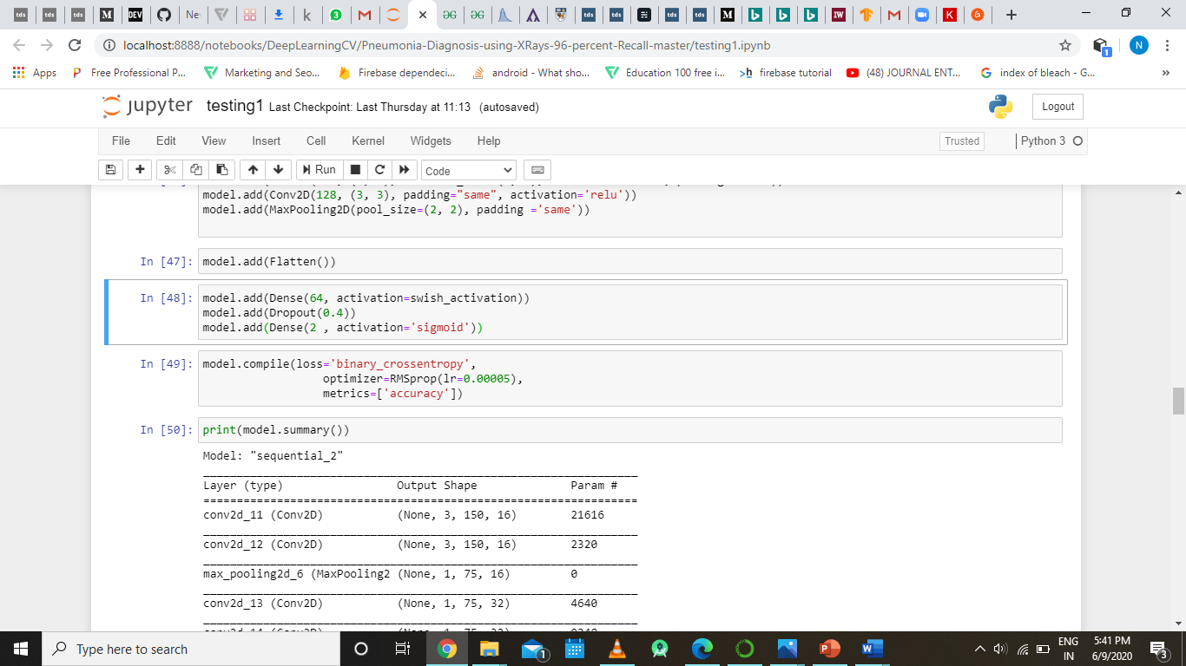

This line of code flattens the layers that is it converts two-dimensional input to one dimensional input that is required by the fully connected layer.



The above snippet of the code contains three lines of code the first line add the dense/ fully connected layer to the model with 64 neurons in the input layer and with swish activation function that we have defined in the part 9.

The second line off the code add a dropout to the model with the dropout factor as 0.4 to introduce regularization.

The third line of code adds another layer of dense / fully connected layer into the model with 2 neurons in the input layer and with sigmoid activation function.



Here we have compiled the above constructed model with binary cross entropy as its loss function and optimizer as RMSprop with learning rate as 0.0005 and the metric over which loss is calculated is accuracy.



This line of code prints the summary of the model the model that we have just created.The output of the above code is given below.

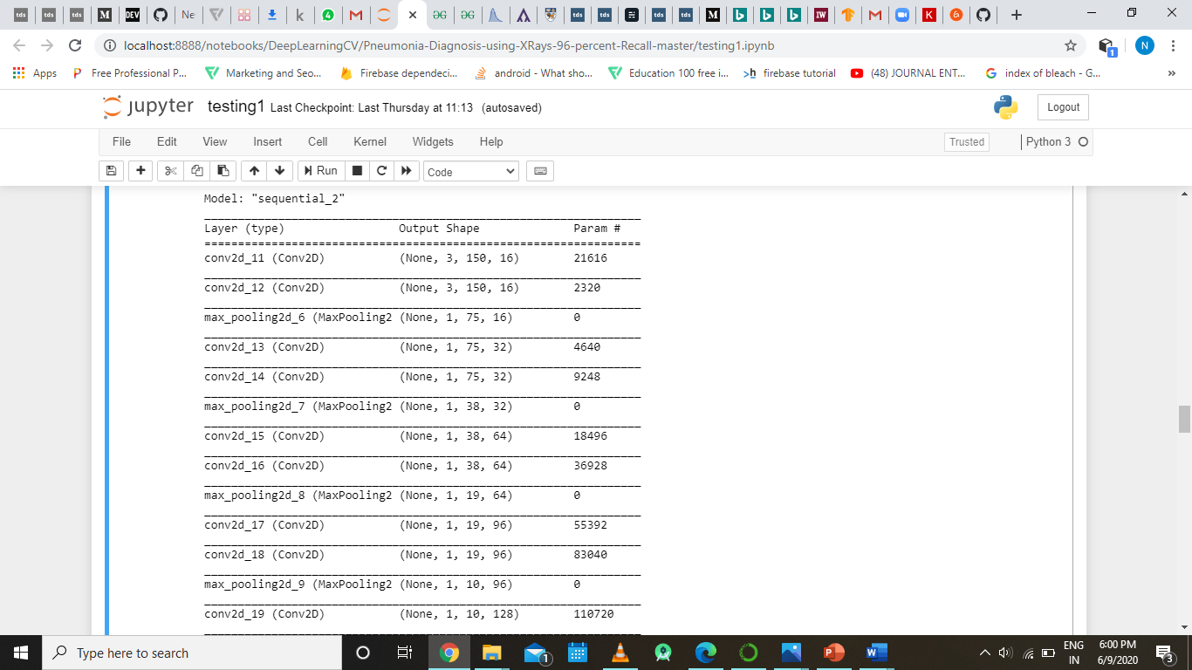

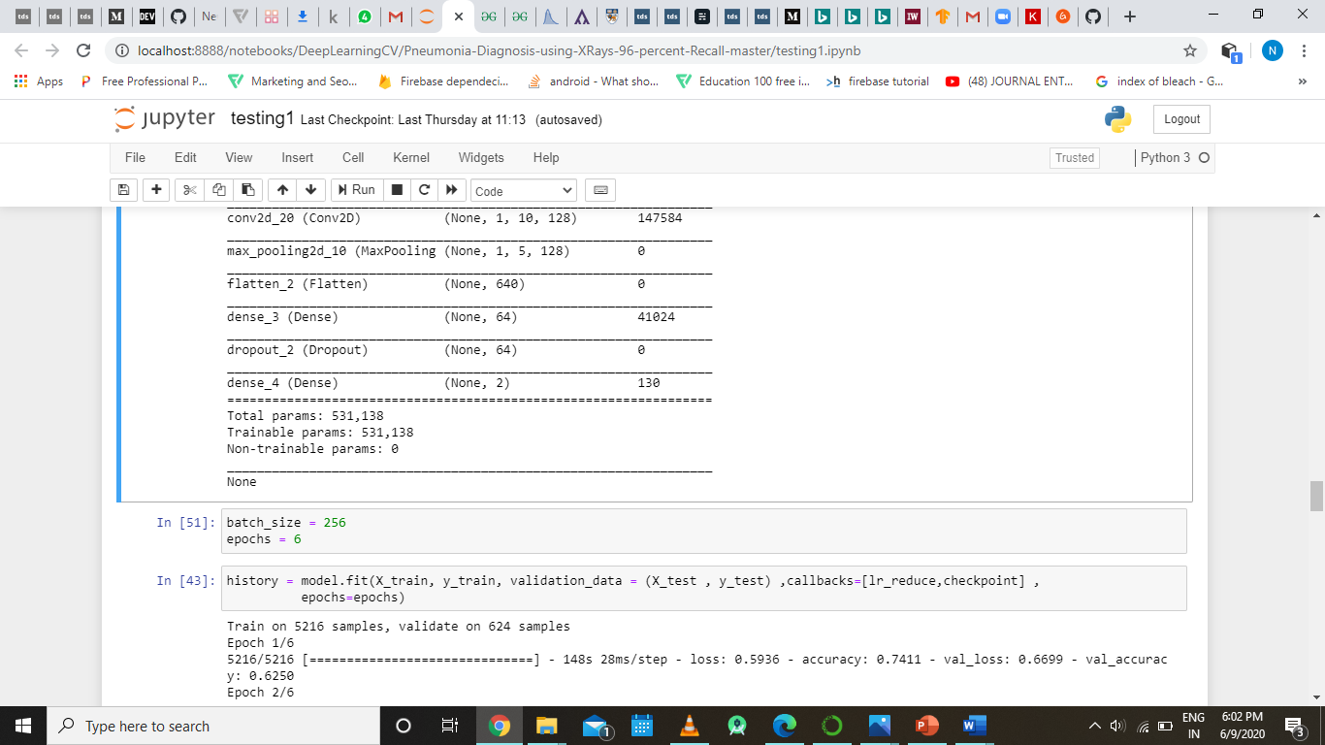

**Part 11:**

This part will deal with the training part convolutional neural network.

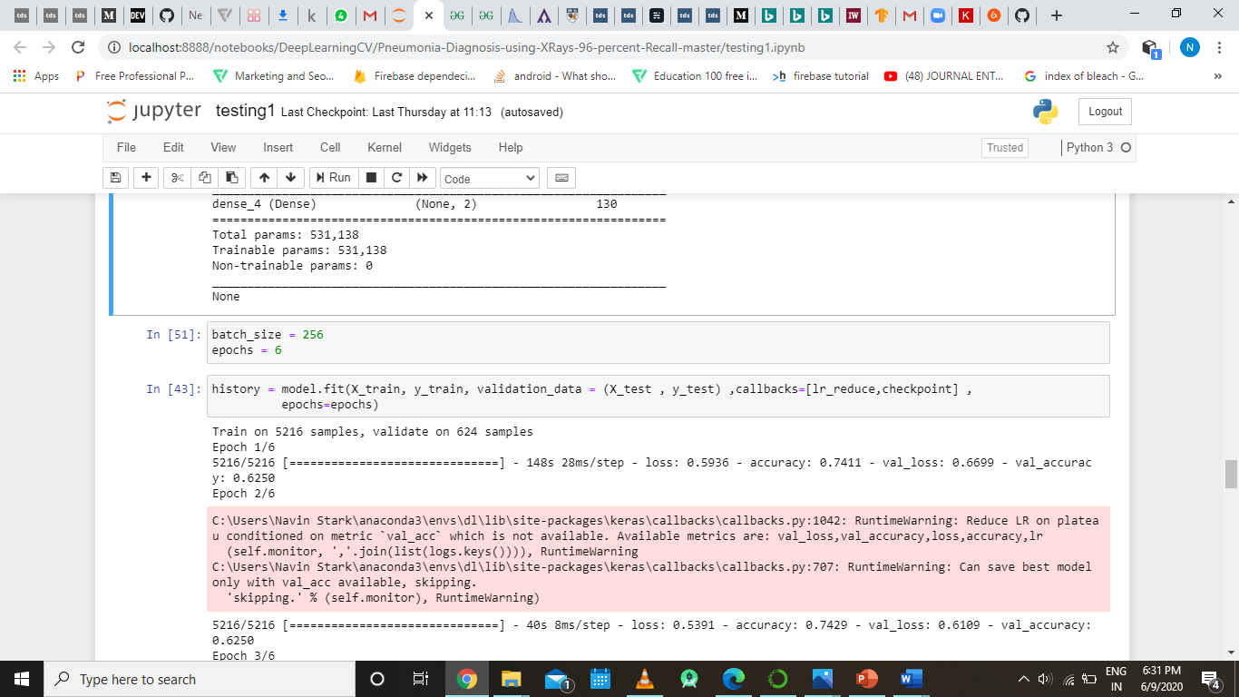

The above code defines two variable the defines the batch_size and epochs for training the model.

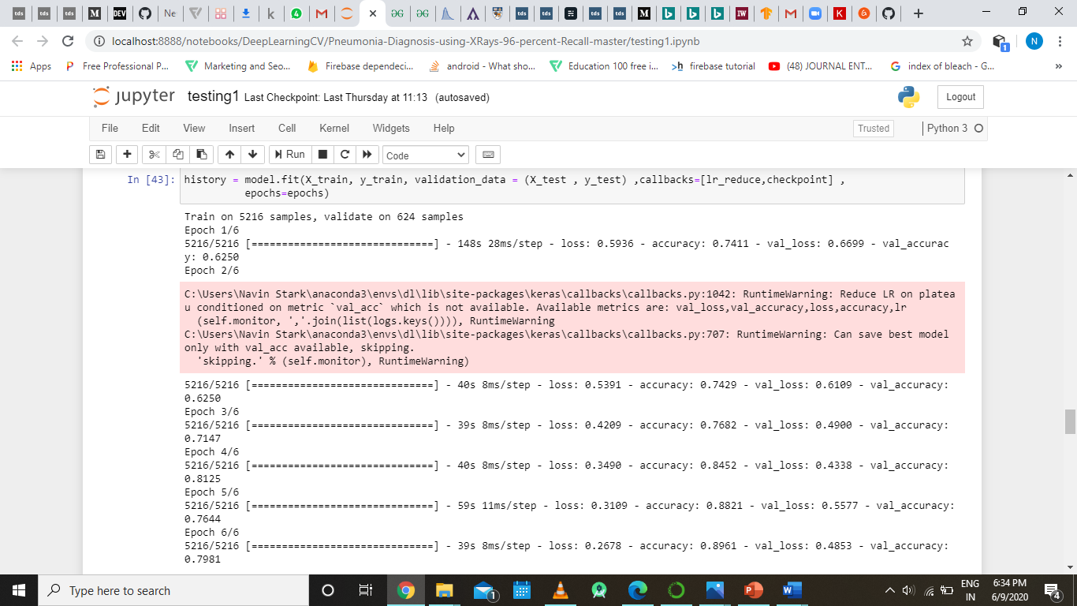

Model.fit () is used to train model that we just created and the method takes taining data, training labels, validation data ,callbacks and epochs as it input parameters. Here in the callbacks part we are passing the two callbacks that we have defined in part 9 of the code, then is tarined model is passed to a variable called history that wil be used analyze the resultant accuracy.



The above is the output of the line model.train(), we can also see the loss, accuracy, and validation accuracy and validation loss of the model over each ecpoch.

**Part 12:**

In this part of the code we will be visualizing the output metrics of the model that we just trained using various visualization libraries present python.

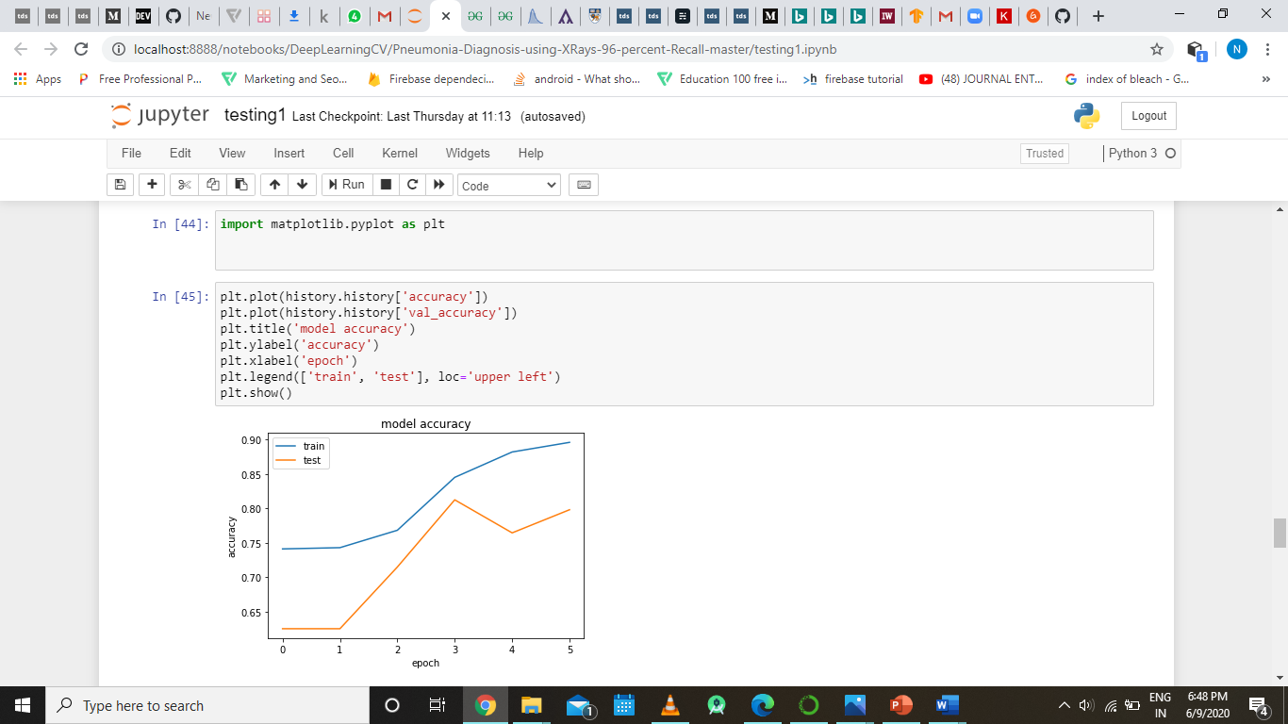

Here we are using the matplotlib as our visualization library for visualizing the accuracy and the validation accuracy of the model we just trained, here the plot generated will have accuracy at its y axis and epoch at its x axis.

The output of the above code is shown below:



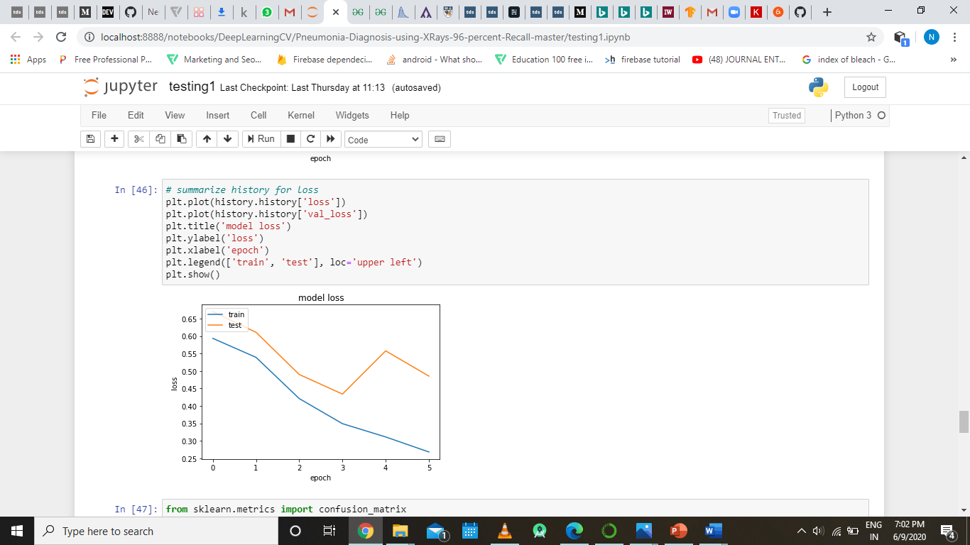

The above code is the exact copy of the previous code that was used to plot the graph of accuracy and validation accuracy, the only difference here is instead of accuracy we plotting the graph around training loss and validation loss.

The below graph is the output of the code that we discussed just right now.



Now we will be visualizing our out metrics from our trained model using another visualization method which is the confusion matrix.

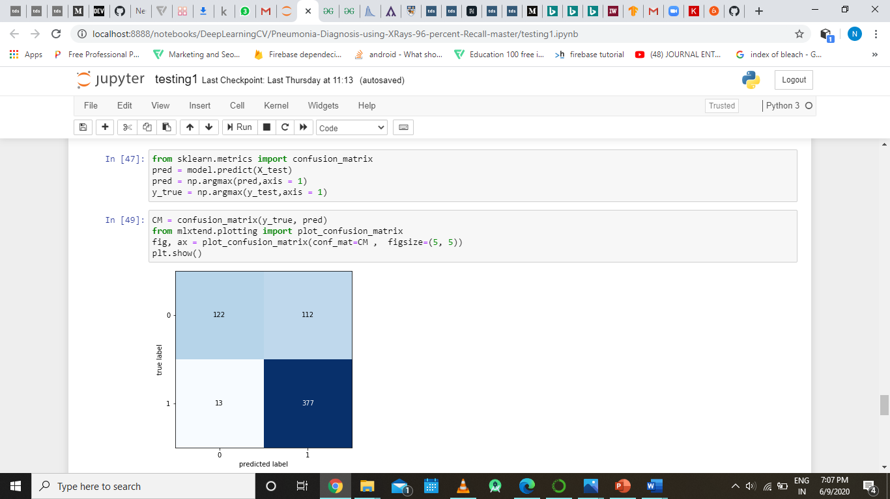

Here we are plotting the confusion matrix for our model that we trained. The output of the above code is shown below.

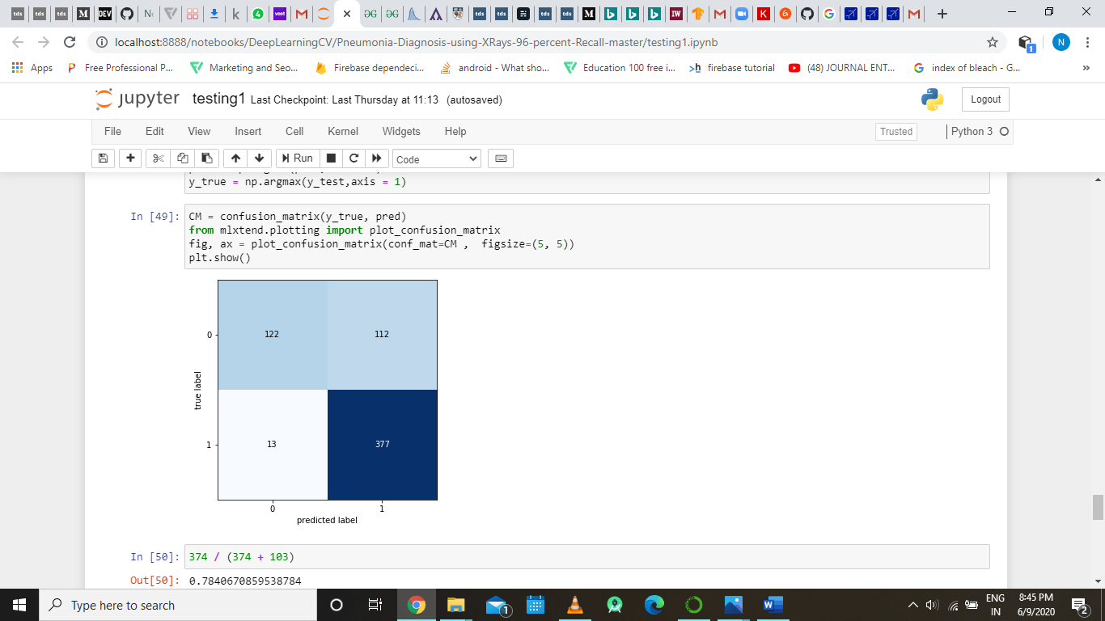

**Part 13:**

In this part we are saving the model that we trained int part 11, so that we can use saved model for classifying the image without training it again and again whenever we wanted to use the classifier.

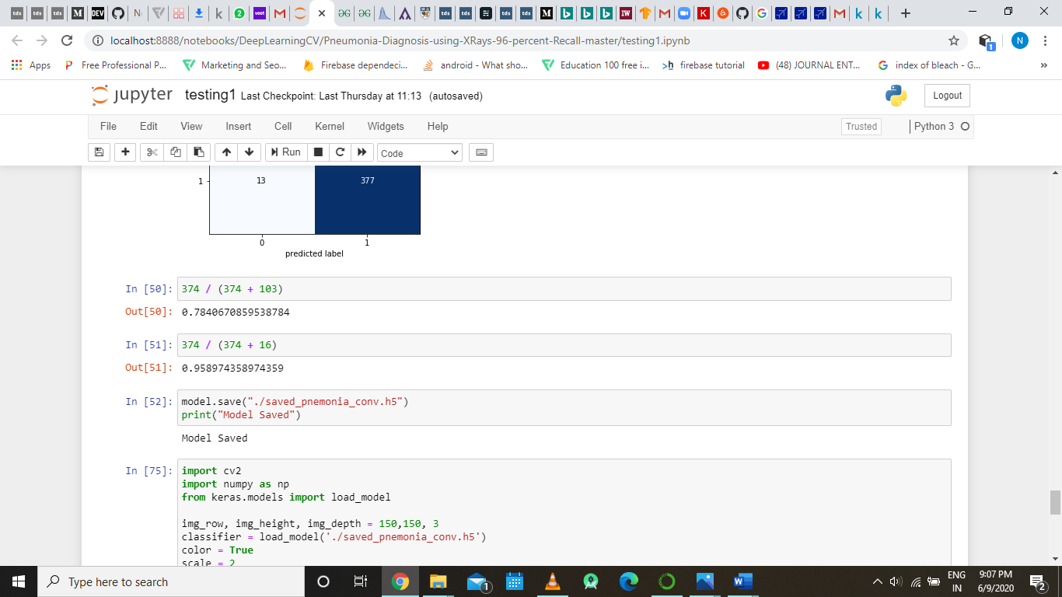

**Part 14:**

In this part we will be using the saved model to classify the images that we provide to the classifier as input and test whether our classifier is working or not.

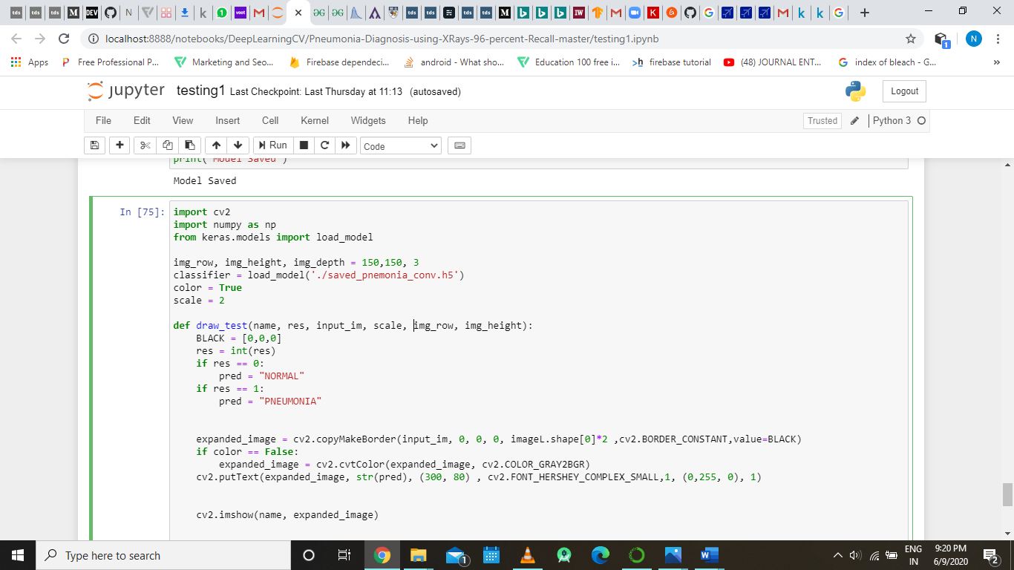

We are loading our saved mode using the load_model() function form the keras.models package and we are also defining that takes in name/title (to be displayed on the window) , result , input image and dimension of the image as input argument and displays the input image in a separate window and also labels the image whether it is normal or pneumonia affect chest x ray.

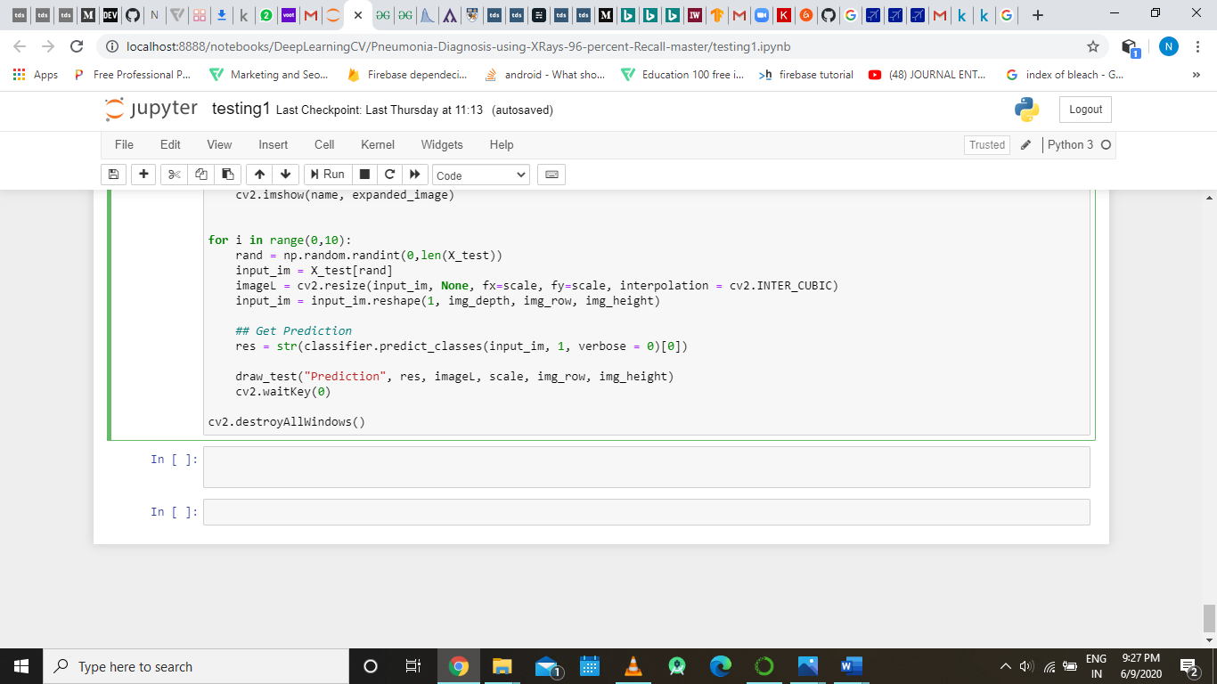

In this part we using a for loop and iterating over the code 10 times, the code over which we are iterating is basically taking a random image form the x_val numpy array and classifying the image using our loaded model using the predict_classes() function.

The output of this sub part is as follows:

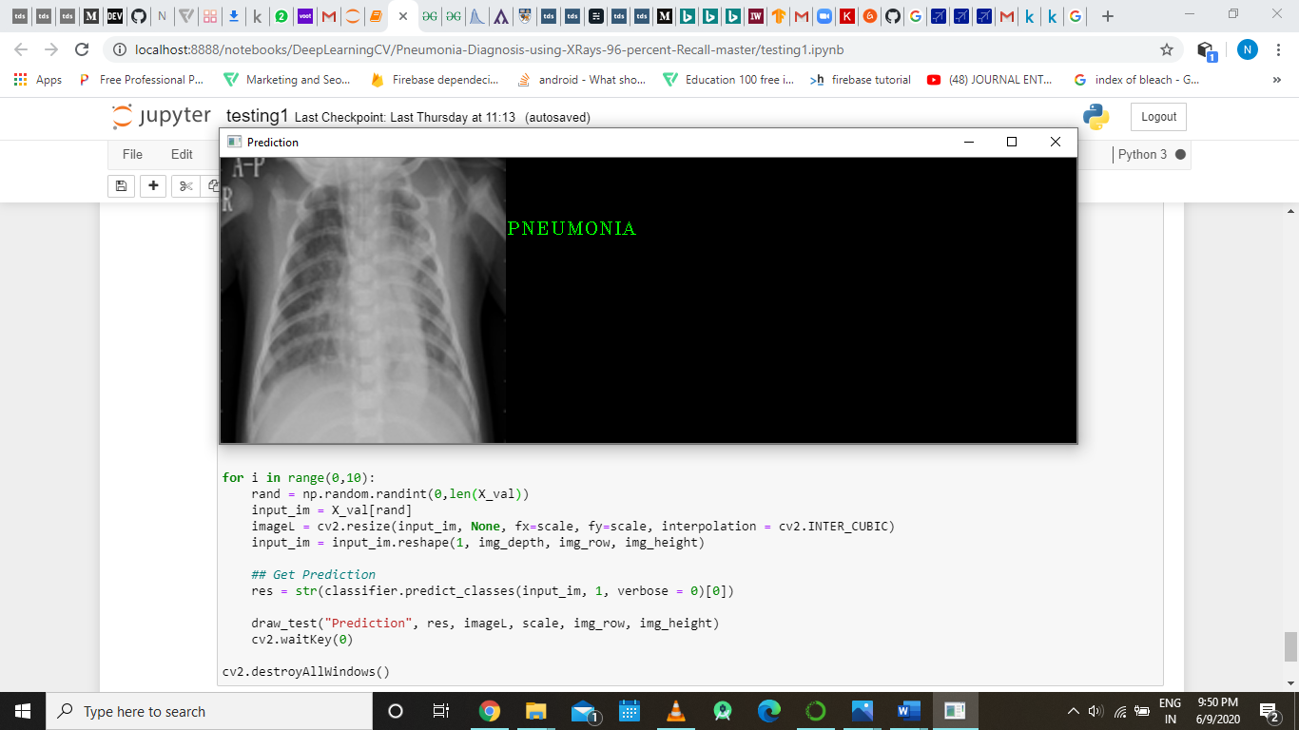

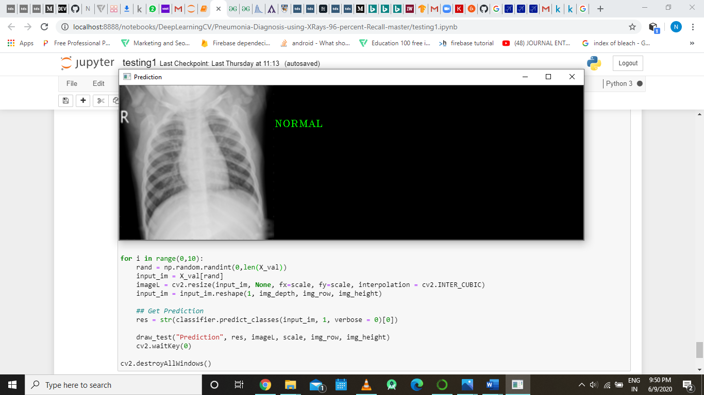

As we can see the model is able predict whether person is affect with pneumonia or not just looking at the chest Xray images.

**Transfer Learning**

For increasing the accuracy of the model we introduced the concept of transfer learning in our model. The transfer learning is applied using the GoogleLeNet teams developed model which is the inception v3 model whose brief description has already been given in the report.

The inception V3 model has been developed as a entirely separate program file itself so as to compare the performance of both the models. This program is exactly similar to the previous model up to part 9, here in the upcoming sections we will be discussing the code part of the inception v3 model which is different from the previously implemented part.

**Part 10 (Inception Model):**

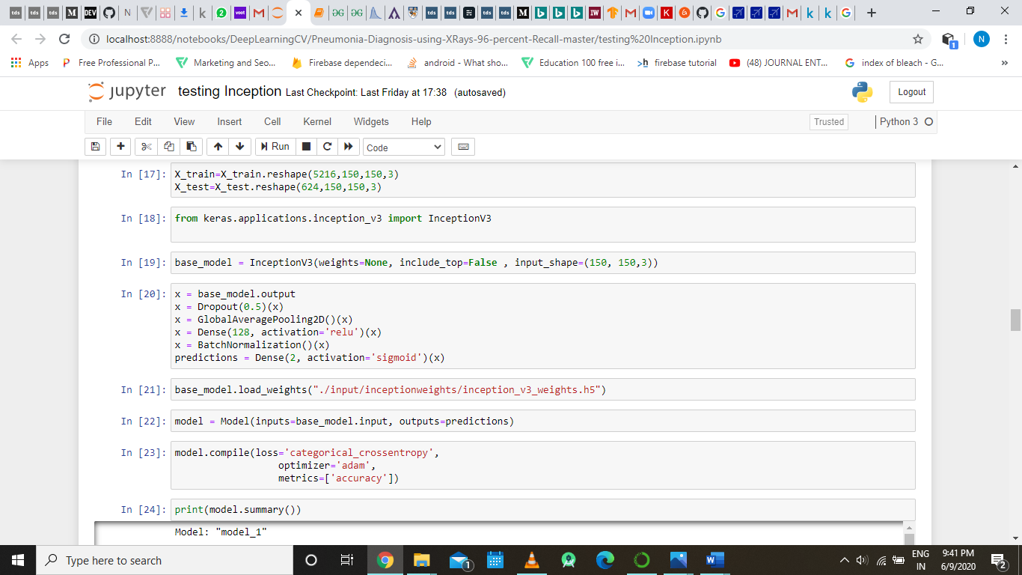

Here import the InceptionV3 class from the keras.application.inception_v3 package, this harbors all the api required for developing a model that resonates inception V3.

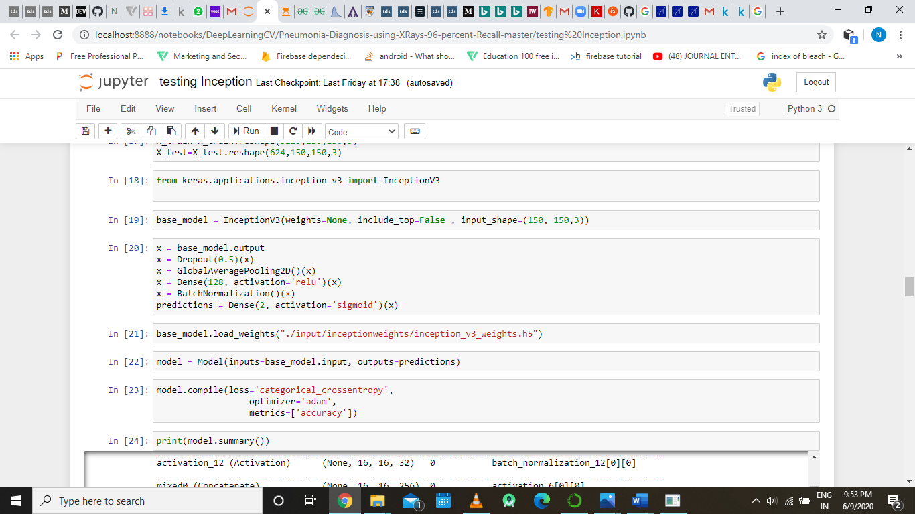

The above line of code creates a base model which has the skeleton structure of inception v3 architecture, the skeleton structure is passed to the variable base_model using the InceptionV3()

method which takes in three input parameter the first saying that we are not including the weight into our inception v3 skeleton model, the second argument means that we are not adding the fully connected layer of the inception v3 architecture, this is evident since we only need up till the bottom part so as to extract feature using the inception v3 architecture after that we will build our own fully connected layer according to our requirement of classification, the third argument takes in the dimension of the input image.



The above code defines the fully connected/ dense layer of the convolutional model as we have not taken the fully connected layer of the inception v3 model, and this dense layer is exactly similar the last dense layer of the previous model as they both have been built for the same purpose.



In this above line of code we are loading the weight to base model , these weights are being taken from inception_v3_weight.h5 file which is open source weights file for inception v3, that anyone can download from the web.



Here in this sub part of the we are defining our entire inception v3 model and compiling it with categorical cross entropy as its loss function and adam as its optimizer over the accuracy metric of the model.

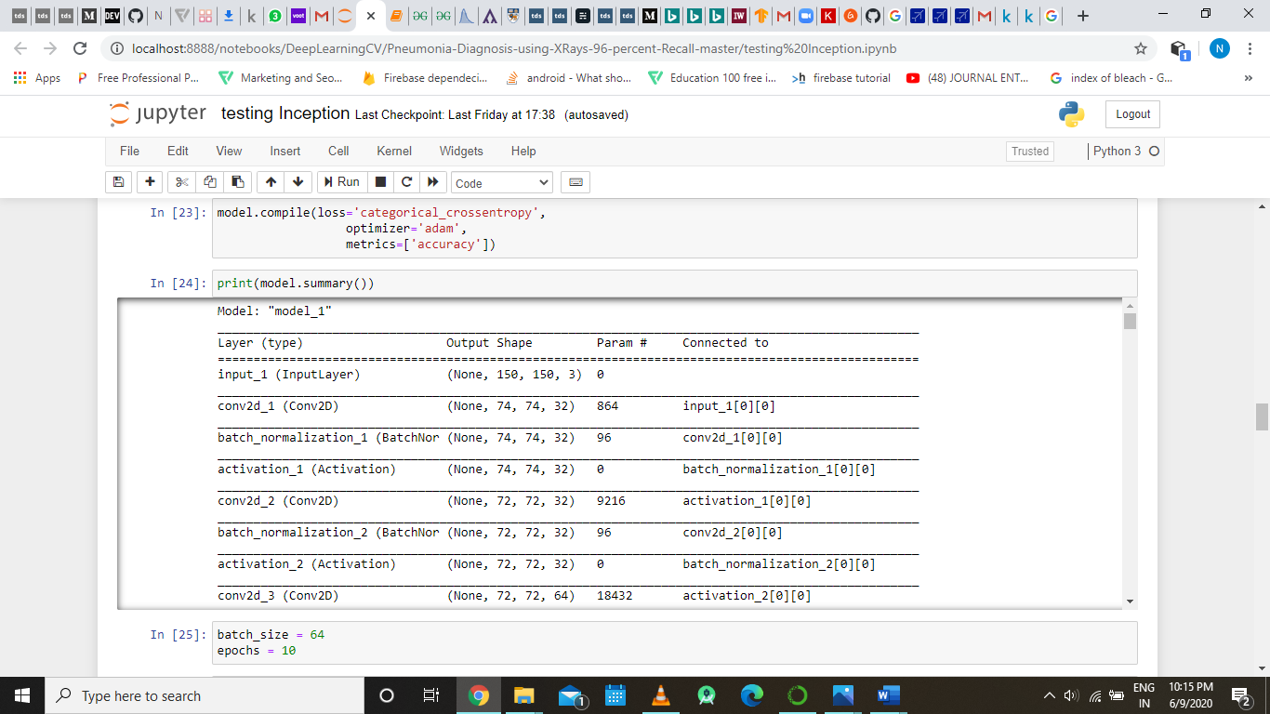

The above line of code prints the summary of the model, whose output is displayed below:



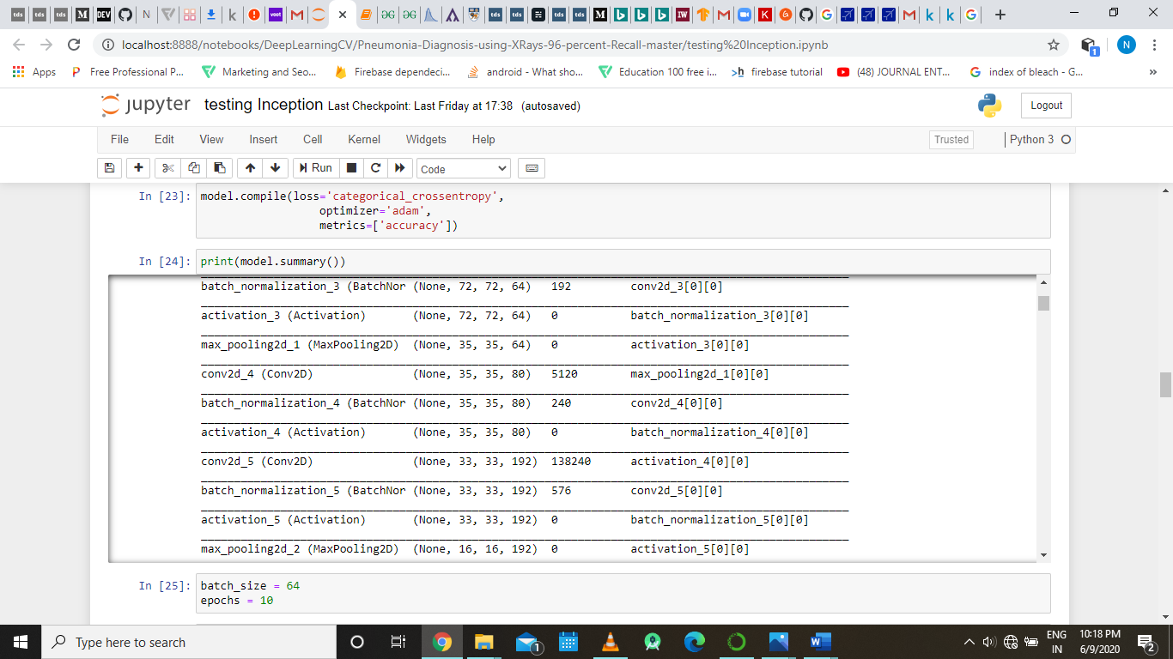

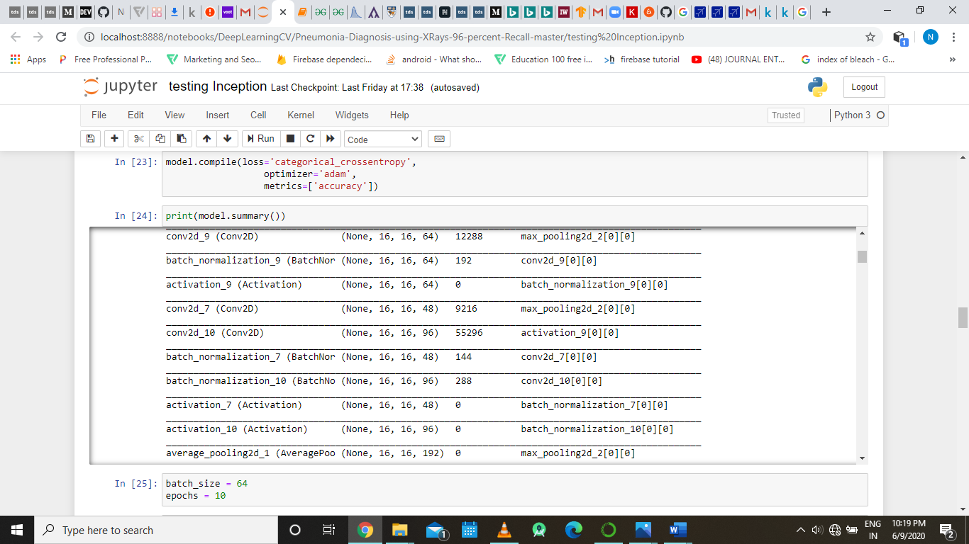

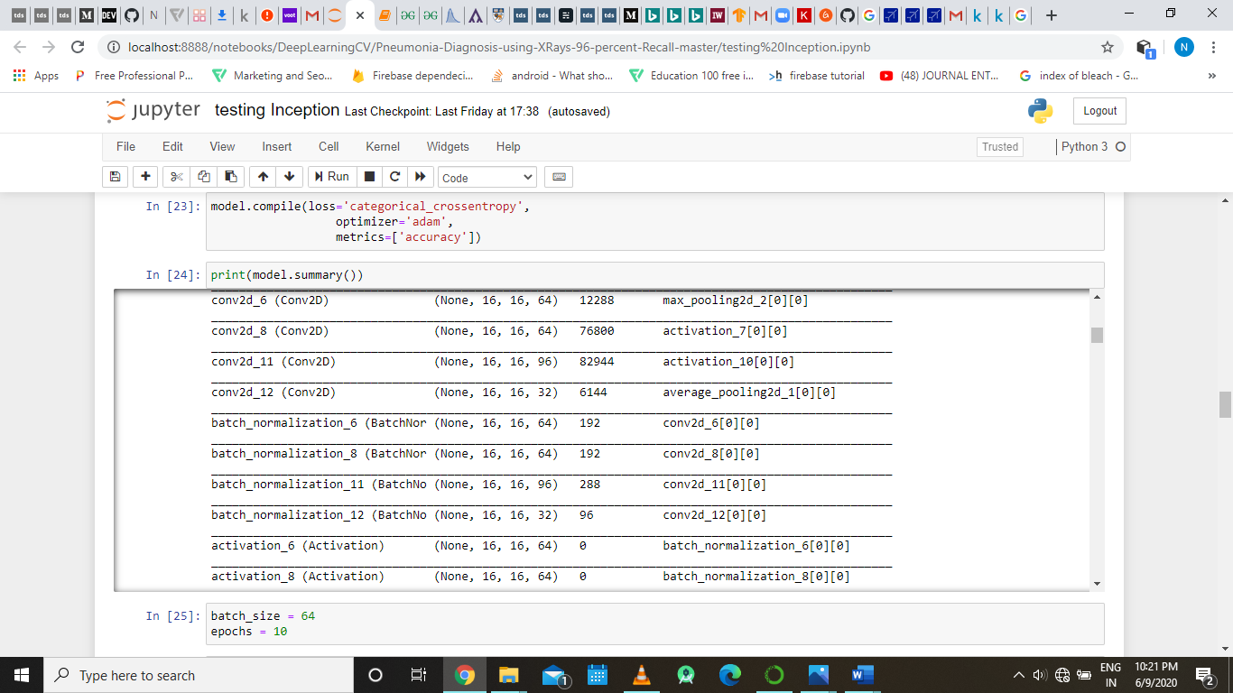

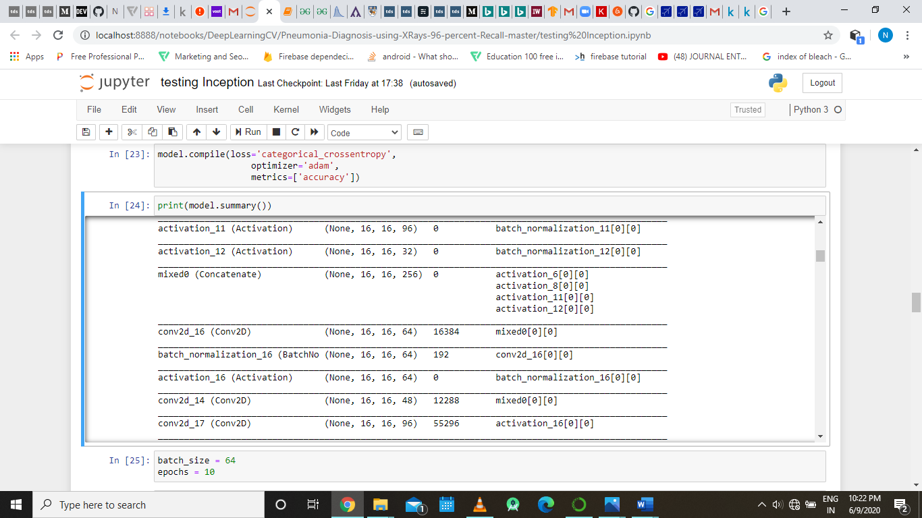

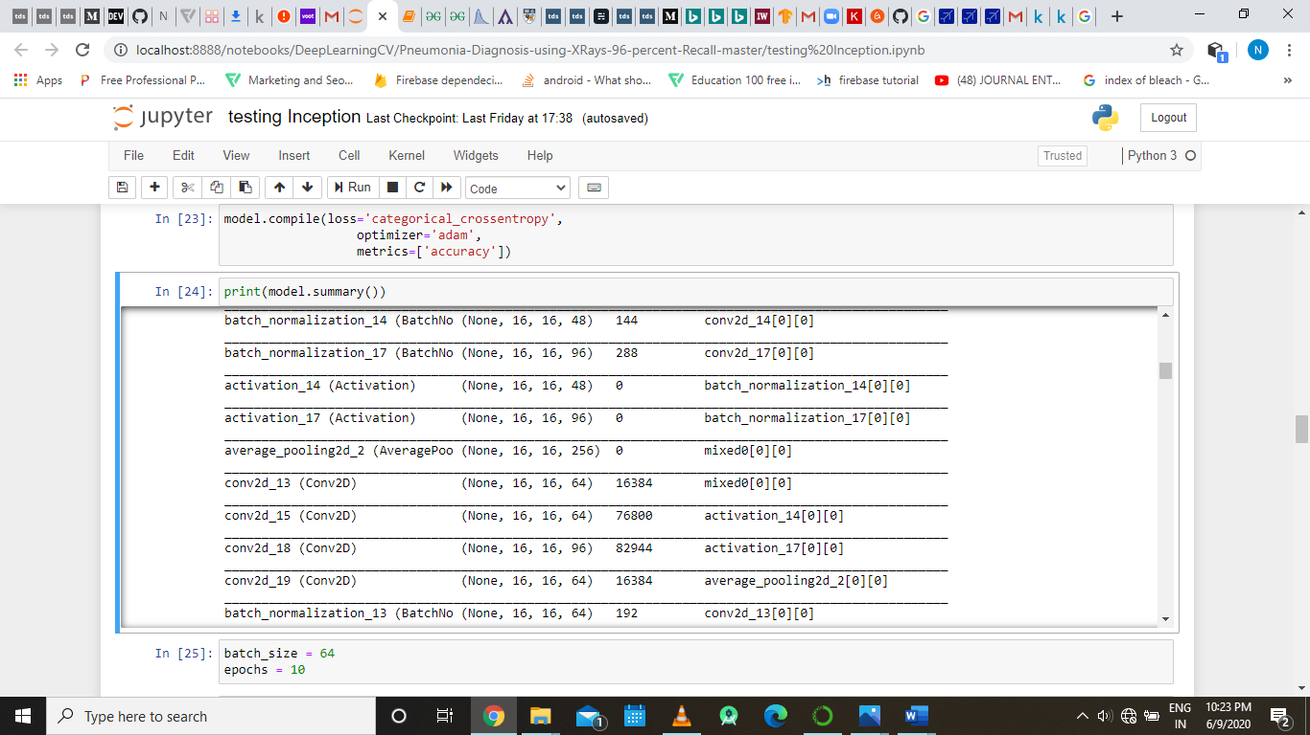

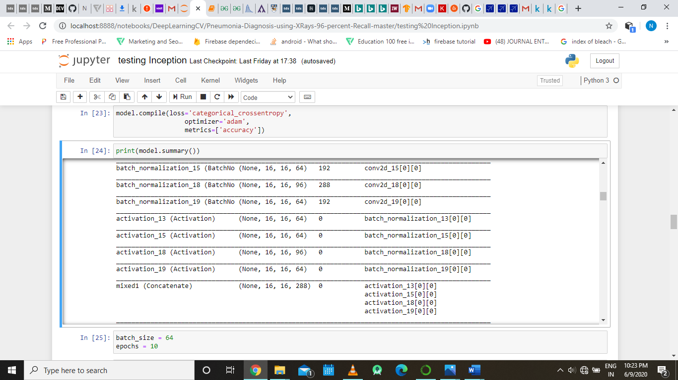

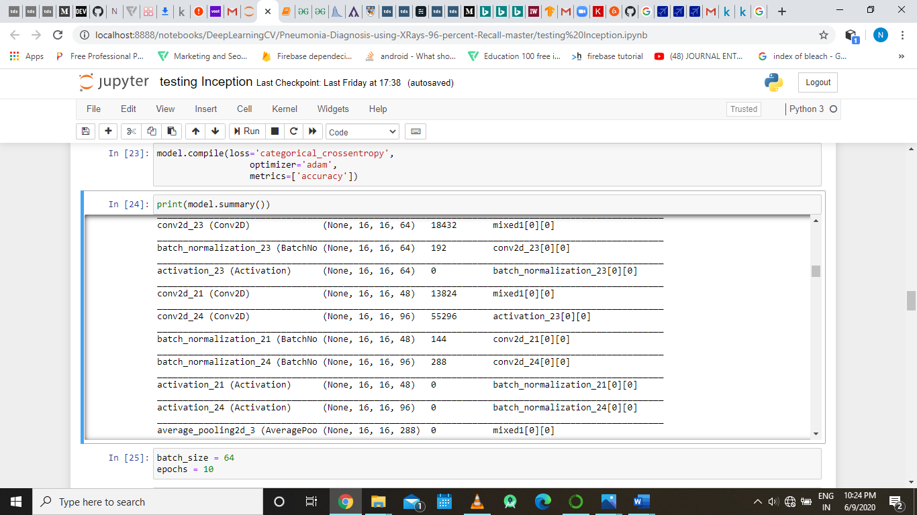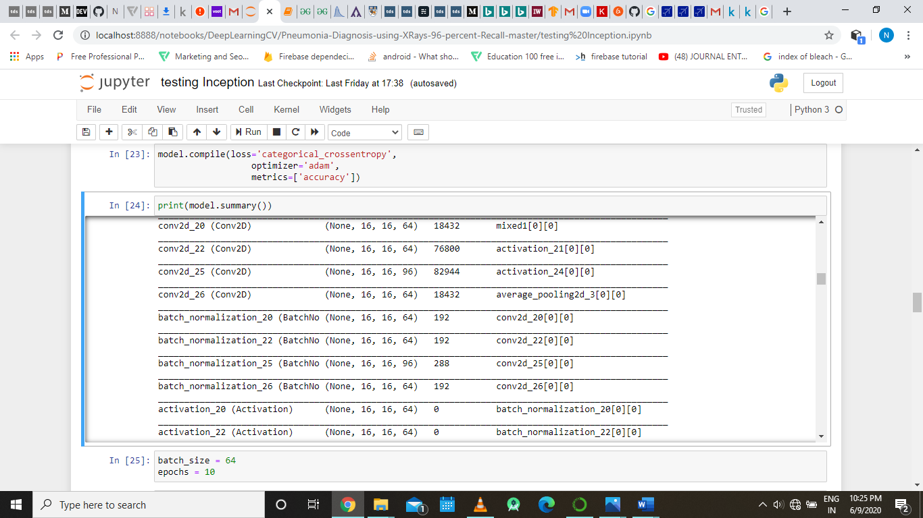

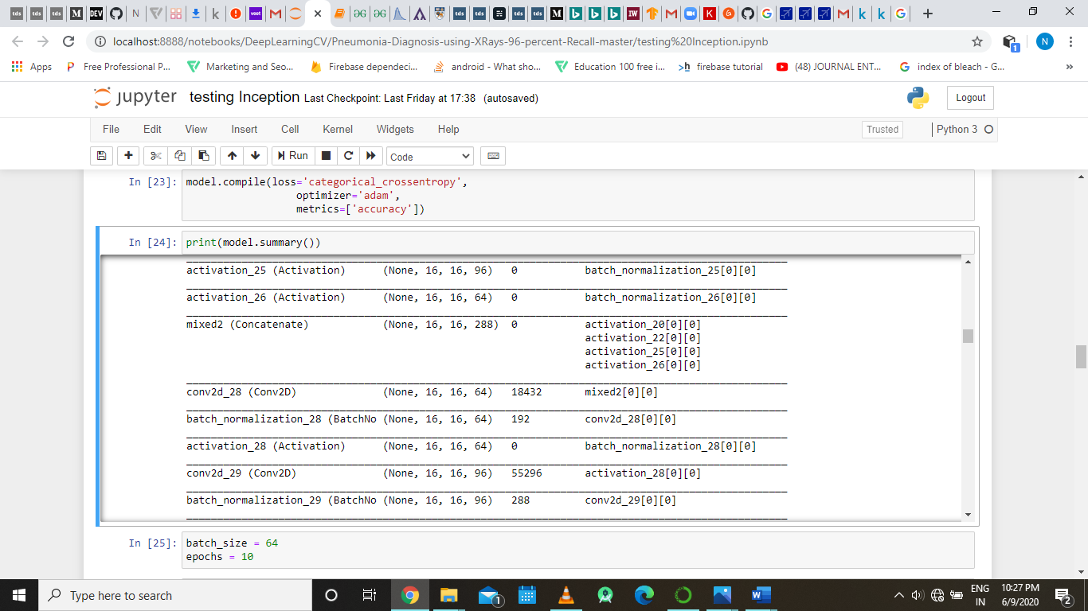

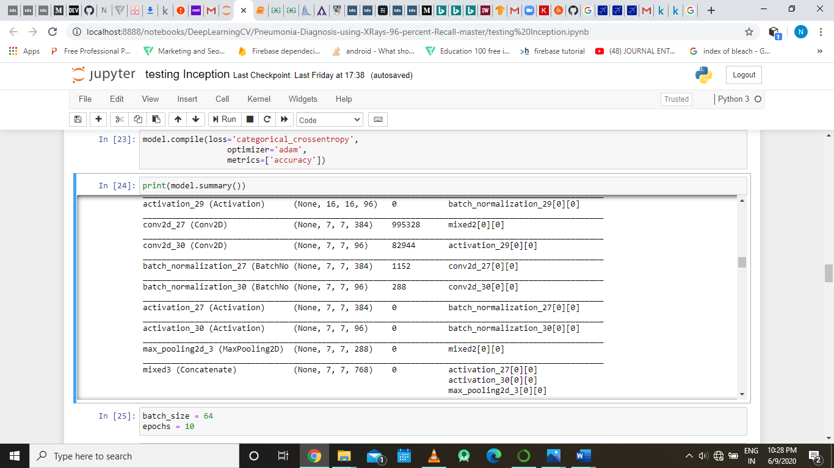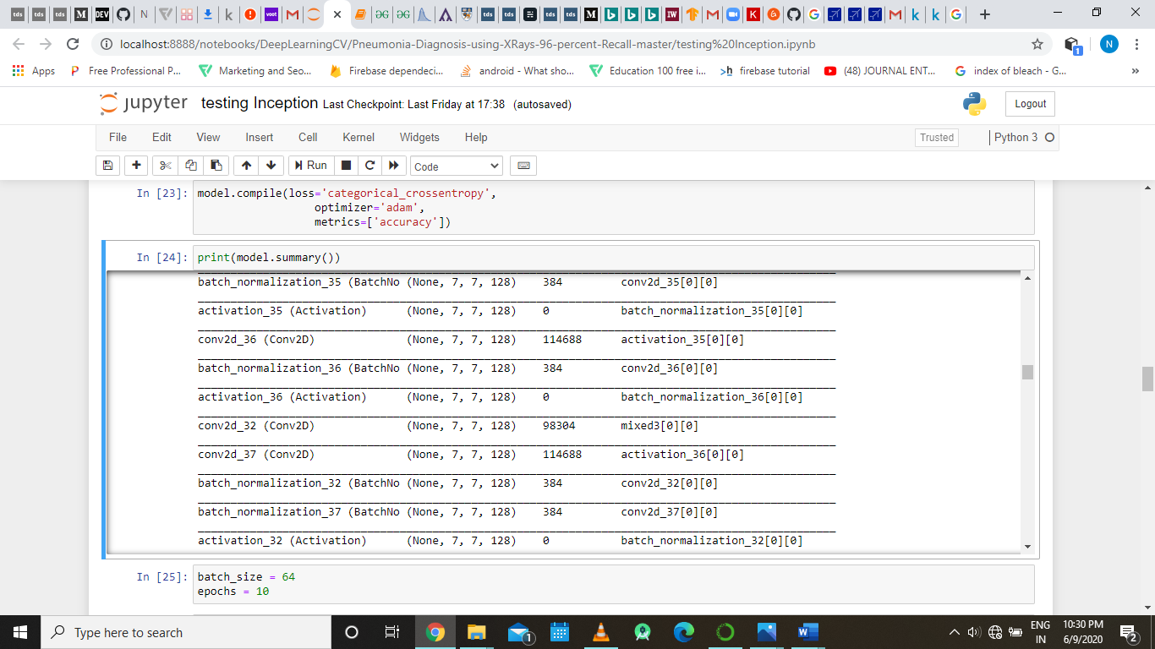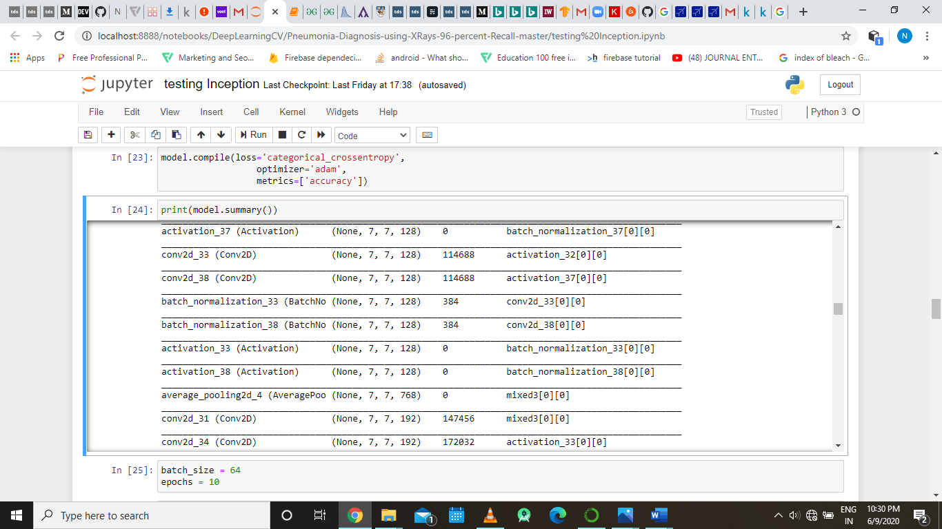

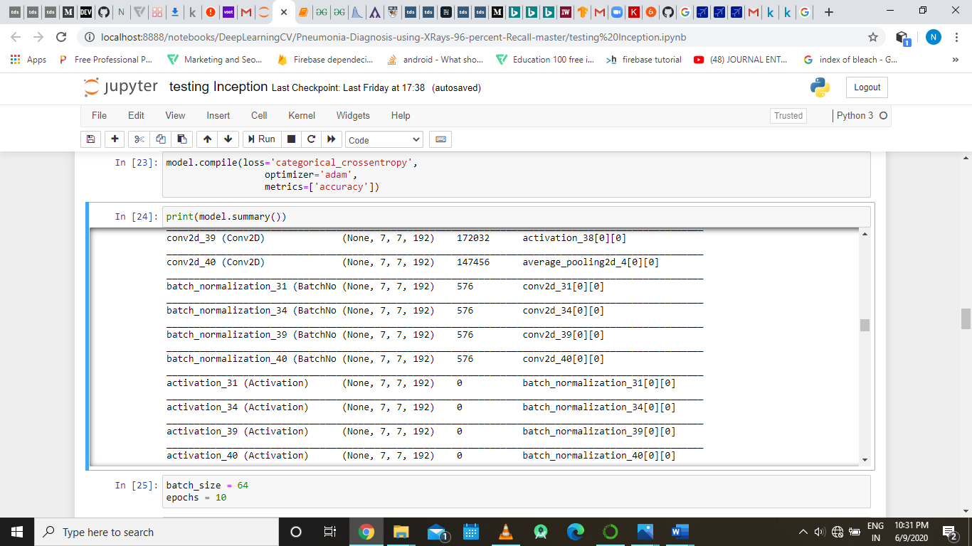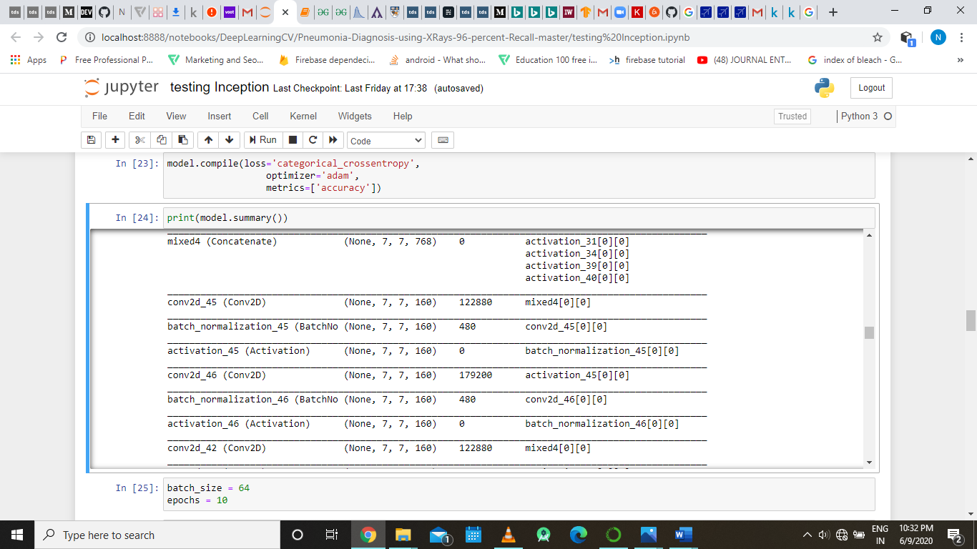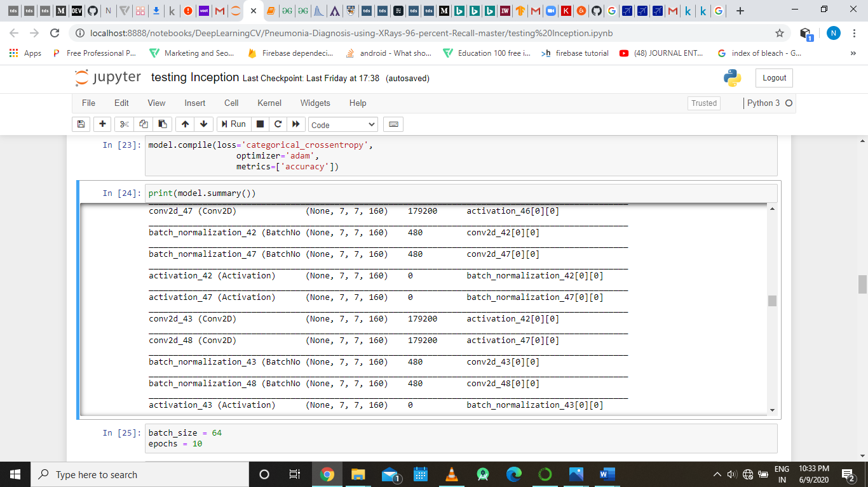

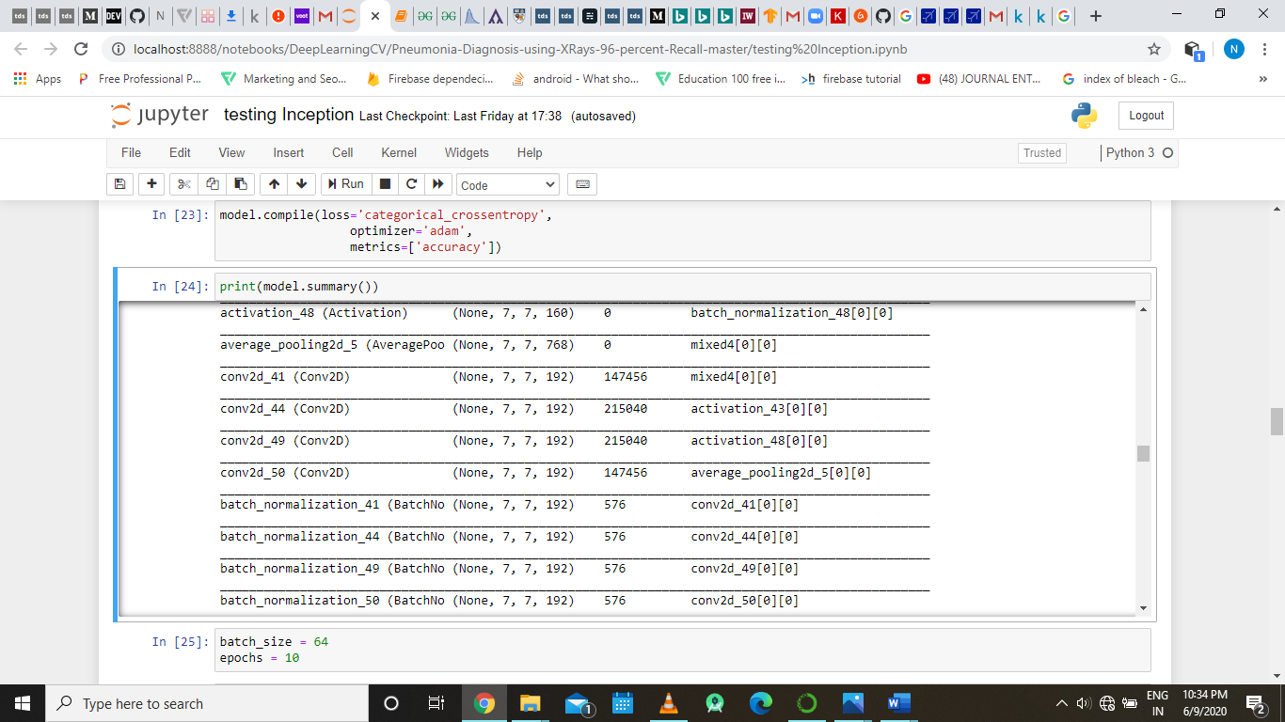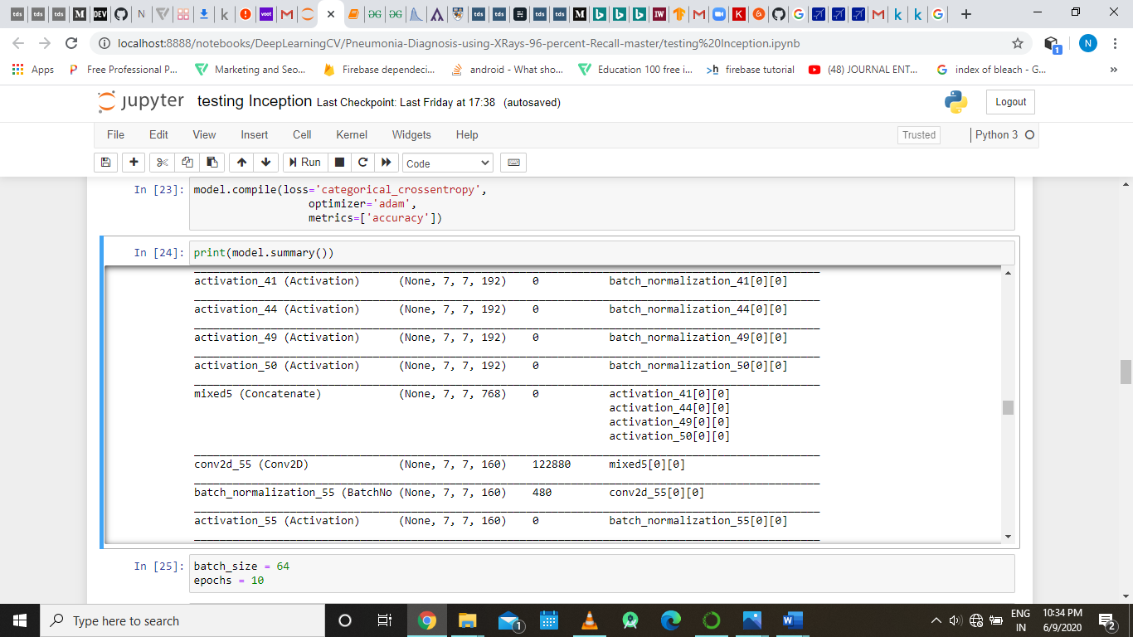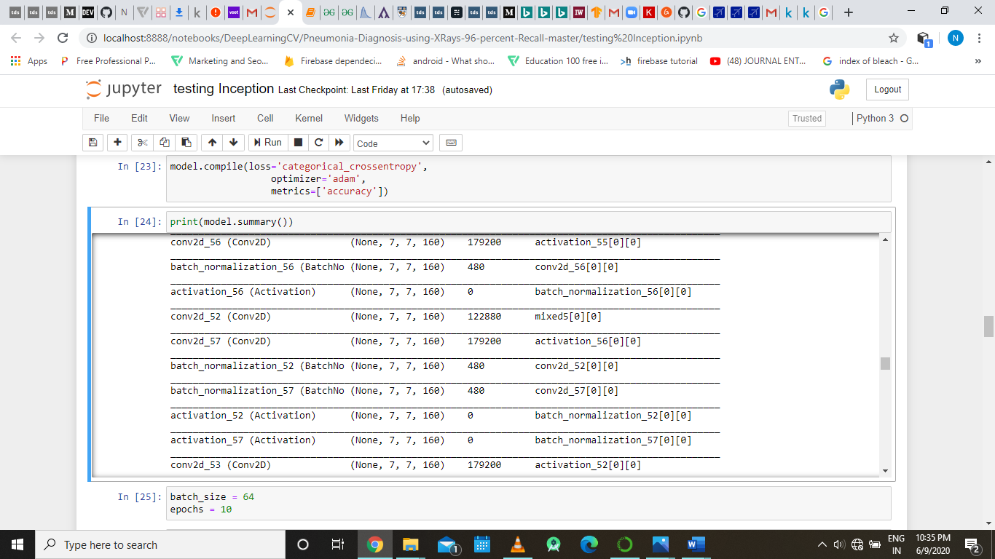

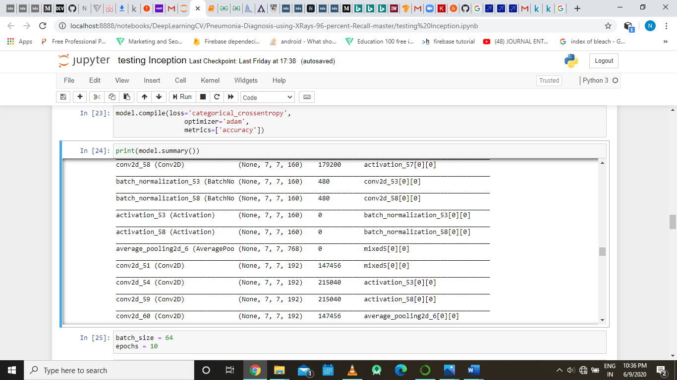

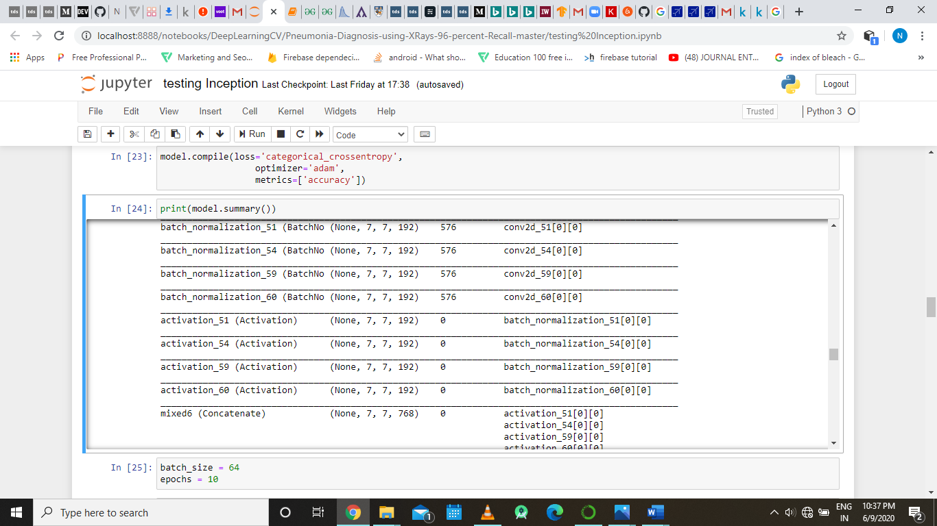

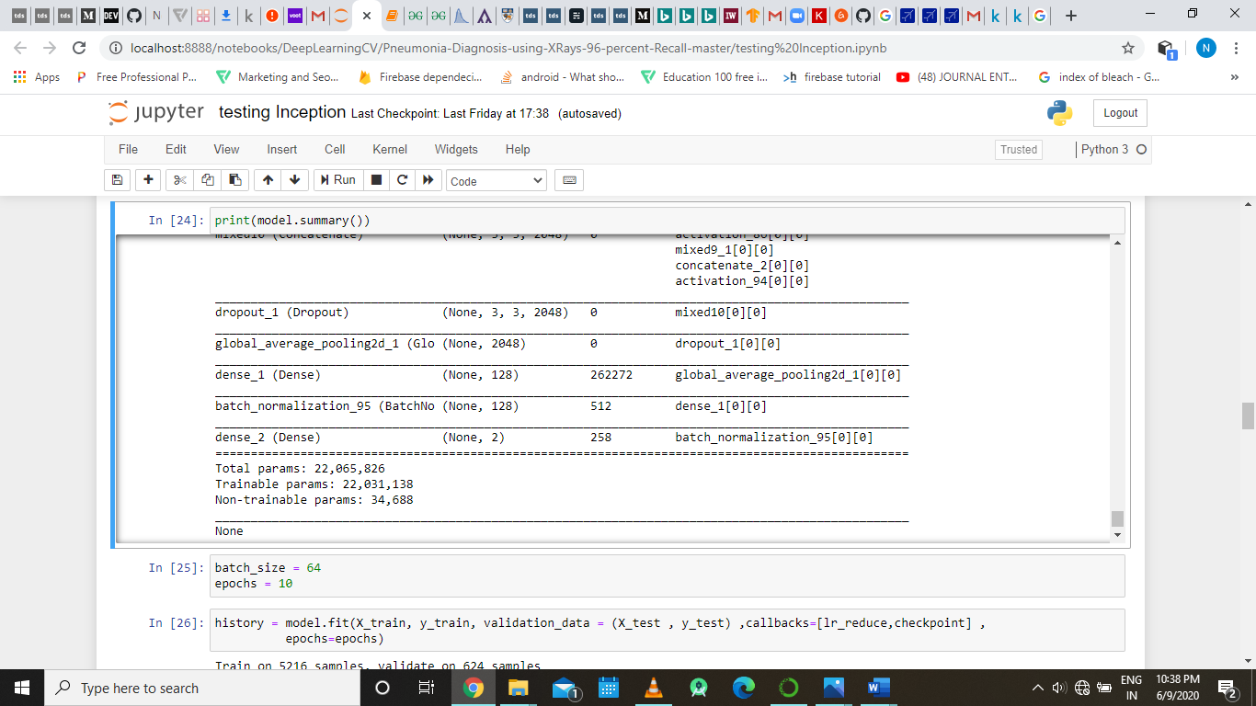

The above image is the partial output of model.summary()

**Part 11(Inception v3 Model):**

In this we will be training our inception v3 based convolutional neural network model

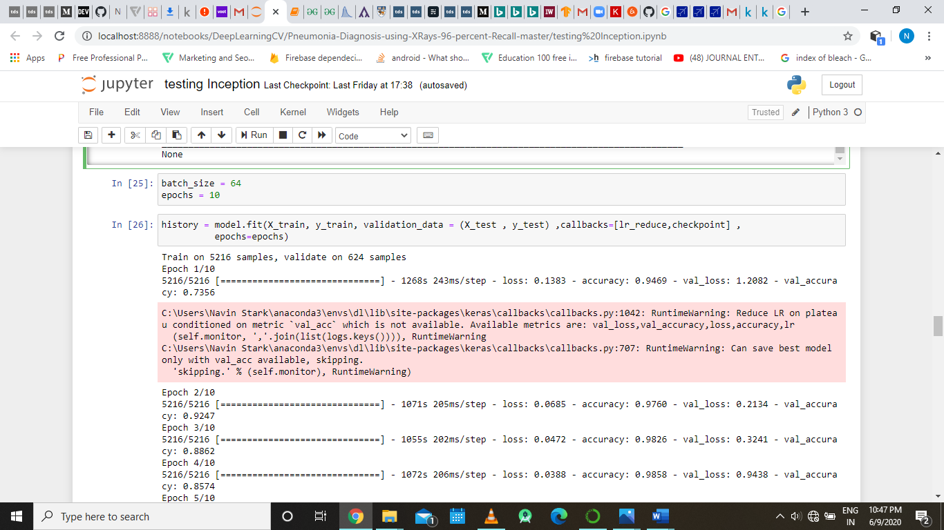

Here we declaring the batch size and epochs that we will be using in our inception model while we are training it.



Model.fit () is used to train model that we just created and the method takes taining data, training labels, validation data ,callbacks and epochs as it input parameters. Here in the callbacks part we are passing the two callbacks that we have defined in part 9 of the code, then is tarined model is passed to a variable called history that wil be used analyze the resultant accuracy.

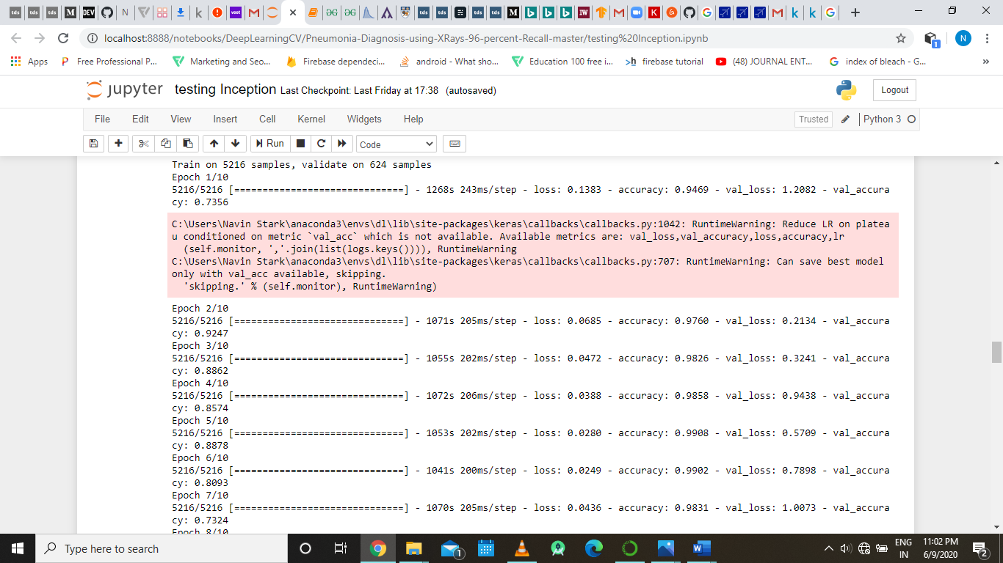

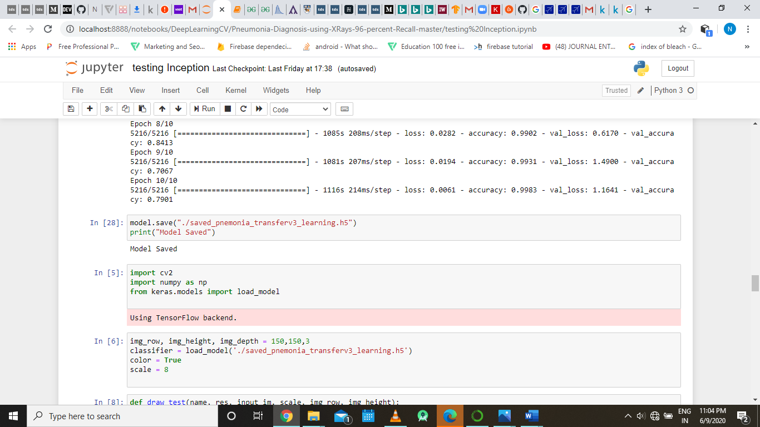

The above is the output of the line model.train(), we can also see the loss, accuracy, and validation accuracy and validation loss of the model over each ecpoch.

**4.2.2 Implementation of Coronavirus Detection Part For Mild Symptoms**

**Importing Libraries**

Importing a library means loading it into the memory. In order to import Pandas all we have to do is run the following code:

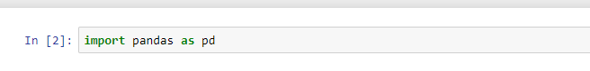

Usually we would add the second part (‘as pd’) so we can access Pandas with ‘pd.command’ instead of needing to write ‘pandas.command’ every time we need to use it.

**Pandas** is the most popular python library that is used for data analysis. It provides highly optimized performance with back-end source code.

**Reading Data**



CSV (comma-separated value) files are a common file format for transferring and storing data.

The basic process of loading data from a CSV file into a [**Pandas DataFrame**](https://pandas.pydata.org/pandas-docs/stable/generated/pandas.DataFrame.html) is achieved using the **“read_csv”** function in Pandas.

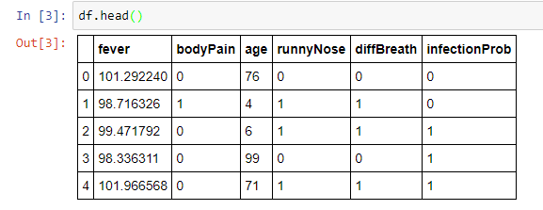

The head() function is used to get the first n rows. This function returns the first n rows for the object based on position. It is useful for quickly testing if our object has the right type of data in it.

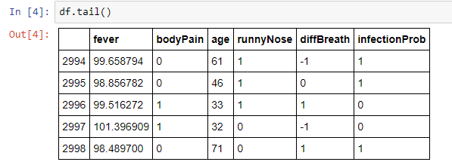

The tail() function is used to return the last n rows. This function returns last n rows from the object based on position. It is useful for quickly verifying data, for example, after sorting or appending rows.

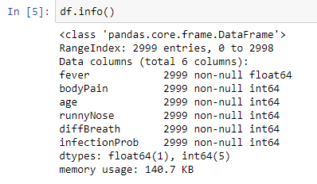

Print a concise summary of a DataFrame. This method prints information about a DataFrame including the index dtype and column dtypes, non-null values and memory usage.

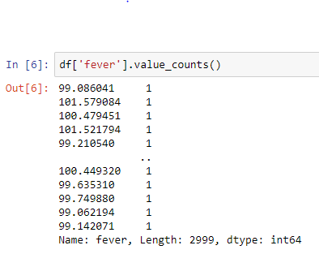

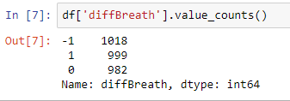

The value_counts() function is used to get a Series containing counts of unique values. The resulting object will be in descending order so that the first element is the most frequently-occurring element. It rxcludes “NA” values by default.

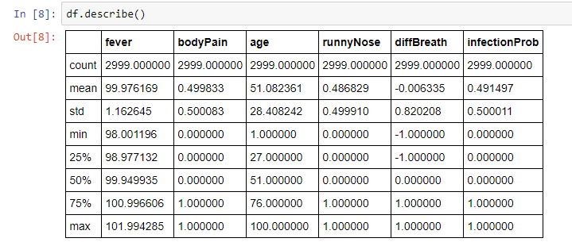

The describe() function is used to generate descriptive statistics that summarize the central tendency, dispersion and shape of a dataset’s distribution, excluding NaN values.

**Train Test Splitting**

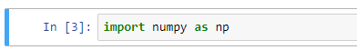

[Numpy](http://www.numpy.org/) is the core library for scientific computing in Python. It provides a high-performance multidimensional array object, and tools for working with these arrays.

The numpy package is bound to the local variable. The “import as” syntax simply allows us to bind the import to the local variable.

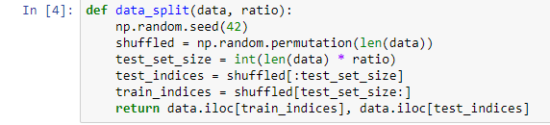

Here a function “data_split()” is created for splitting data into training and test data sets.

If we set the “np.random.seed(a_fixed_number)” every time we call the numpy's other random function, the result will be the same.

“np.random.permutation(len(data))” randomly permute a sequence, or return a permuted range. If *x* is a multi-dimensional array, it is only shuffled along its first index.

After this, dataset is splitted into train_indices and test_indices.

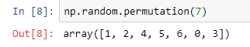

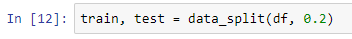

By using “data_split” function, we are splitting dataset into train and test data in the ratio “80::20”.

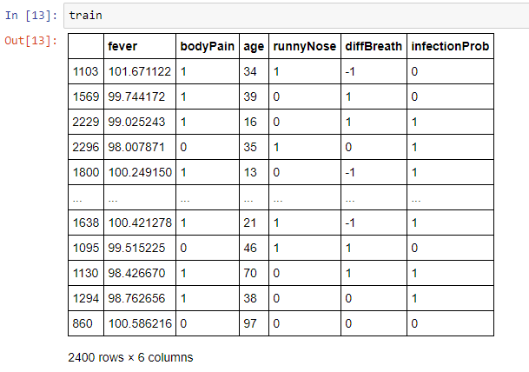

Visualizing training dataset.

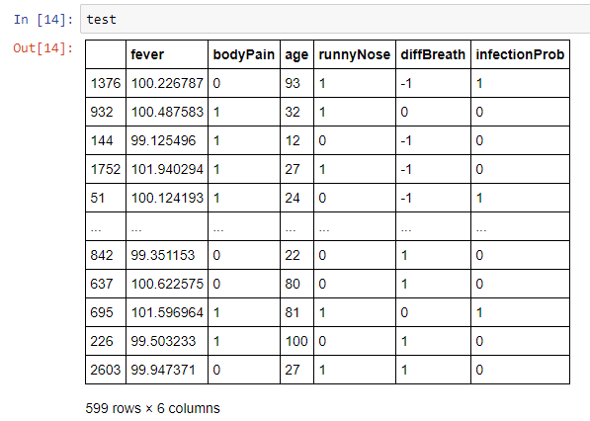

Visualizing test dataset.

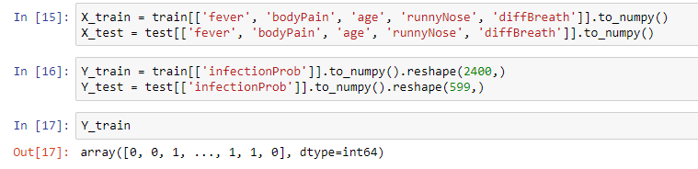

“DataFrame.to_numpy” converts the DataFrame to a NumPy array.

By default, the dtype of the returned array will be the common NumPy dtype of all types in the DataFram.

“numpy.reshape()” gives a new shape to an array without changing its data.



This class implements logistic regression. It is a machine learning classification algorithm that is used to predict the probability of a categorical dependent variable. In logistic regression, the dependent variable is a binary variable that contains data coded as 1 (yes, success, etc.) or 0 (no, failure, etc.). In other words, the logistic regression model predicts P(Y=1) as a function of X.

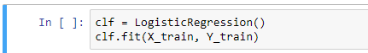

Here, we're "fitting" our training features and training labels. Now, our classifier is now trained.

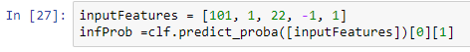

Here, we are taking random inputs in order to predict probability of infection.

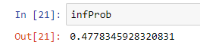

Visualizing Infection Probability.

CHAPTER 5

RESULTS AND DISCUSSIONS

**CHAPTER 5**

**Results & Discussions**

**5.1 Results of Coronavirus Detection Part for Severe Symptoms (Pneumonia detection)**

Here for the pneumonia part we have worked upon two different models one is a simple convolutional neural based on a hit and trail architecture and other convolutional neural network based on Inception v3 architecture her will be comapraing both the models based precision , recall and and f1 score which the generall use to measure the performance of neural network.

Before that we wil be giving you the brief description of the precision, recall and f1 score.

The formula for calculating [Precision and Recall](https://en.wikipedia.org/wiki/Precision_and_recall#Definition_(classification_context)) is as follows:

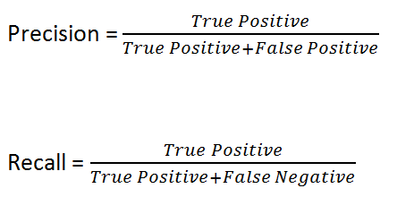

Let me put in the confusion matrix and its parts here.

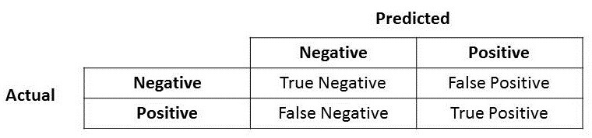

Precision is a good measure to determine, when the costs of False Positive is high. Recall calculates how many of the Actual Positives our model capture through labelling it as Positive (True Positive).

F1 which is a function of Precision and Recall, the formula is as follows:

F1 score is a better measure to use if we need to seek a balance between precision and recall and when there is uneven class distribution.

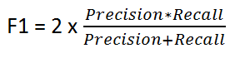

Here we will be comparing both the models with respect to their precision, recall and f1 score, but for that we have to first look at the confusion matrix of both the models that we have generated previously, the confusion matrix are as follows:

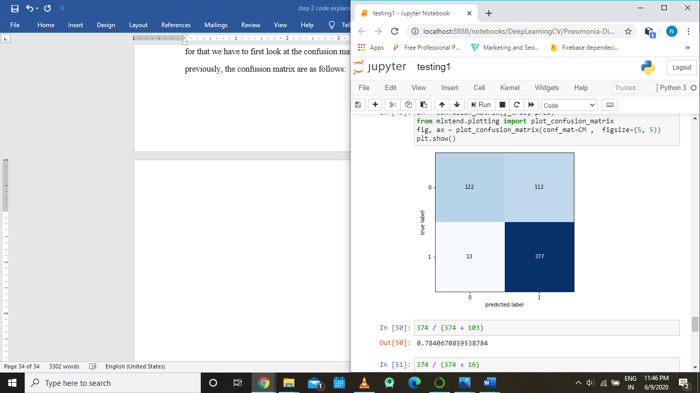

Fig: confusion matrix of normal convolution neural network model

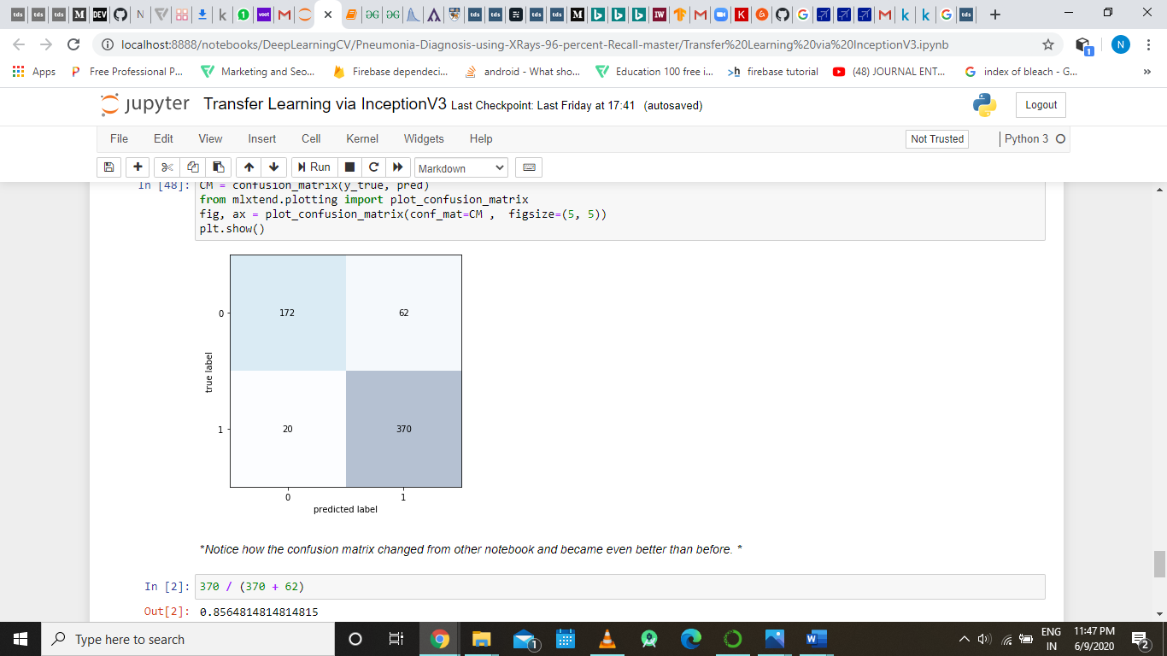

Fig : confusion matrix of convolution neural network implementing inception v3 architecture model

First we will be calculating the recall, precision and f1 score for the normal convolutional model

Precision = 374 / (374 + 112) = 0.7695473251028807

Recall = 374 / (374 + 1) = 0.9973333333333333

F1 score = 2*0.9973*0.7695 / (0.9973 + 0.7695) = 0.8687144555127915

Now we will be calculating the recall, precision and f1 score for the convolutional model implementing the inception v3 architecture:

Precision = 370 / (370 + 62) = 0.8564814814814815

Recall = 370 / (370 + 20) = 0.9487179487179487

F1 score = 2*0.9487*0.8564 / (0.9487 + 0.8564) = 0.9001902166084982

Clearly, the inception v3 architecture has better precision and f1 score as compared to the normal model, so we can conclude that inception v3 is a better model.

The point to be noted is that we developed a model that is able to

classify pneumonia affect chest xrays from normal unaffected chest xrays.





**5.2 Results of Coronavirus Detection Part For Mild Symptoms**

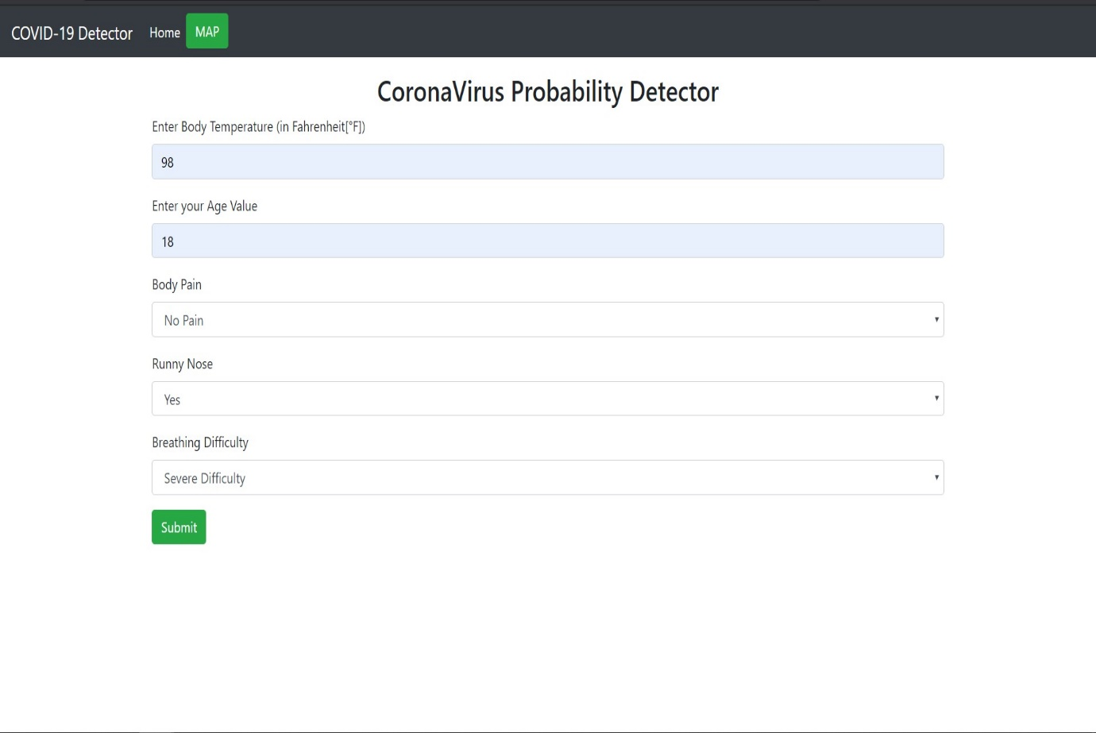

In our Corona Virus Probability Detector assistance, we will take random inputs i.e. Body Temperature = 98F, Age Value = 18, Body Pain = No Pain, Runny Nose = Yes and Breathing Difficulty = Severe Difficulty.

After submitting the inputs we will get output i.e.

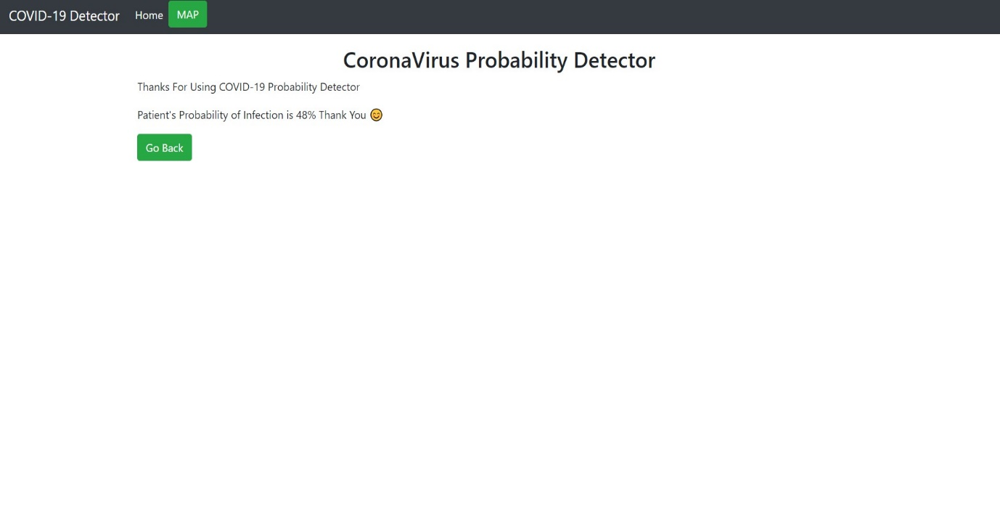

Here patient’s probability of infection is 48%.

By training the Database and importing the machine learning model into an HTML file with the Flask (web framework). Data to be randomly generated for this Prototype. We tested our model and the data and achieved 81% accuracy on the training set and 80% accuracy on the test set.

CHAPTER 6

INTERFACE

**CHAPTER 6**

**6.1 Interface**

For the interface of the project we wanted to create an application that could be accessible by the masses easily and with a very simple and intuitive user interface, considering the above three major and day to day information needs on coronavirus of a common person, we decided to build a android application that would provide all the essential information about the coronavirus and its daily updates about the number of cases in each state of India as well as the number of cases present in each country, as well as personalized starting home page for the user so that he can access all the information in one screen only.

Since we cannot host a machine learning model on android device and due to limitation of android devices, we hosted our machine learning models, that is the neural network model that we build for pneumonia detection and the coronavirus probability predictor, over a web application and also have provided its respective URL on the android application so that we can use those machine learning either from the android application or the web application according to our convenience.

**User interface and User Experience:**

UX design refers to the term “[user experience design](https://careerfoundry.com/en/blog/ux-design/what-is-user-experience-ux-design-everything-you-need-to-know-to-get-started/)”, while UI stands for “user interface design”. Both elements are crucial to a project/product and work closely together. But despite their professional relationship, the roles themselves are quite different, referring to very different aspects of the product development process and the design discipline. Before we consider the key differences between UX and UI, let’s first define what each term means individually.

**User experience (UX) design**

User experience design is a human-first way of designing products. Don Norman, a cognitive scientist and co-founder of the [Nielsen Norman Group Design Consultancy](https://www.nngroup.com/), is credited with coining the term “user experience” in the late 1990s.

UX Design encompasses any and all interactions between a potential or active customer and a company. As a scientific process it could be applied to anything; street lamps, cars, Ikea shelving and so on. However, despite being a scientific term, its use since inception has been almost entirely within digital fields; one reason for this being that the tech industry started blowing up around the time of the term’s invention.

Essentially, UX applies to anything that can be experienced—be it a website, a coffee machine, or a visit to the supermarket. The “user experience” part refers to the interaction between the user and a product or service. User experience design, then, considers all the different elements that shape this experience. A UX designer thinks about how the experience makes the user feel, and how easy it is for the user to accomplish their desired tasks. For example: How easy is the checkout process when shopping online? How easy is it for you to grip that vegetable peeler? Does your online banking app make it easy for you to manage your money? The ultimate purpose of UX design is to create easy, efficient, relevant, and all-round pleasant experiences for the user.

### **User interface (UI) design**

Despite it being an older and more practiced field, the question of “**What is user interface design?**” is difficult to answer because of its broad variety of misinterpretations. While user experience is a conglomeration of tasks focused on the optimization of a product for effective and enjoyable use, user interface design is its complement; the look and feel, the presentation and interactivity of a product.

 A user interface is the point of interaction between the user and a digital device or product—like the touchscreen on your smartphone, or the touchpad you use to select what kind of coffee you want from the coffee machine. In relation to websites and apps, UI design considers the look, feel, and interactivity of the product. It’s all about making sure that the user interface of a product is as intuitive as possible, and that means carefully considering each and every visual, interactive element the user might encounter. A UI designer will think about [icons and buttons](https://careerfoundry.com/en/blog/ui-design/icon-design-process/), [typography](https://careerfoundry.com/en/blog/ui-design/beginners-guide-to-typography/) and [color schemes](https://careerfoundry.com/en/blog/ui-design/introduction-to-color-theory-and-color-palettes/), spacing, imagery, and responsive design.

Like user experience design, user interface design is a multi-faceted and challenging role. It is responsible for the transference of a product’s development, research, content and layout into **an attractive, guiding and responsive experience for users.**

**UI and UX of the android app:**

**As we have discussed about user interface and user experience in our previous sub topic we also channeled our thought about the application in a similar keeping a distinction between UX and UI, first we focused upon the UX part of the application and the main goal of it was to produce an application that could easily understood by the masses and have hassle free experience with this inference we designed the following UI for the android application.**

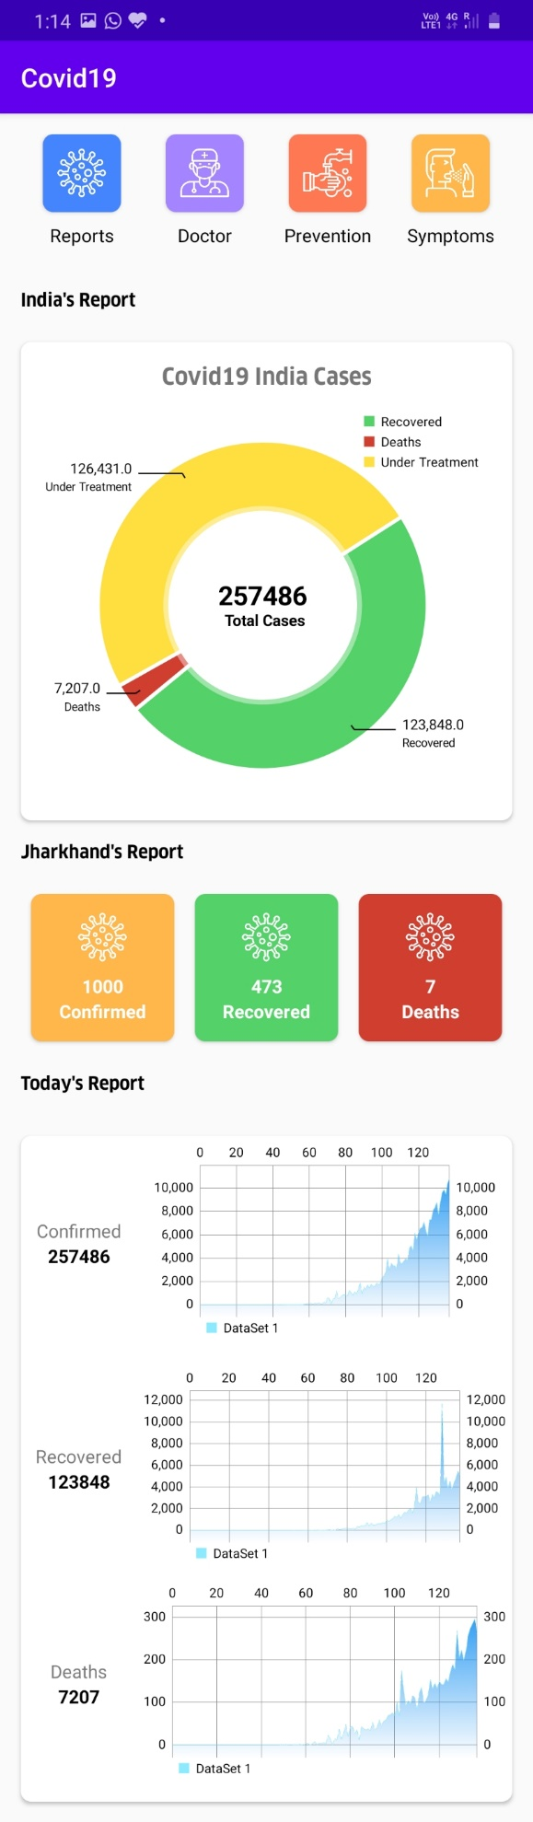

Fig: the customized home dashboard for the user

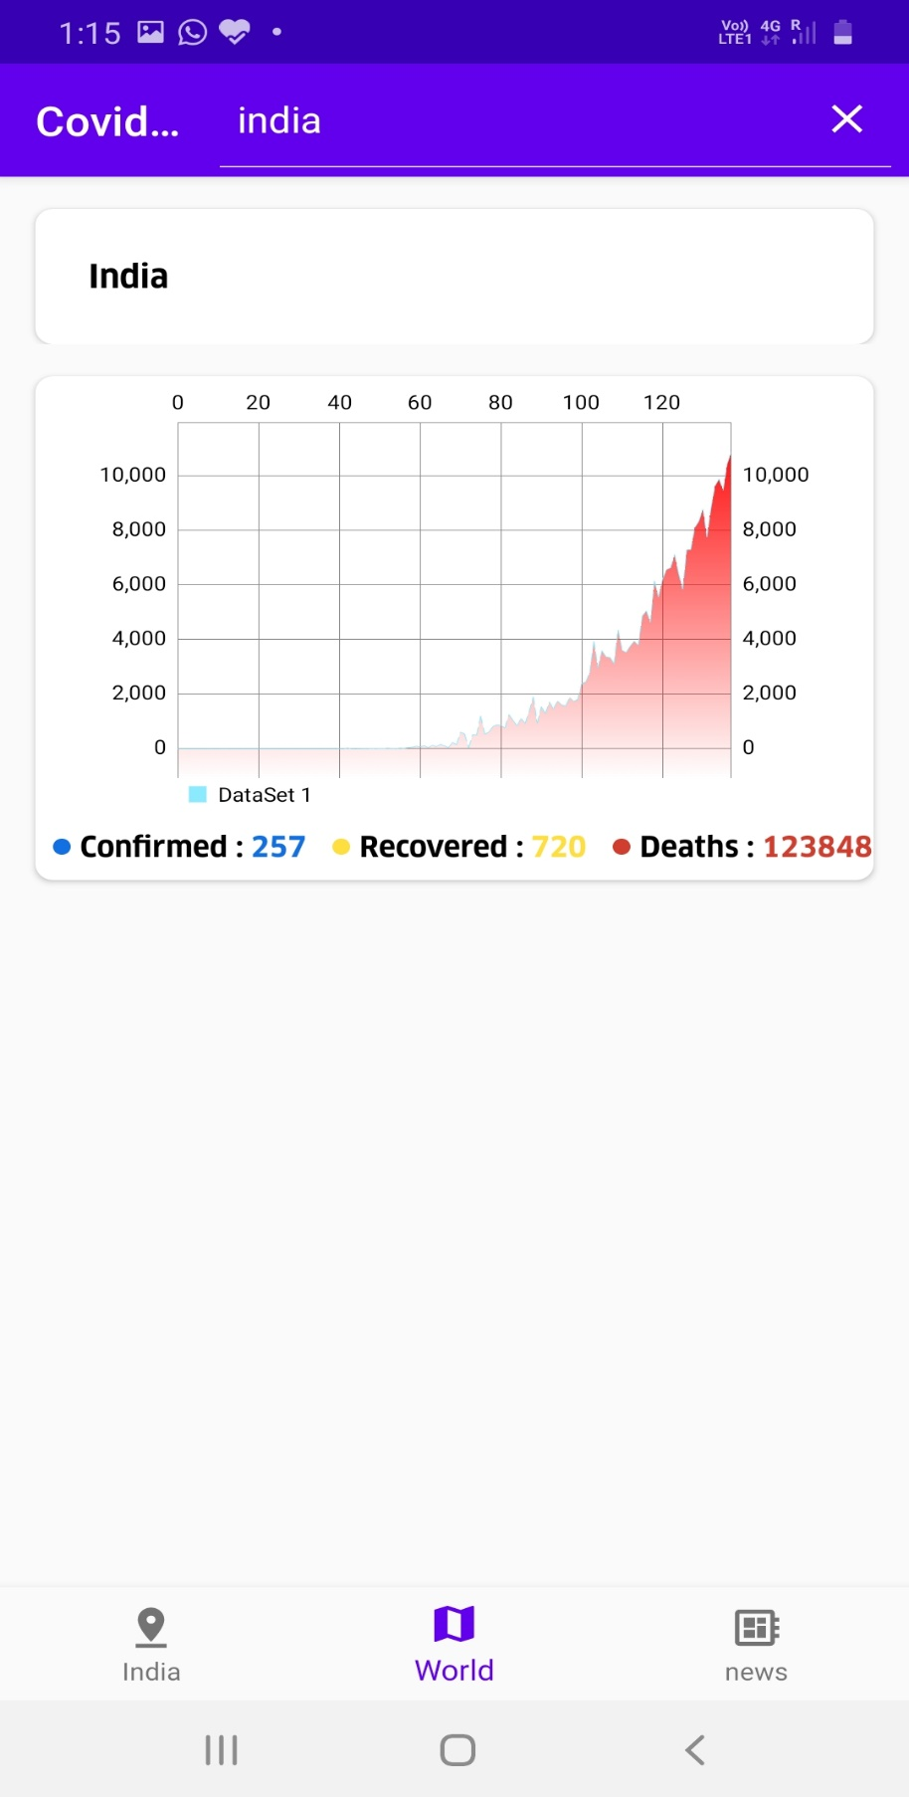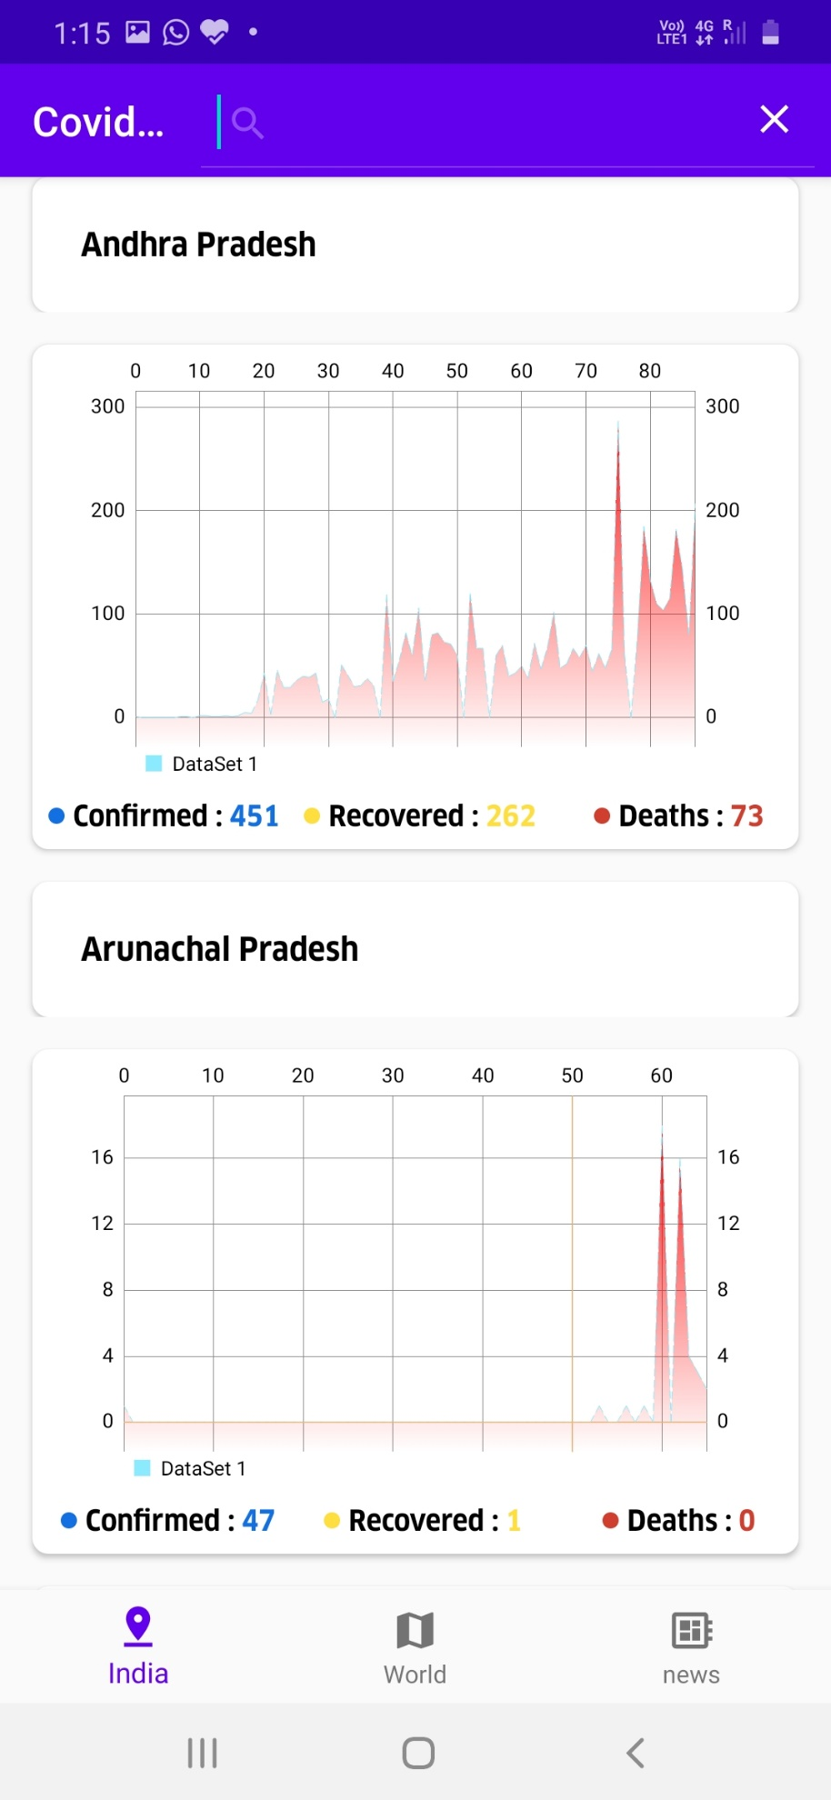

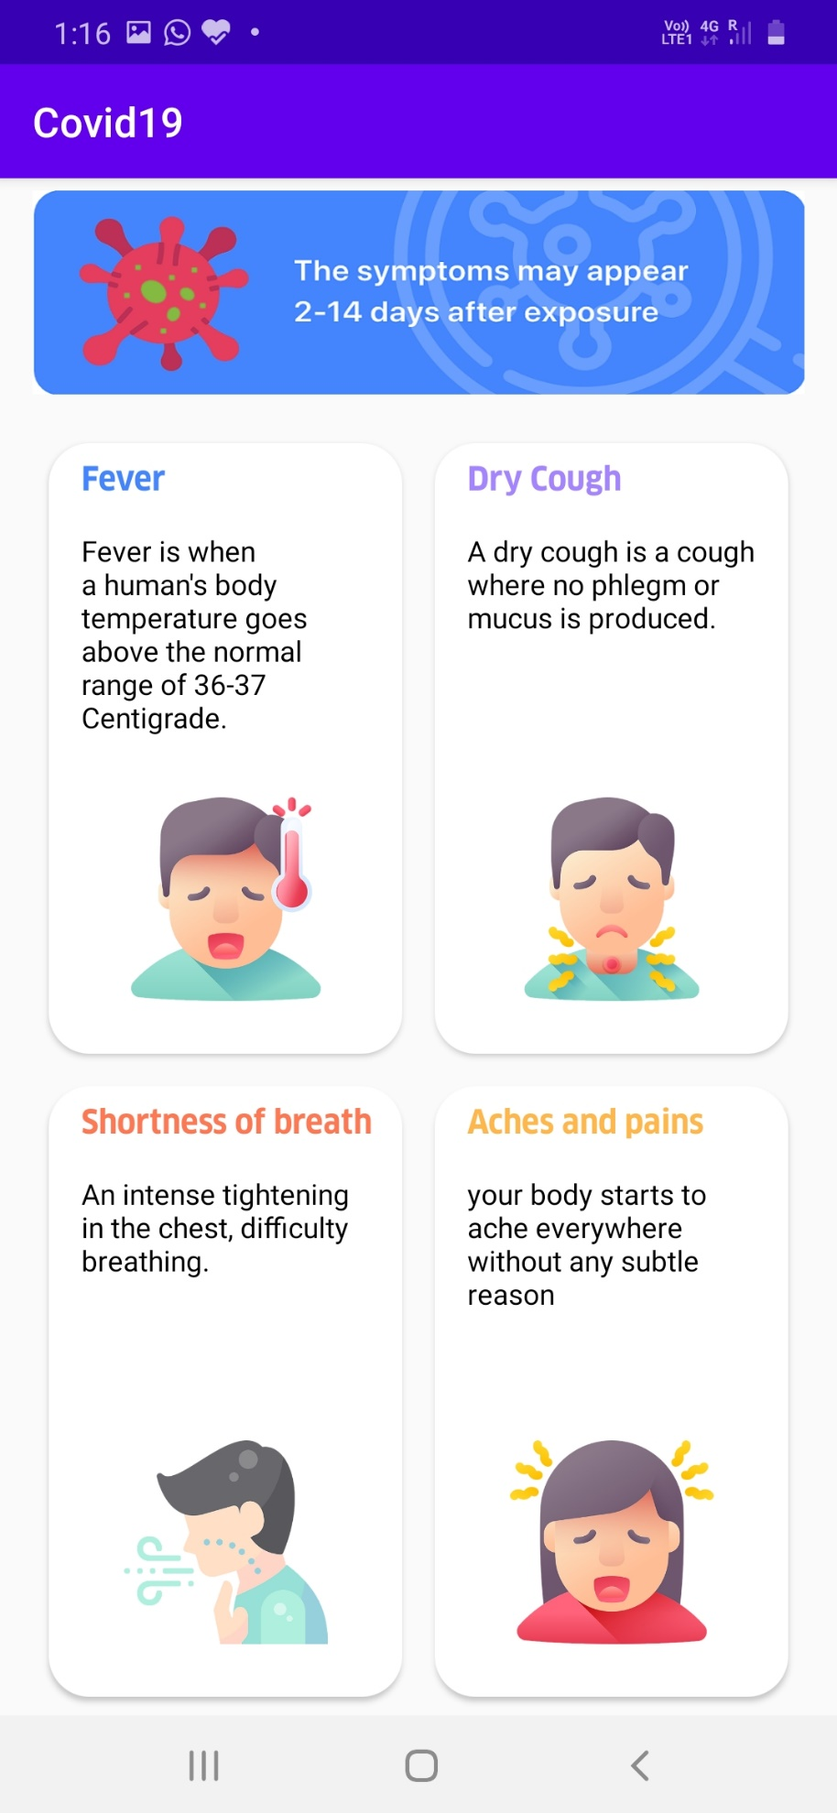

As we can see from the above design screenshot, we have basically designed an application that is capable of displaying complex data into human interpretable representation and also in a way that is ravishing to the eyes of the user.

The implementation of some important architectural elements of the above application is explained concept wise that has been used in the application development.

**Fragments**

**Fragments in this application are used for splaying the report of Indian states and countries of the world all in a single screen that is screen when you go after clicking on the reports button. Here the fragment are traversed over as bottom navigation bar.**Fragments are Android app components that represent a self-contained portion of user interface in an activity. We can refer them as mini activities.

Fragments are reusable, modular and can be dynamically changed at runtime. They can help us build responsive and flexible layouts. Fragments are reusable pieces of UI, similar to a layout or viewGroup, and can be arranged differently based on screen size.

They commonly used to create single-pane and multi-pane layouts, depends on what looks better on our given screen size (Ex: Gmail app in phone and tablet).

The layout can change based on the screen size, and it’s best to use fragments to define each layout and make the best use of the screen space to make our app user friendly.

This is a common pattern which called the master/detail flow. The master lists of items will take up an entire phone screen but only the left portion of a tablet screen. The detailed content pane will take up the entire phone screen as a separate activity but only the right portion of a larger tablet screen.

The power of using fragments is that they allow us to fully modularize our activities. We can combine multiple fragments in a single activity to build a multi-pane UI, like on a tablet. We can also reuse a single fragment in multiple activities.

Fragment has its own life cycle. It can receive its own user input events like clicks and swipes. We can dynamically add or remove them while the activity is running.

Activities are meant to be in separate screens and not embedded within one another, that’s why we use fragments, which are designed to be placed alone or in groups within a single activity. Fragments must always be embedded within activity and the fragment’s life cycle is directly affected by the activity’s life cycle.

When the activity moves through its life cycle callbacks, so does the fragments they contains.

In most cases, we can move any functionality from the activity lifecycle callbacks to their corresponding callback inside a fragment.

There are some differences — Fragment have additional lifecycle callbacks that allow them to be created or removed in an activity at runtime:  
(1) Fragment use onCreateView() in addition to onCreate(). OnCreateView() is where a fragment inflates its UI, hooks up any data sources it needs, and then returns the created view to the host activity.  
(2) There is also a corresponding onDestroyView() callback that can be called before the activity is destroyed.

With these additional callbacks, the fragment can cycle through its whole life cycle multiple times while its activity is running.

In the application the Report activity consists of fragments IndiaReport Fragment and worldReport fragment which is displayed in the below project structure.

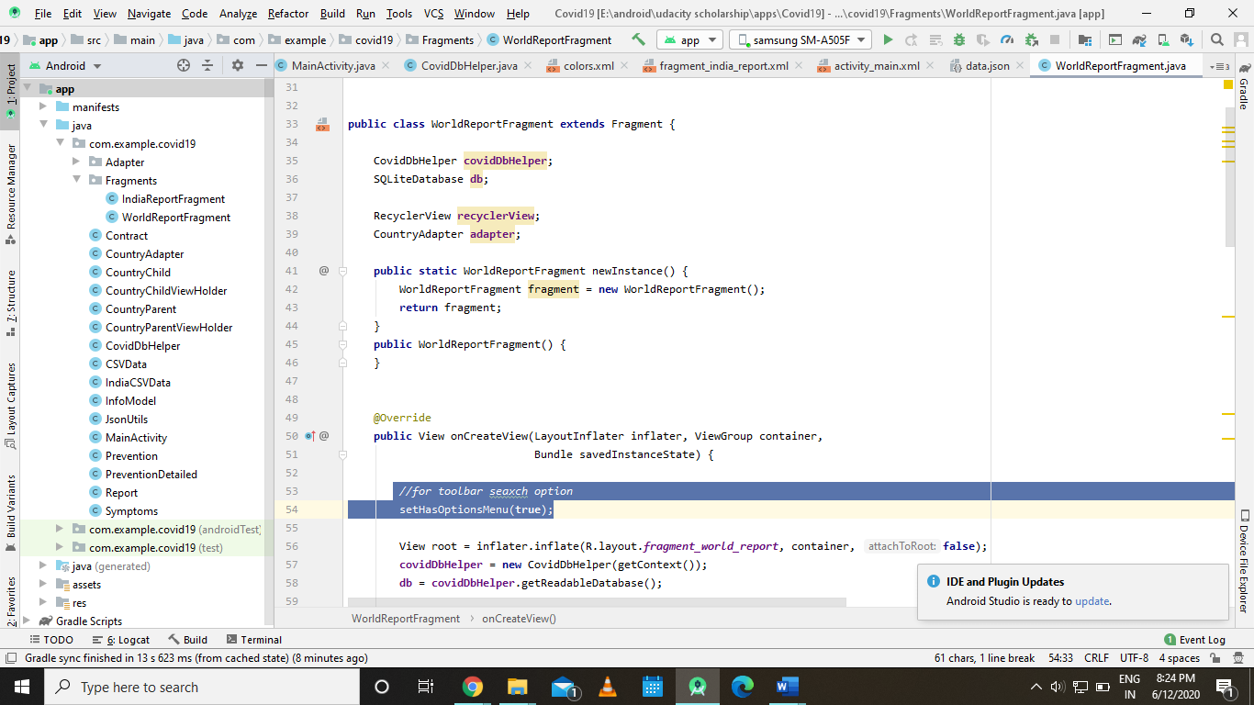

**Steps to dynamically display a fragment**  
(1) Create a layout that defines the appearance of the fragment  
(2) Create a new fragment class that inflates the layout  
(3) Create a new fragment instance in a host activity  
(4) Add the fragment to it’s host activity using the FragmentManager and a fragment transaction

**FragmentManager and transactions**Android uses the FragmentManager to create or swap out fragments.

The FragmentManager class provides methods that allow to add, remove and replace fragments in ac activity at runtime.

Add, Remove and Replace are all types of fragment transactions. These transactions let you create a dynamic experience and help efficiently add and remove fragments without you have to worry about the finer details of memory management.

An important rule when dealing with dynamically adding or removing fragments while an activity is running is that our activity layout must include a fragment container in which you can add each fragment, which is often an empty FrameLayout. The container is responsible for defining the size and placement of a fragment, since the fragment doesn’t have to take up the entire screen like an activity.

When we add or replace a fragment at runtime, we need to tell the fragment transaction the container to place the updated fragment in. Containers are needed if we plan on performing fragment transactions.

The only case we won’t need a fragment container is when we know our fragment will remain static, which means it won’t change during runtime. Then it will not need a container layout because a static fragment size, content and location can be defined and will stay the same for the duration of an activity. In this case we can place the fragment in a layout using the <fragment> tag instead of a transaction. The <fragment> should have a name, width and height. The name of the fragment should point to the type of fragment we want to be.

To get our FragmentManager we need to call getSupportFragmentManager(). This gives as a fragment manager using the support library APIs. The manager is responsible for starting and completing fragment transactions. When we ready to complete the transaction we must call commit().

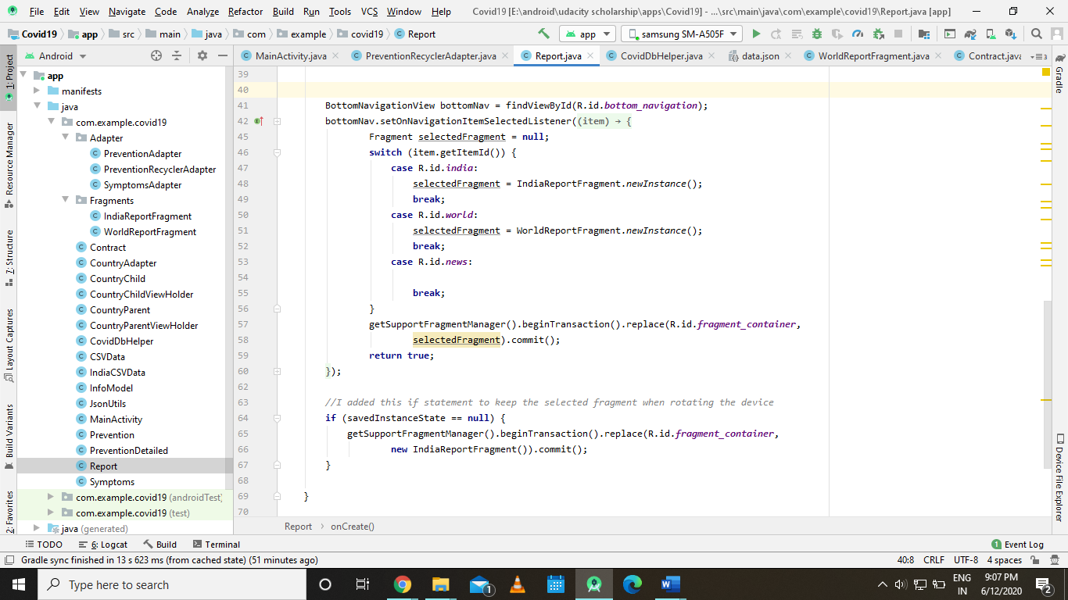

Fig: snippet of the fragment manager that we have used in our application

**SQLite**

**In our application the data is taken from a csv file and that is cached using the SQLite databases that is used for faster and easier retrieval of information**

Android stores its persistent data in the file system. These files can be stored in internal/external storage that is private to your app. It provides 2 functional layers on top of the file system in the form of SharedPreferences and SQLite.  
  
SQLite is a relational database which store and organize information in tables. Each row being the data record and each column is the data field. We need to think of which tables and columns we need to represent our app data.  
  
We can Create/Read/Update/Delete (CRUD) data.  
  
Any operation in an SQL database is executed using SQL queries.

**Creating the contract**Contract is what both sides agree on before they move forward. In Android, is important to define in the very beginning what your database design (structure) would look like.  
  
We can use the contract to tell any information we need about the database.  
  
The contract in Android is a clause that defines the tables and their columns.  
  
We should never need to create an instance of the contract class because the contract is simply just a class filled with DB related constants that are all static, so the constructor should be always defined as private.  
  
Inner classes inside the contract defines the table contents and may implement BaseColumns which automatically created the _ID column, a constant representing the primary key field. Some android adapters will expect your contract to have this constant defined. It’s not always required to implement BaseColumns but that can help your database fit in better with the Android framework.

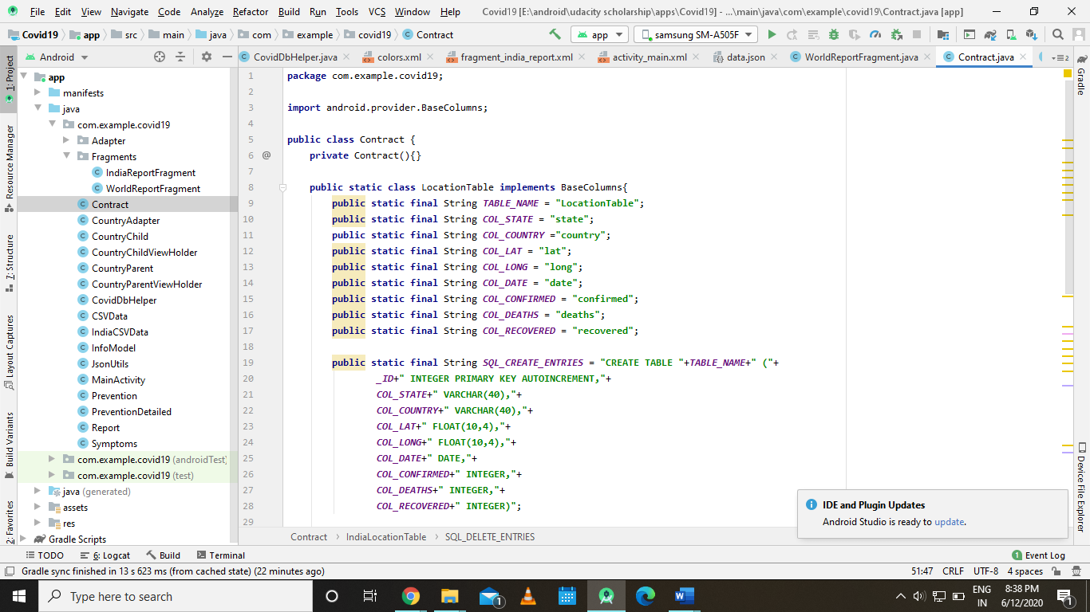

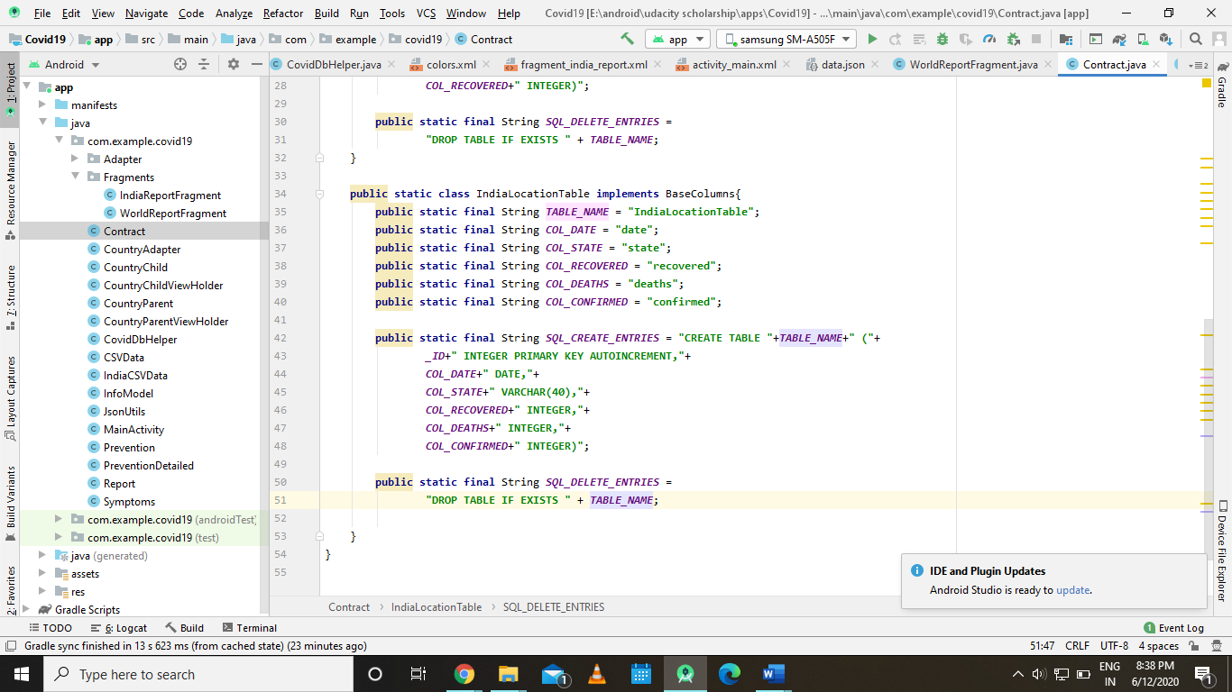

Fig: the above two images show the contract class of our application

I have defined two tables in our contract class. The location table contains the data about countries and the India Location Table contains the information of the states, and table’s respective columns datatypes are also defined in the contract class.

**Creating the database**

The contract is not the actual database, and we need to create it.To do that we need to create a new class called DB Helper which will extend SQLiteOpenHelper.  
  
SQLiteOpenHelper exists mainly to take care of creating the database for the first time and upgrading it when the schema changes.  
  
DB Helper also provides other classes with a reference to the database, giving them a way to access it’s information through queries.  
  
SQLiteOpenHelper provides us with two important methods we need to override:  
(1) onCreate — onCreate is responsible for creating the actual database for the first time.  
(2) onUpgrade — onUpgrade is responsible to making sure the database schema is up to date.  
  
In the file we need to define two constants:  
(1) DATABASE_NAME, a String, ends with “.db” that will be the name of the local file on the Android device that will store all our data.  
(2) DATABASE_VERSION, an int, stores the current database storage number, which will be first set to 1 and will be manually increased everytime we change our db scheme. It use to force users to upgrade their databases whenever we release a new version of our app.  
  
The constructor don’t do anything special here so we can just call its parent by using super and passing the database name and the database version.  
  
We need to override the onCreate() method that will actually create the database file when called. We do it in two steps:

(1) Writing the SQL statement that will describe the database schema, while following the contract we created. An SQL create table statement starts with “CREATE TABLE “ followed by the table name and the table description from the contract. That is a comma separated list of each column name followed by its type, all in a set of parentheses — “(“. The _ID column is set as “INTEGER PRIMARY KEY AUTOINCREMENT”. The other fields might be described as “NOT NULL”. If we want to use a timestamp, it will be described as “TIMESTAMP DEFAULT CURRENT_TIMESTAMP”, which means the SQL database system will automatically assign the current time any time a new row is added. The statement will be ended by a closing parentheses sign and a semicolon “)”. All names of the table and fields taken from the contract so we can update only the contract when needed.

(2) Execute the query by calling db.execSQL(NAME_OF_THE_STATEMENT); to create the database.  
  
We need to override the onUpgrade() method as well. This method being called only when the database version number becomes larger than the version number of the database on the device. It’s meant to update the database schema without losing any user data.  
  
Since we only have one version so far all we need to do is to drop the current database , if exists, and create a new one — “DROP TABLE IF EXISTS <TABLE_NAME>” — call onCreate() with the name of the database.  
  
But in case we just adding a new column to the contract we don’t need to drop the actual database just implement more code on onUpgrade() with an SQL statement that would append that column to the database without having to drop it.

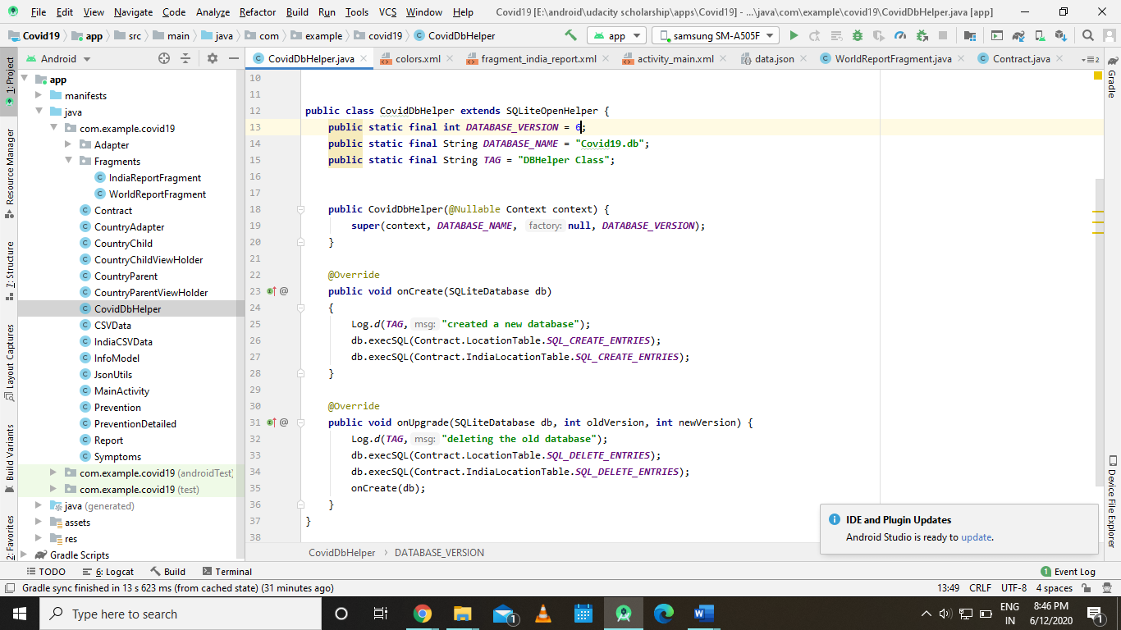

Fig: the DBbhelper class that we have used in our application

**Using a cursor and updating the adapter**A result of any selection query is formed as a table, if you select everything from the database table, the result table is identical to that table.  
  
We can think of the cursor as if it’s pointing to a particular row in that result.  
  
To extract information from a particular row, you can move the cursor to point there, and then extract the specific goal information. We can do it by moving the cursor to a particular row and calling getString passing in the index of that column.  
  
We do it in the onBindViewHolder() method in the adapter. First, we will move the cursor to the current binding position using movetoposition() method on the cursor. It will return false if there’s no data there, or if it’s out of the bounds of the cursor we should exit the onBindViewHolder() method in that case.

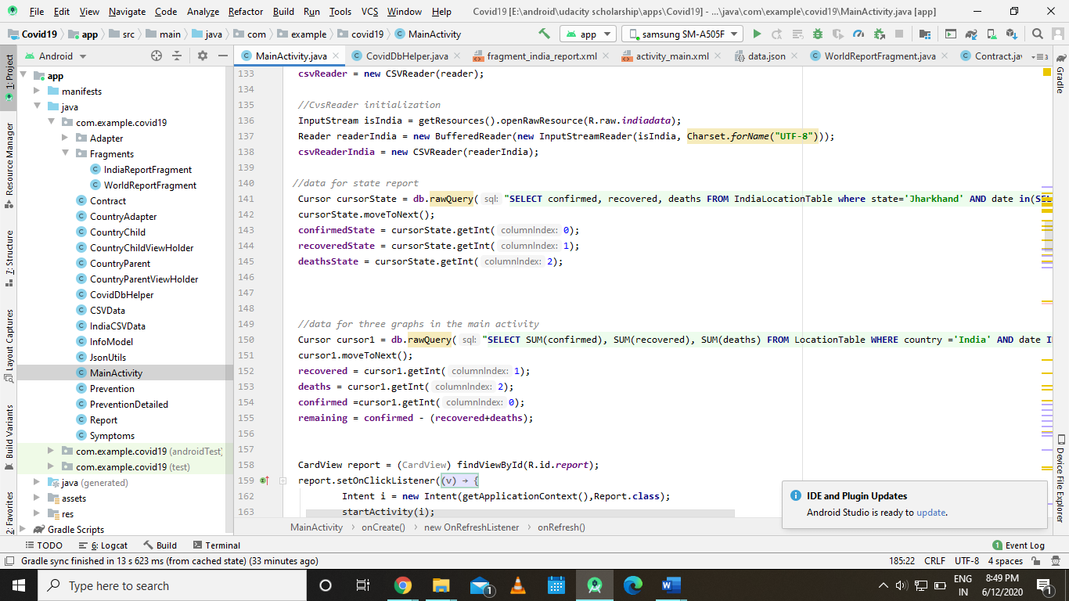

Fig: one of instance where I have used the cursor object for data retrieval

# **RecyclerView**

We have used the recycler views to shoe our data in the form of a list there two recycler view used in our application one is used to shoe the list of states and other used to show the list of countries and the both are present in each fragment of the report activity.

RecyclerView is a list drawing library that essentially provides a fixed-size window to load a large dataset into. It recycles the views it created at the beginning when the views go out of scope (window) and then if there is a need, reuses them to make it seem as if the views were never offloaded and were virtually present outside the window. See the three windows below? All three are having a RecyclerView in them.

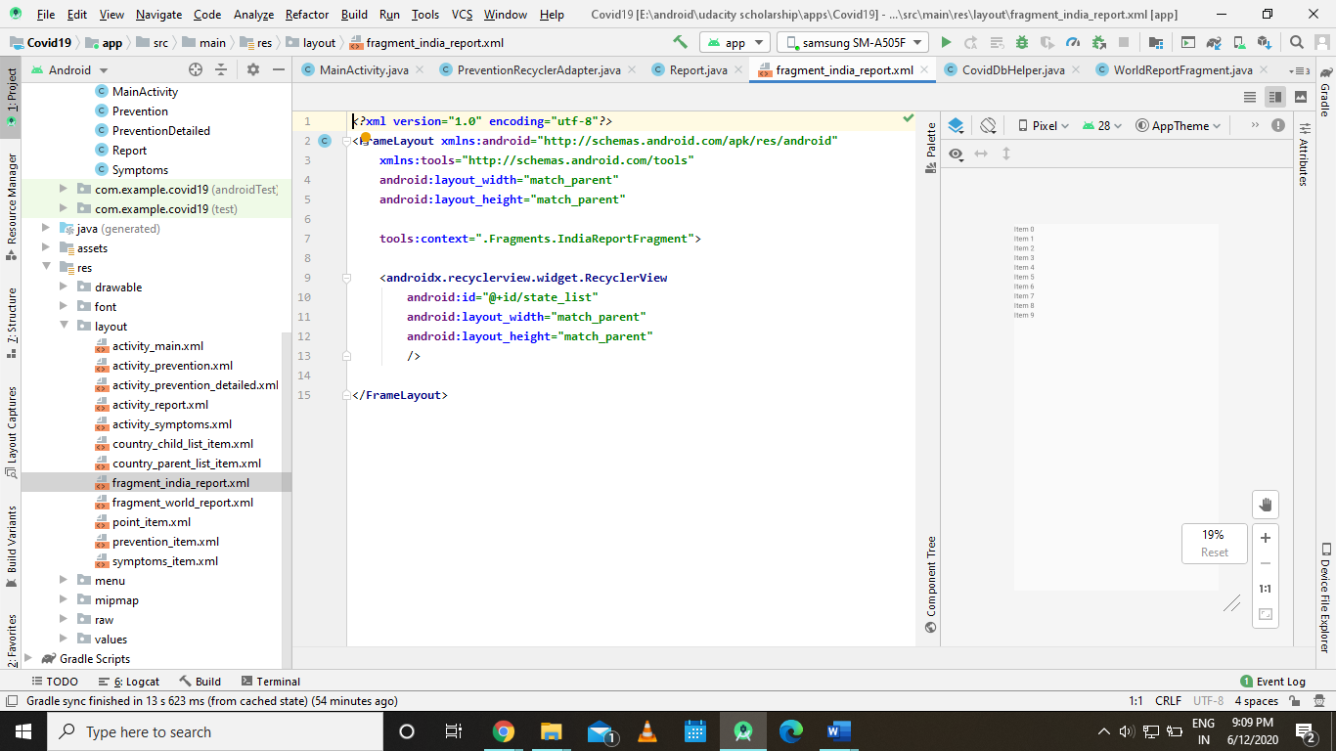

Fig: snippet of the code where have used a recycler view

# **Recycler Adapter**

The most important part of the whole RecyclerView architecture. A RecyclerView adapter just like any other adapter has the responsibility to bind datasets to Views that will be displayed in the window. A general adapter, essentially, is just an iterator that gets its limit from **getCount()** that generally depends on the size of the dataset and creates new views and binds data to them from that very dataset. ListView or ViewPager uses this kind of adapter. RecyclerView on the other hand uses a more complex system to bind data and handle views.

RecyclerView makes use of ViewHolders by default. So, the Recycler Adapter instead of creating Views, creates ViewHolders that hold the inflated views. Once created the ViewHolder is put in the cache and can be reused if required.

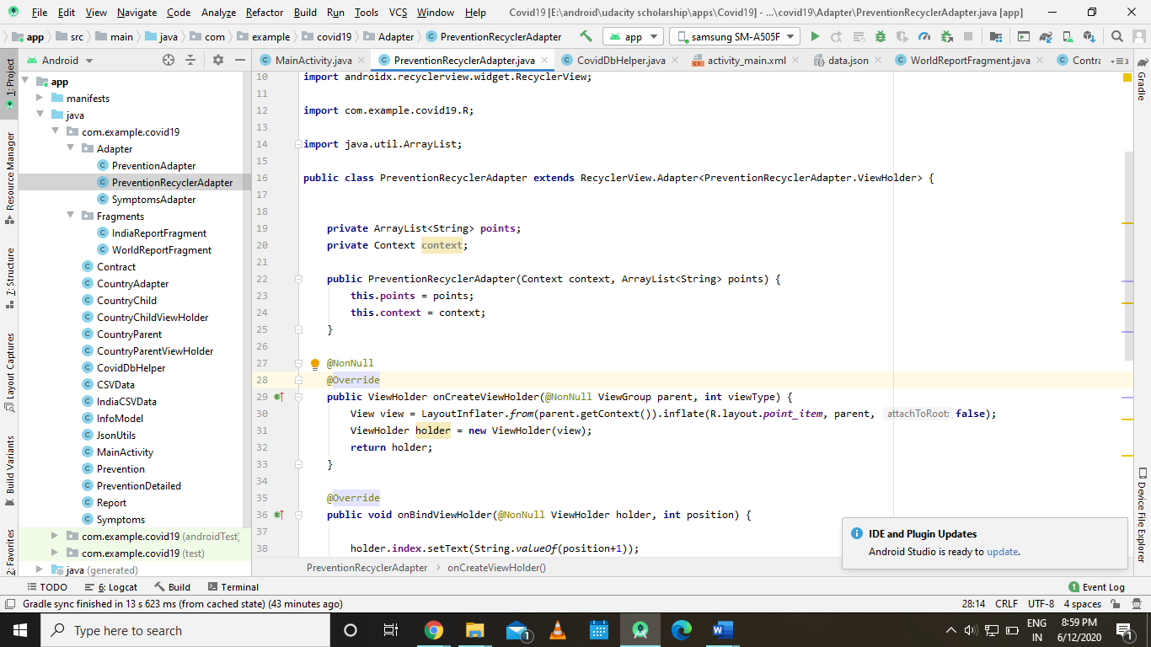

Fig: the above figure shows the view holder that we have created with a sample view holder taken from our application

**UI and UX of web application**

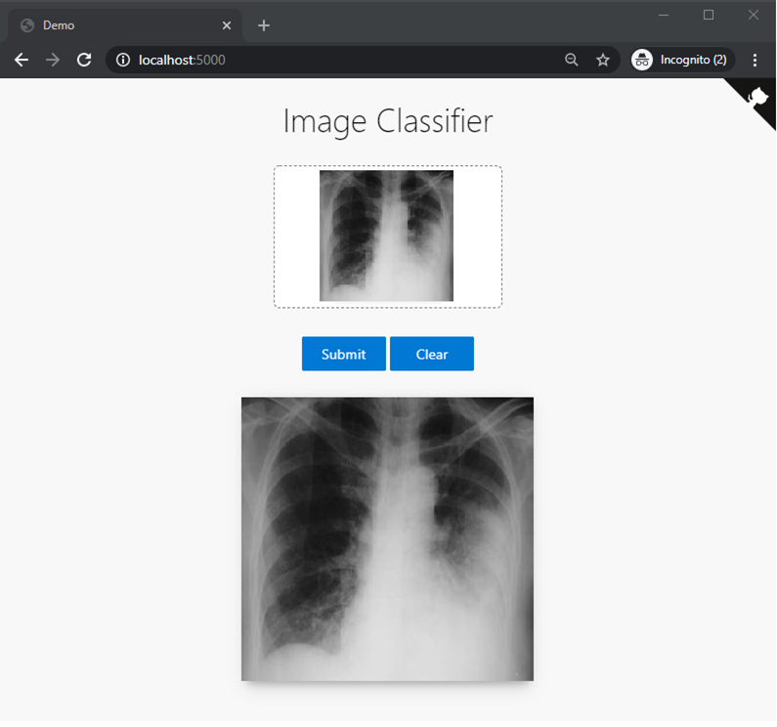

Chest X-ray Image taken as input to predict whether the person has pneumonia

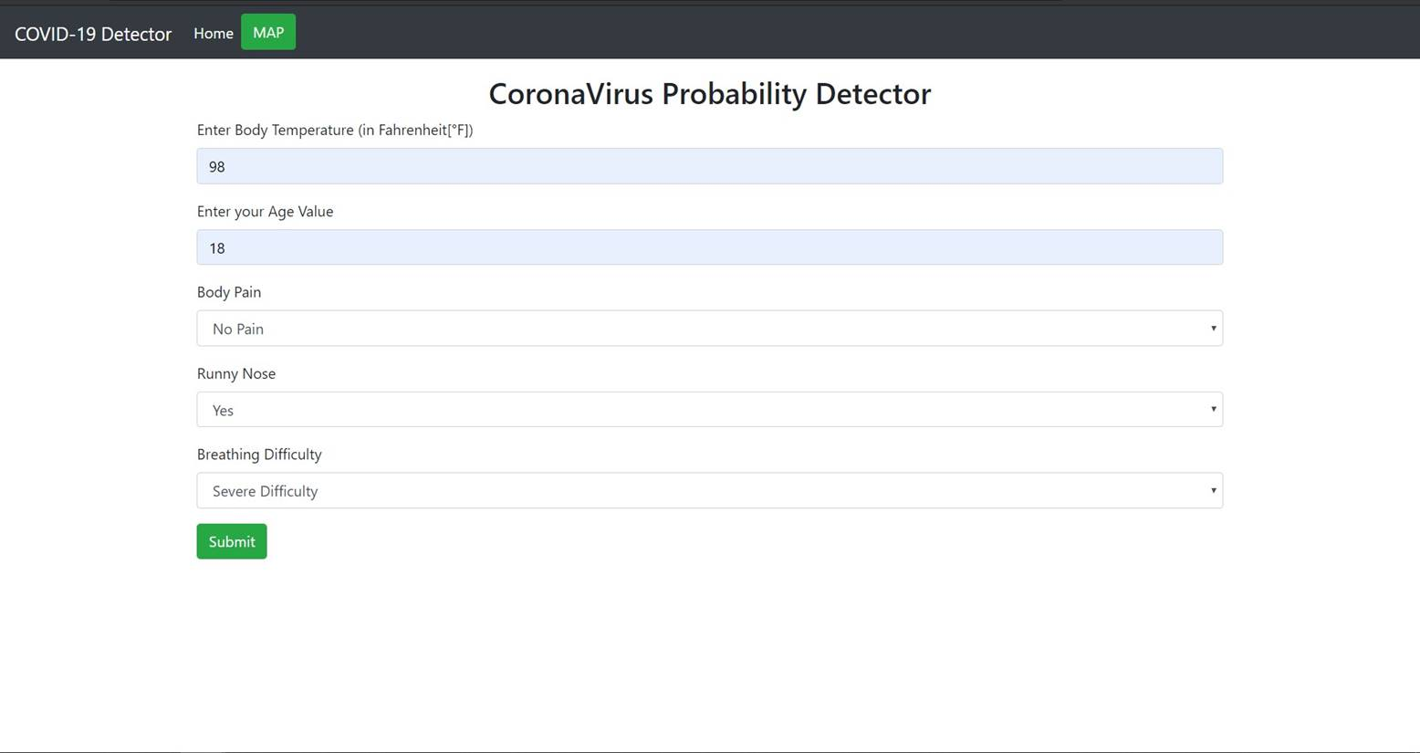

Symptoms taken as input to check the probability of the person having corona

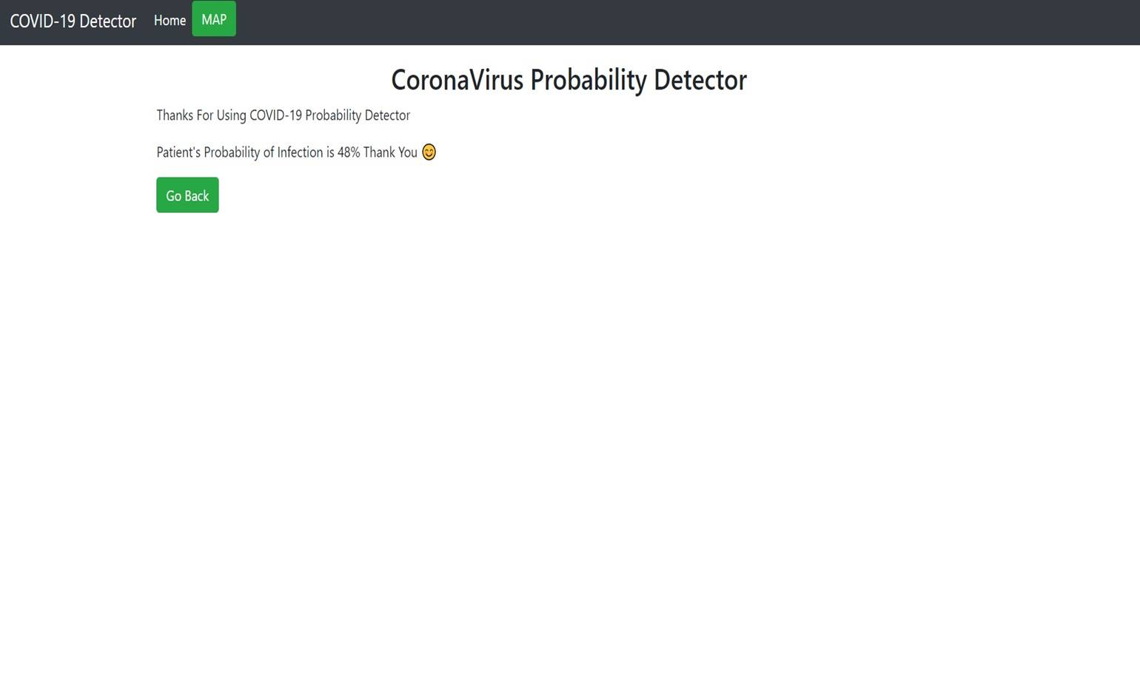

Output probability showing the chances of the person having corona.



**Flask**

**Overview**

Flask is a web application framework written in Python. It is developed by Armin Ronacher, who leads an international group of Python enthusiasts named Pocco. Flask is based on the Werkzeug WSGI toolkit and Jinja2 template engine. Both are Pocco projects.

* Flask is a lightweight **WSGI** web application framework.
* It is designed to make getting started quick and easy, with the ability to scale up to complex applications.
* It began as a simple wrapper around **Werkzeug** and **Jinja** and has become one of the most popular Python web application frameworks.

To get the idea about flask we have to understand the following terms:-

* WSGI Web Server Gateway Interface (WSGI) has been adopted as a standard for Python web application development. WSGI is a specification for a universal interface between the web server and the web applications.
* Werkzeug It is a WSGI toolkit, which implements requests, response objects, and other utility functions. This enables building a web framework on top of it. The Flask framework uses Werkzeug as one of its bases.
* jinja2 is a popular templating engine for Python. A web templating system combines a template with a certain data source to render dynamic web pages.

**Installation:**

We will require two packages to setup your environment. Virtualenv for a user to create multiple Python environments side-by-side. Thereby, it can avoid compatibility issues between the different versions of the libraries and the next will be Flask itself.

1. Virtualenv

Command- pip install virtualenv

2. Flask

Command- pip install Flask

**HTTP methods**

Http protocol is the foundation of data communication in World Wide Web. By default, the Flask route responds to the GET requests. However, this preference can be altered by providing methods argument to route() decorator.

**Templates**

* Flask supports Jinja2 as its template engine.
* Flask facilitates us to return the response in the form of HTML templates.
* Flask facilitates us to render the external HTML file instead of coding the HTML in the view function. Flask provides us the render_template() function which can be used to render the external HTML file to be returned as the response from the view function.

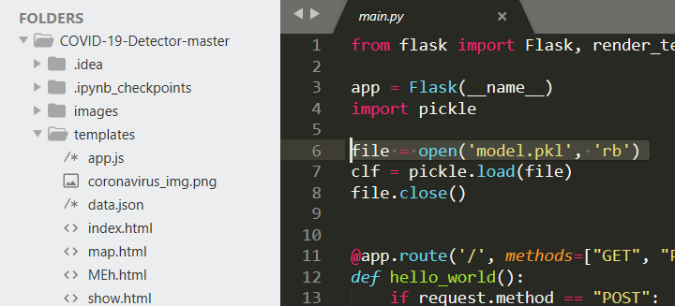

We must create a ***templates*** folder in the application directory which contain all the html files. When flask uses the render_template() function, all the files are searched and executed from the templates folder. As in our case we can see the above image that the templates folder contains all the html files.

**HTML**

* HTML stands for Hyper Text Markup Language
* HTML is the standard markup language for creating Web pages
* HTML describes the structure and makes the basic skeletal of a Web page
* HTML consists of a series of elements that starts and ends with html tags.
* HTML elements tell the browser how to display the content
* HTML elements label pieces of content such as "this is a heading", "this is a paragraph", "this is a link", etc.

**CODE**

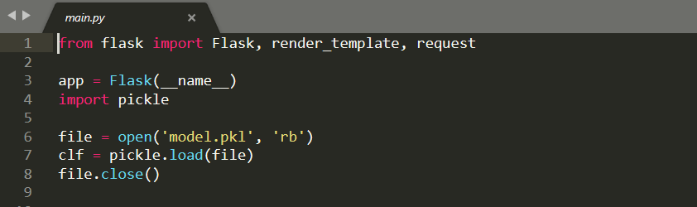

**In line 1-8**

* First we import the Flask class. An instance of this class will be our WSGI application.
* Next we create an instance of this class with the name app. The first argument is the name of the application’s module or package. We used ( __name__) because depending on if it’s started as application or imported as module the name will be different. This is needed so that Flask knows where to look for templates, static files, and so on.
* We import the pickle module. The pickle module implements binary protocols for serializing and de-serializing a Python object structure.
* The model which we have created is saved to a file ‘*model.pkl’*. We open that file to load. We load or assign the file into new object called *‘clf’* and then close the open file.

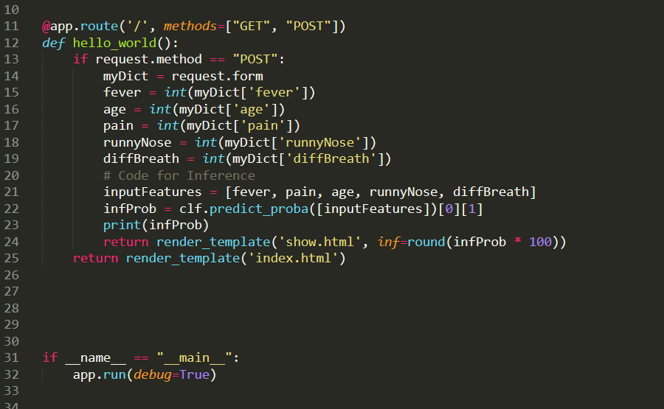

**In line 11-25**

* We then use the route() decorator which tells Flask what URL should trigger our function. This route is basically what we type in our browsers to got different pages. The forward slash (‘/’) inside the route is for our root page or considered as the homepage. The methods indicate the http methods used by the route() decorator. In this case we have used the ‘GET’ and ‘POST’ methods.

GET - sends data to the server

POST –send HTML form data to the server

* We then create a function by the name hello_world(). This is the main function which renders the template according to the HTTP method being used.

If- The method requested is of type ‘POST’ then a form is requested (request.form: the key/value pairs in the body, from a HTML post form) and assigned to *myDict*. As a result all the data that are available in the HTML form are passed on to the server. The Html page takes the input values of all the attributes namely ‘*fever’, ’age’, ’pain’, ’runny nose’* and *‘diffBreadth’* that are to be used by the model.

Then we create an array *inputFeatures* that contains all the input values *‘fever’, ’age’, ’pain’, ’runny nose’ and ‘diffBreadth’*.

Now using the *inputFeatures* we predict the probability of the file *clf* using the **predict_proba()** function. This function returns the probability estimates. This probability is assigned to ‘***infProb’.*** We then print ***infProb*** and use render_template to render the html file namely ’show.html’ with rounding and multiplying the probability with 100.

Else-

We directly use the render_template() function to render the ‘*index.html’* file.

**In line 31-32**

* Python assigns the name "__main__" to the script when the script is executed. If the script is imported from another script, the script keeps it given name (e.g. hello.py). In our case we are executing the script. Therefore, __name__ will be equal to "__main__". That means the if conditional statement is satisfied and the app.run() method will be executed. This technique allows the programmer to have control over script’s behaviour.

We also have set the debug parameter to be True. That will print out possible Python errors on the web page helping us trace the errors.

CHAPTER 7

CONCLUSION AND FUTURE SCOPE

**CHAPTER 7**

**7.1 Conclusion & Future Scope**

The Final goal that we want to achieve from this project is to create an application that could be used by any individual to examine whether he or she is infected with coronavirus or not.

Currently natural language processing (NLP) is one tool used by BlueDot to track diseases with the company being successful in detecting diseases around the globe. For instance, BlueDot analyzes human languages around the world and use the information to assist them forecast disease outbreaks.

But In our case we are using one of the recognized symptom of coronavirus stated by World Health Organization and the geographical location history of the patient for the detection coronavirus, which may prove to be better than the current proposed algorithm.

In near future we are trying the improve the accuracy of the model by introducing the transfer learning to our classification model which can produce results with accuracy up to 97 per cent

CHAPTER 8

REFERENCES

**CHAPTER 8**

**8.1 References**

1. Identifying Medical Diagnoses and Treatable Diseases by Image-Based Deep Learning (Daniel S. Kermany, Michael Goldbaum, Wenjia Cai, M. Anthony Lewis, Huimin Xia, Kang Zhang) <https://www.cell.com/cell/fulltext/S0092-8674(18)30154-5>

2. https://keras.io/models/sequential/ [2] [https://medium.com/technologymadeeasy/the-best-explanation-ofconvolutional-neural-networks-on-the-internet-fbb8b1ad5df8 [3](https://medium.com/technologymadeeasy/the-best-explanation-ofconvolutional-neural-networks-on-the-internet-fbb8b1ad5df8%20%5b3)]

3. <https://machinelearningmastery.com/keras-functional-api-deeplearning/>

4. Dataset link <https://www.kaggle.com/paultimothymooney/chest-xraypneumonia>.

5. Hindawi Journal of Healthcare Engineering Volume 2019, Article ID 4180949, 7 pages <https://doi.org/10.1155/2019/4180949>

6. I. Rudan, L. Tomaskovic, C. Boschi-Pinto, and H. Campbell, “Global estimate of the incidence of clinical pneumonia amongchildrenunderﬁveyearsofage,”BulletinoftheWorld Health Organization, vol. 82, pp. 85–903, 2004.

7. <https://scitechdaily.com/coronavirus-spreads-to-5-more-countries-and-over-1000-more-people-outside-of-china-overnight/>